Initial Invitation
Subject: Invitation to meet with EIA to Provide Feedback on Data Center Energy Use

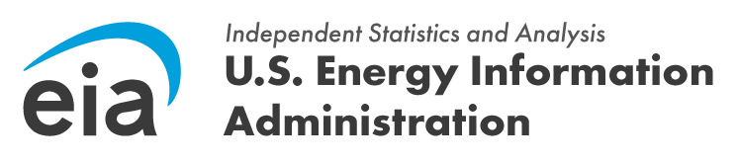

Good Morning,

The U.S. Energy Information Administration (EIA) is piloting an important survey to understand energy consumption patterns in data centers across the United States. To ensure the clarity and effectiveness of our survey instrument, we are inviting knowledgeable professionals on data centers, such as yourself, to participate in a one-on-one interview. Your expertise in data center operations and energy management is invaluable to this process. By participating, you directly help shape the quality and relevance of future data collection efforts, ensuring that the unique operational characteristics and infrastructure of data centers are accurately represented.

We are conducting in-person interviews between the dates of xx/xx – xx/xx. If you would like to participate in an interview, please use the following link below to set up a date and time that works best with your schedule at calendly.com/xxx.

Your responses will be protected as confidential information. According to the Paperwork Reduction Act of 1995, an agency may not conduct or sponsor, and a person is not required to respond to, a collection of information unless it displays a valid OMB control number. The valid OMB control number for this information collection is 1905-0186. The cognitive interview will take approximately 60 minutes on average. If you have any questions or need additional information about this research project, contact me at [insert phone], or by email at [insert email].

OMB Control Number: 1905-0186
Expiration Date: 07/31/2028

Reminder Email for Cognitive Interviews

Subject: Reminder: Invitation to meet with EIA to Provide Feedback on Data Center Energy Use

Good Morning,

This is a reminder to sign up for a time to participate in a one-on-one interview with the U.S. Energy Information Administration (EIA) on data center energy consumption. Your unique perspective as a data center professional is highly valued as we pilot a survey to explore energy consumption patterns in data centers across the United States.

We are conducting in-person interviews between the dates of xx/xx – xx/xx. If you would like to participate in an interview, please use the following link below to set up a date and time that works best with your schedule at calendly.com/xxx.

Your responses will be protected as confidential information. According to the Paperwork Reduction Act of 1995, an agency may not conduct or sponsor, and a person is not required to respond to, a collection of information unless it displays a valid OMB control number. The valid OMB control number for this information collection is 1905-0186. The cognitive interview will take approximately 60 minutes on average. If you have any questions or need additional information about this research project, contact me at [insert phone], or by email at [insert email].

OMB Control Number: 1905-0186
Expiration Date: 07/31/2028

