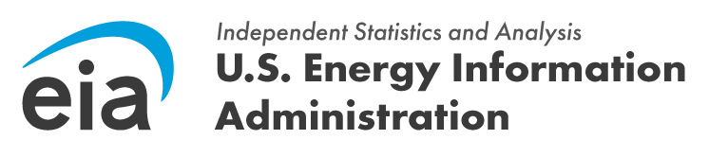
OMB Control Number: 1905-0186
Expiration Date: 7/31/2028

Hello, may I speak with [Recipient Name]?
My name is [Your Name], and I am calling from the U.S. Energy Information Administration (EIA). I am calling regarding an invitation we sent to you recently to participate in a vital pilot web survey on nuclear fusion technologies.
Did you receive the email invitation, and have you had an opportunity to complete the survey?

[Pause for Recipient's Response]

[If yes]
Thank you so much for participating, your time is very appreciated. Have a great day! [End call]

[If no]
We understand you are a key player in this innovative field, and your insights are exceptionally important to help the EIA accurately assess the current state and future potential of nuclear fusion. The data we collect will directly inform future EIA research and analysis, which is critical for fostering innovation and development within the nuclear fusion industry.
The survey is designed to take approximately 15 minutes to complete.
Would you be willing to participate in the pilot?

[Pause for Recipient's Response]

Scenario 1: Recipient has not completed it and has no immediate objections. We would greatly appreciate your participation. Would you be willing to complete it now, or would you prefer me to resend the link for you to complete at your convenience?

Scenario 2: Recipient expresses concern about time. I understand your time is valuable. The survey is designed to be concise, taking approximately 15 minutes. Your contribution is highly impactful, allowing us to accurately track this emerging sector. Would it be possible to revisit it later today or perhaps tomorrow? I can resend the link for your convenience.

Scenario 3: Recipient expresses concern about confidentiality. I can assure you that all data collected through this survey will be treated with the utmost confidentiality. The information gathered will be used solely to help the EIA develop a foundational understanding of the nuclear fusion sector. Individual responses will not be publicly identified. Does that address your concerns?

Concluding the call (if they will complete later or need the link resent): Thank you. I will ensure the survey link is sent to you again shortly. Please do not hesitate to contact Aryn Hernandez at aryn.hernandez@eia.gov or at 202-586-6480 if you encounter any difficulties or have further questions.
Thank you for your time.

Scenario 4: Recipient refuses to complete the web survey. Thank you for clarifying. We understand that participating in a full web survey may not be feasible for everyone. However, your insights are exceptionally valuable to the EIA's efforts to assess the current state and future potential of nuclear fusion.
Would you be open to answering just a few key questions over the phone right now? This would only take about 5 minutes and would still provide us with critical information to inform our research and analysis. All information shared would be treated with the same level of confidentiality as the web survey.
[Pause for Recipient's Response]
If they agree to answer questions over the phone: Excellent, thank you. To confirm, this conversation will be kept confidential and used solely for aggregated analysis to develop a foundational understanding of the nuclear fusion sector. My first question is...
Key Questions:
When do you anticipate completion of your company’s first commercial fusion plant?
- 2026-2030
- 2031-2035
- 2036-2040
- 2041-2045
- 2046-2050
- After 2050

Has your company had preliminary discussions with any of the following entities regarding the development of a fusion plant? Select all that apply.
- Nuclear Regulatory Commission
- State Regulatory Authorities
- IAEA International Atomic Energy Agency
- NNSA National Nuclear Security Administration
- Other government entities – Please specify: [Open-Ended]

What advantages does your company anticipate nuclear fusion will have over other power generation methods (including other fusion, non-fusion nuclear, and non-nuclear technologies)?
[Open-ended]

Those were the major questions we wanted to get information for at this time. Thank you for answering them and for your time. Have a great day. [End call]

If they still decline: I understand. Thank you for your time and for considering our request. We genuinely appreciate your time.

