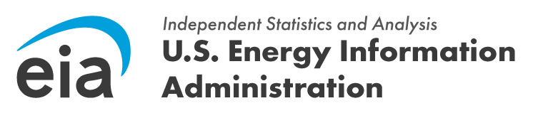
OMB Control Number: 1905-0186
Expiration Date: 7/31/2028

Subject: Reminder: Invitation to Participate in EIA Nuclear Fusion Study
Dear [Recipient Name],
This is a reminder regarding our recent invitation to participate in a vital pilot web survey on nuclear fusion technologies. The U.S. Energy Information Administration (EIA) greatly values your expertise as a key player in this field, and your insights are crucial for our efforts to understand the current state and future potential of nuclear fusion.
Your participation will directly inform future EIA research and analysis, which is critical for fostering innovation and development within the nuclear fusion industry. The survey will take approximately 15 minutes to complete, and all data collected will be treated with the utmost confidentiality.
If you have already completed the survey, we sincerely thank you for your contribution. If not, we encourage you to share your valuable perspectives by accessing the survey here:
[Survey Link]
Should you have any questions or require assistance, please do not hesitate to contact Aryn Hernandez at aryn.hernandez@eia.gov or at 202-586-6480.
Thank you for your time and consideration.
Sincerely,

