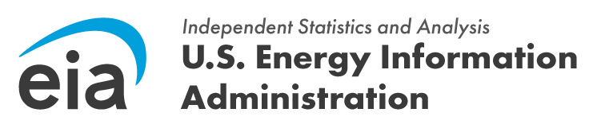
OMB Control Number: 1905-0186
Expiration Date: 7/31/2028

Subject: Invitation to Participate in a Crucial EIA Study on Nuclear Fusion

Dear [Recipient Name],

The U.S. Energy Information Administration (EIA) is initiating a vital pilot web survey to better understand the emerging landscape of nuclear fusion technologies and enterprises. As a key player in this innovative field, your insights are invaluable to our efforts to accurately assess the current state and future potential of nuclear fusion.

Your participation in this pilot survey is exceptionally important. The data we collect will directly inform future EIA research and analysis. This understanding is critical for fostering innovation and development within the nuclear fusion industry.

All data collected through this survey will be treated with the utmost confidentiality. The information gathered will be used solely to help the EIA develop a foundational understanding of the nuclear fusion sector.

We anticipate that completing the survey will take approximately 15 minutes. Your time and expertise are greatly appreciated, and your contribution will have a significant impact on our ability to effectively monitor and report on this transformative energy technology.

To access the survey, please click on the following secure link: [Survey Link]

Should you have any questions or require assistance, please do not hesitate to contact Aryn Hernandez at aryn.hernandez@eia.gov or at 202-586-6480.

Thank you for considering this request and for your valuable contribution to advancing our understanding of nuclear fusion.

Sincerely,

