OMB Control Number: 1905-0186
Expiration Date: 7/31/28
Initial Email Invitation:

Subject Line: Share your Insights on Proposed EIA-810 additions

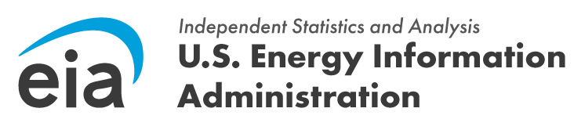

Good Morning “CONTACT_NAME”,

The U.S. Energy Information Administration (EIA) is considering adding new questions on vanadium production and inventories to the Monthly Refinery Report (EIA-810). Prior to adding these questions, we are conducting research to assess the feasibility of this new data collection and to improve question content and wording.

We are contacting you to invite you to participate in a short web survey where you will be able to provide your feedback on the proposed questions. Your participation is voluntary, and the survey should take approximately 15 minutes. Please use this link to access the survey:

<insert Qualtrics link>.

Your responses will be protected as confidential information. According to the Paperwork Reduction Act of 1995, an agency may not conduct or sponsor, and a person is not required to respond to, a collection of information unless it displays a valid OMB control number. The valid OMB control number for this information collection is 1905-0186.

If you have any questions or need additional information about this research project, contact me at [phone], or by email at [email].

Sincerely,

First Reminder Email

Subject Line: Reminder: Provide feedback on proposed additions to EIA’s Monthly Refinery Report

Good Morning,
We recently sent you an email invitation to participate in research evaluating new questions that may be added to the Monthly Refinery Report (EIA-810). Your feedback is valuable and helps us improve future data collection efforts.
If you would like to participate in this survey, please use the following link:

<insert Qualtrics link>.

The survey will take approximately 15 minutes, and your responses will be protected as confidential information.

If you have any questions or need additional information about this research project, contact me at [phone], or by email at [email].

According to the Paperwork Reduction Act of 1995, an agency may not conduct or sponsor, and a person is not required to respond to, a collection of information unless it displays a valid OMB control number. The valid OMB control number for this information collection is 1905-0186.

Thank you,

Second Reminder

Subject Line: Reminder to provide feedback on changes to the EIA-810

Good Morning,
There is still time to provide feedback on proposed changes to the EIA Monthly Refinery Report (EIA-810). Your feedback will help determine the feasibility of adding new questions on vanadium production and inventories to the Monthly Refinery Report (EIA-810). To participate, please use the following link:
[insert link]
Your responses will be protected as confidential information. According to the Paperwork Reduction Act of 1995, an agency may not conduct or sponsor, and a person is not required to respond to, a collection of information unless it displays a valid OMB control number. The valid OMB control number for this information collection is 1905-0186. The time required to complete this information collection is estimated to average 15 minutes per response

If you have any questions or need additional information about this research project, contact me at [phone], or by email at [email].

Thank you,

