Subject Line: Provide Feedback on the Residential Utility Disconnections Survey (EIA-112)

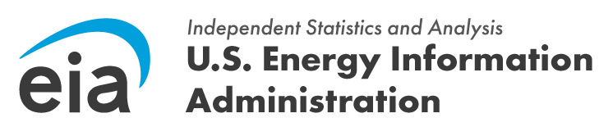

Good Afternoon,

The U.S. Energy Information Administration (EIA) is conducting research on the Residential Utility Disconnections Survey (EIA-112). We would like to meet and gather your feedback on the survey questions and any challenges you encountered when reporting the requested data to EIA. This research will help us improve this survey in the future.

The meetings will be conducted virtually and last approximately one hour. Meetings will take place between [insert dates]. If you would like to participate, please use the link below to set up a date and time that works best with your schedule:

[insert Calendly link]

Participation is voluntary. Your responses will be protected as confidential information. According to the Paperwork Reduction Act of 1995, an agency may not conduct or sponsor, and a person is not required to respond to, a collection of information unless it displays a valid OMB control number. The valid OMB control number for this information collection is 1905-0186. If you have any questions or need additional information about this research project, contact me at [insert phone number], or by email at [insert email].

Thank you,

