Cognitive Testing and Recording Keeping Guide – EIA-112
Respondent ID:
Interviewer:
Observer:
Date:
Time:

(This protocol is a guide – the questions presented here won’t necessarily be asked exactly as worded in the protocol or in this order. It is important to note that not all questions will be asked in every interview. Interviewers may also ask emergent probes as necessary.)

Introduction
My name is _______ and I work for EIA. With me on this call today is ____. The purpose of this study is to evaluate the questions asked on the Residential Utility Disconnections Survey (EIA-112). We want to ensure that the survey questions are easy to understand and that you can easily report these data to us. For this study, we are particularly interested in learning more about how your records are organized and the process you engage in when gathering data from your records to answer the survey questions.

If you have never participated in one of these interviews before, my questions may sound strange. I will be asking you questions about how you interpret each survey question, and how you go about constructing your response to each question. This will include questions regarding how you track this information in your records and any issues you encounter when reporting these data to us. This process will help me ensure that our questions are working properly and we are capturing valid data. Do you have questions before we get started?
Recording Interview

(If provided consent to recording) Thank you for allowing us to record this interview. As part of our procedures, I have to read the following: This MS Teams meeting is being recorded and will be used internally to supplement our notes. If you do not wish to have your voice recorded, please do not speak during the call or disconnect now. If you do not wish to have your image recorded, please turn off your camera or participate only by phone. If you speak during the call or use a video connection, you are presumed to consent to recording and to the use of your voice or image.

[The following is a semi-structured interview guide that includes draft scripted probes. Emergent probes may be asked as well.]
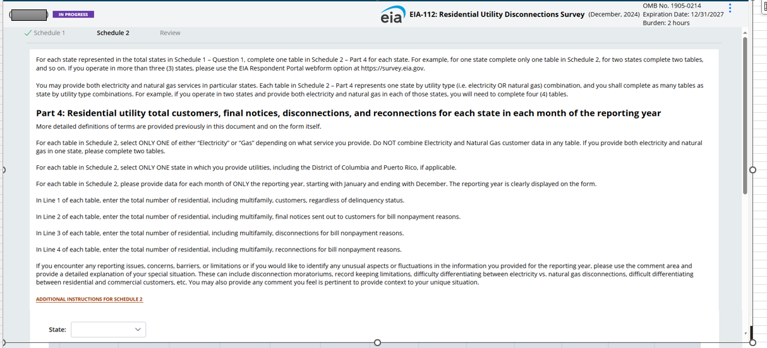
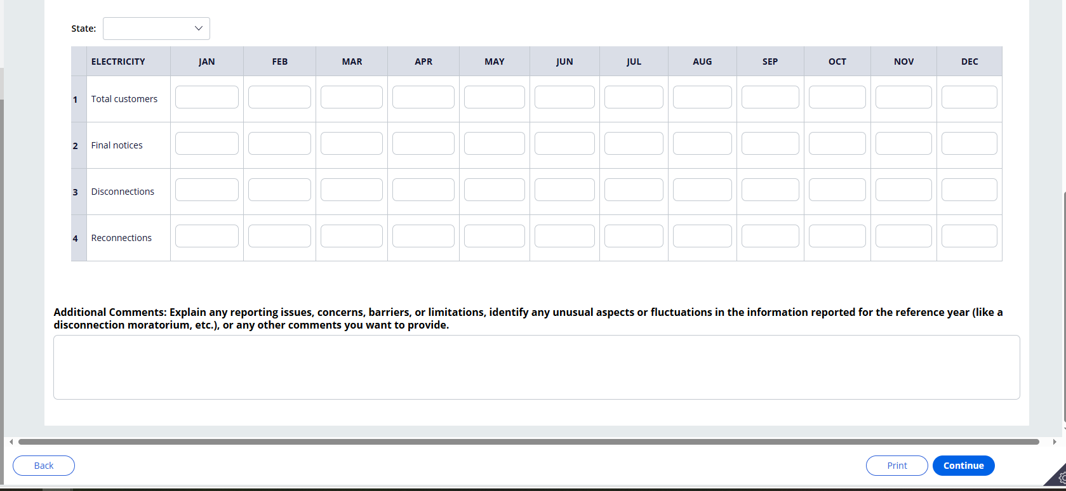

Research Questions
1) Why is the percentage of net disconnections higher than expected given the total number of customers? (Reconnections lower than disconnections each month)
2) How are respondents interpreting and reporting final notices?
3) Why are reported total customer counts different than customer counts on our EIA-861 and EIA-176 frames?
4) Why do different respondents within an entity report different numbers (e.g., electricity respondent reports different numbers than gas respondents)?
5) If needed, how much time and resources would it take to change their systems?

Probing
(These are draft probes. Interviewers should ask emergent probes as needed)
Response History
Show respondent screenshots of their reported data. Give time to review all parts.
These are the data your organization reported in 2025 for calendar year 2024. Were you the person that reported these data?
If yes, what is your role within your organization? What department are you in?
If no, who did? What is their role within your organization? What department are they in?
How knowledgeable/familiar are you with these data? Tell me more about that.
Confirm how many states they operate in and the services they provide.

Comprehension Probes
Now I’d like to review each row in Part 4 and talk about each question.
Show respondent Part 4. For each of the following items, probe on respondent’s interpretation (e.g., what do you think this question is asking for?)
Total Customers:
Final Notices:
Disconnections:
Reconnections:
Show definitions. Now I’d like you to review these definitions we provide. Do you see anything in these definitions that do not match how you would define these terms at your organization? If discrepancies, please tell me more about that. How would you handle this when reporting?
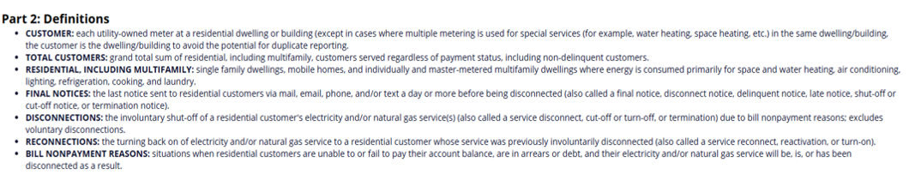
Record Keeping
Next, I’d like to discuss how your records are organized and the process you would engage in when answering these survey questions.
To start, can you walk me through how your records are organized? Do you keep records of total customers, final notices, disconnections and reconnections? What data do you track? How are these data organized in your system?
- Are records identified as residential? Are there types of residential customers that are difficult to identify?
- How are final notices, disconnects, and reconnects tracked? By account numbers? Billing cycle (explain)?
- Do you send multiple notices of bill nonpayment to a customer before disconnecting them? If so, can your system differentiate between earlier notices and the final notice?
- If your system records more disconnections than reconnections, do you expect to see your customer count drop by the difference (e.g. are customers who were disconnected but not reconnected no longer customers)? How long would a customer remain disconnected for nonpayment before they would no longer be considered a customer?
- If a customer is disconnected but no reconnection record exists, do you have records to indicate whether the customer no longer lives at the address, or was reconnected under a different account? Are there any other common outcomes for a disconnection with no corresponding reconnection?
- Is the reason for disconnection tracked?
- Are the customers reported under final notices, disconnects, and reconnects on the survey all customers that had unpaid bills? If not, who else is included in these numbers? How hard or easy would it be to separate these out and only report those with unpaid bills?
- Are you able to pull final notices, disconnections, reconnections totals for each month? How are these data organized in your system? By monthly billing cycle?
- How would you determine the counts for each month when reporting? Did all the final notices, disconnections, and reconnections reported for each month occur within the month reported? If respondent reports that data are not tracked by month or had any difficulty reporting counts for each month, ask how did you handle this when reporting?
- For dual service, how are records on residential electric and natural gas customers kept within your organization? Are they stored in the same place? Do you need to pull information on residential electric and gas customers from different datasets? Do you need assistance from others to do that?
- For entities that provide services to more than one state, are your records organized in the same manner for each state?

If needed: Can you walk me through how you would formulate your response to the questions in the table? Do you need to transform these data in any way before reporting to EIA? Make sure to ask this about final notices.
If you don’t have the data in the requested format, what would you do? Could you estimate it? How would you estimate it? How difficult would it be to start tracking these data?

Discuss other data issues (if any) seen with this organization’s data.
- We noticed the reported number of disconnections appears high in comparison to reconnections. Can you walk me through how you determined your total number of disconnections and reconnections?
- Your total customer count reported on this survey differs from the numbers of customers reported on the Electric Power Industry Report EIA-861/ Annual Report of Natural and Supplemental Gas Supply and Disposition EIA-176. Do you report for the 861/176? Do you know who does? Do you have any insight into why these numbers might be different?
- The numbers reported by the 861respondent and the numbers reported by 176 respondent vary substantially. Can you explain why this might be?
- Who in the company has access to these records? How knowledgeable are these individuals with regard to this information? If different people have access to different data, how would you go about gathering and reporting these data to EIA?

Document any issues related to reporting these data to EIA and what steps, if any, the respondent can take to resolve the issues in the future. What resources would be needed?
A secondary, yet important, goal is to assist the respondent in enhancing data quality before the subsequent survey cycle. Try to help resolve any lingering questions regarding the intent of the survey.

