aOMB Control Number: 1905-0186
Expiration Date: 07/31/2028

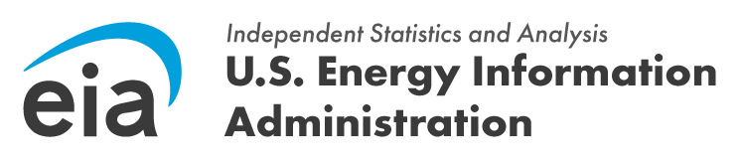

Good Morning,

The U.S. Energy Information Administration (EIA) is conducting user experience interviews with respondents that complete the Residential Utility Disconnection Survey, Form EIA-112. EIA would like to observe, ask questions, and take notes on how you complete and submit the webform for EIA-112. Your voluntary participation and feedback in this study will help us understand how to improve the web instrument for all respondents during the next data collection. We are only interested in your experience completing the webform, therefore, it is not necessary to enter actual data during the interview.

We are conducting video conferencing interviews between the dates of xx/xx – xx/xx. If you would like to participate in an interview, please use the following link below to set up a date and time that works best with your schedule at calendly.com/UserExperience_EIA-xxx.

Your responses will be protected as confidential information. According to the Paperwork Reduction Act of 1995, an agency may not conduct or sponsor, and a person is not required to respond to, a collection of information unless it displays a valid OMB control number. The valid OMB control number for this information collection is 1905-0186. The EIA-112 usability interview will take 60 minutes on average. If you have any questions or need additional information about this research project, contact me at [insert phone], or by email at [insert email].

