Attachment 1. 2026 CDC eFMS Customer Satisfaction Survey

[Page 1 – Introduction]

You are being asked to complete this survey because you applied to host a fellow from one of our DWD fellowship programs, Epidemic Intelligence Service (EIS) or the Public Health Associates Program (PHAP) The purpose of this survey is to gather information about your experience with the DWD Enterprise Fellowship Management System (eFMS) application portal – the online system where you submitted your Epidemic Intelligence Service (EIS) or the Public Health Associates Program (PHAP) host site application. Your responses will help improve our program recruitment and application portal.

This survey is anonymous, and your participation is completely voluntary. Participating in this survey will not affect your selection into the fellowship program. Results will be reported in aggregate (e.g., 75% of respondents were satisfied with the program).

We estimate that it will take approximately 5 minutes to complete this survey.

Please contact dwdeval@cdc.gov if you have any questions regarding this survey.

Notice: By continuing to the next screen, you consent to complete this survey.

BACKGROUND

Think back to when you submitted your Epidemic Intelligence Service (EIS) or the Public Health Associates Program (PHAP) host site application and the application portal that you used. Please review the next two images as a refresher.

The public reporting burden of this collection of information is estimated to average 5 minutes per response, including the time for reviewing instructions, searching existing data sources, gathering and maintaining the data needed, and completing and reviewing the collection of information. An agency may not conduct or sponsor, and a person is not required to respond to a collection of information unless it displays a currently valid OMB control number. Send comments regarding this burden estimate or any other aspect of this collection of information, including suggestions for reducing this burden to - CDC/ATSDR Reports Clearance Officer; 1600 Clifton Road NE, MS H21-8, Atlanta, Georgia 30333 ATTN: PRA (0920-1050).

[Page 2]

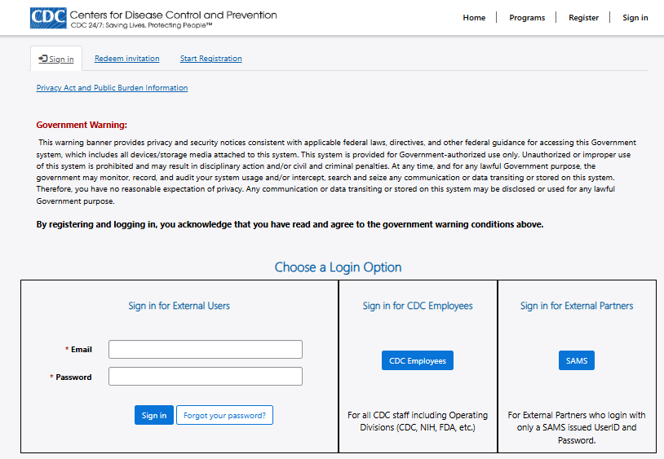

EIS Host Site Application Portal

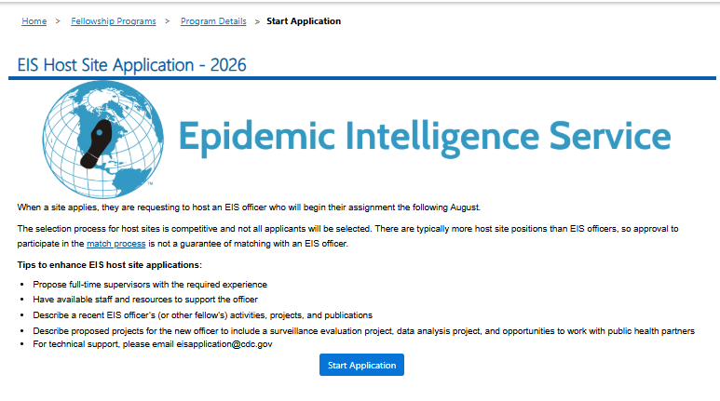

PHAP Host Site Application Portal
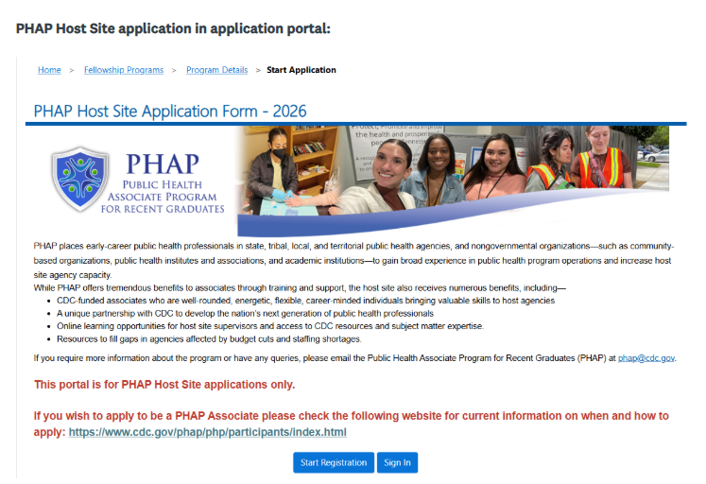

USER EXPERIENCE

We are interested in learning about your experience with the application portal (i.e., website, software). We are NOT asking for your input on your specific application content (e.g., questions, number of questions) at this time.

1. How easy or difficult was it to navigate through the host site application portal?* (Select one)
- Very Difficult
- Difficult
- Neither difficult nor easy
- Easy -> SKIP to 3
- Very Easy -> SKIP to 3

2. Which specific features of the host site application portal were difficult to use? (Open response)
______________________________________________________________

3. Did you encounter any technical issues (e.g., login issues, software errors) while using the host site application portal?* (Select one)
- Yes
- No -> SKIP to 5
- I don’t know -> SKIP to 5

4. Please describe the technical issue(s) you experienced.* (Select all that apply)
- Login/access issues – [application portal down, application portal loading slowly, captcha verification failures, account creation issues]
- Form and submission issues – [error messages indicating incomplete fields or invalid data formats, session timeouts or browser crashes leading to lost data, file upload issues]
- Compatibility and usability issues – [inaccessible features, browser incompatibility, browser not working, application freezing, mobile incompatibility, incorrect output]
- Technical support limitations – [lack of support via live chat or when assistance is needed quickly]
- Other (please specify): ___________________

5. How helpful were the instructions included throughout the host site application portal?* (Select one)
- Not at all helpful
- Slightly helpful
- Moderately helpful
- Very helpful
- Extremely helpful

OVERALL EXPERIENCE

We are interested in learning about your overall experience with the application portal.

6. How long did it take you to complete your application in the host site application portal?* (Select one) Consider the amount of time you spent entering information into the portal, excluding the time it took to gather all the necessary application content.
- 1-30 minutes
- 31-60 minutes
- 61-90 minutes
- 91-120 minutes
- Other (please specify): __________

7. Overall, how satisfied were you with the host site application portal?* (Select one)
- Not at all satisfied
- Slightly satisfied
- Moderately satisfied
- Very satisfied
- Extremely satisfied

8. Is there anything about the host site application portal that could be improved?* (Select one)
- Yes
- No -> SKIP to end
- I don’t know -> SKIP to end

9. Please describe how the host site application portal could be improved: ________________________ (Open response)

[Custom Thank You]
Thank you for taking the time to complete this survey. We appreciate your input and honest feedback. If you have any questions or concerns, please contact us at dwdeval@cdc.gov.

