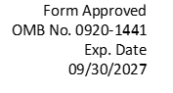
Attachment 8
Post-Test Questionnaire

Participant ID: ______________

1. For the touchscreen task you have just completed, do you prefer the Mobile Data Terminal (MDT) installed on the dash, or the same MDT installed on the pole to the right of the center console? Circle one below.
A. MDT on the dash
B. MDT to the right of the center console
C. No preference.

2. For the license plate number entry task you have just completed, do you prefer to use the MDT installed on the dash, or the same MDT installed on the pole to the right of the center console? Circle one below.
A. MDT on the dash
B. MDT to the right of the center console
C. No preference

3. For the radio zoning task you have just completed, do you prefer the radio installed on:
A. Flat center console:
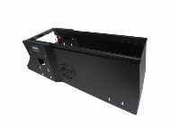
B. Angled center console:
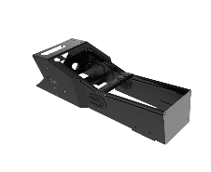
C. No preference

4. For the light/siren control task you have just completed, do you prefer the radio installed on:
A. Flat center console:
B. Angled center console:
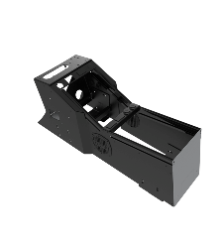
C. No preference

5. In the space below, please comment on your positive or negative experience using all the onboard equipment referred to in Questions 1 through 4.

Positive: ____________________________________________________________________________________________________________________________________________________________________________________________________________________________________

Negative: _____________________________________________________________________________________________________________________________________________________________________________________________________________________________________________

Other comments/suggestions:
____________________________________________________________________________________________________________________________________________________________________________________________________________________________________

Public reporting burden of this collection of information is estimated to average 10 minutes per response, including the time for reviewing instructions, searching existing data sources, gathering and maintaining the data needed, and completing and reviewing the collection of information. An agency may not conduct or sponsor, and a person is not required to respond to a collection of information unless it displays a currently valid OMB control number. Send comments regarding this burden estimate or any other aspect of this collection of information, including suggestions for reducing this burden to CDC/ATSDR Information Collection Review Office, 1600 Clifton Road NE, MS D-74, Atlanta, Georgia 30333. ATTN: PRA (0920-1441)

