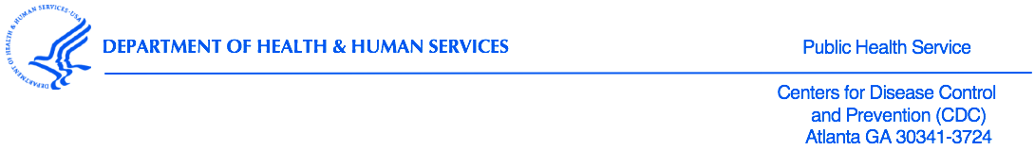

The CDC Human Research Protections Office (HRPO) has transitioned 7068, “National Youth Tobacco Survey” to the 2018 Common Rule.

HRPO’s final determination is that the National Youth Tobacco Survey (NYTS) meets the definition of “Public health surveillance activities,” and therefore it does not constitute research as defined by the 2018 Common Rule. As such, the NYTS is not required to be subject to CDC IRB’s review.

