Hello [Participant Name],

My name is [name] and I am from [Regional/Local office], and I would like to thank you for taking the time to complete the following survey. This survey is designed to inform the future design and content of potential products from the National Weather Service (NWS), and your feedback will have direct influence on the viability and future of these products. We seek to understand how core partners of the NWS use and interpret high impact weather information.

This survey will take approximately 10 minutes to complete. Thank you very much for your feedback and participation in this study.

Burden Statement
We estimate that completing this survey will take 10 minutes on average. Send comments regarding this burden estimate or any other aspect of this collection of information, including suggestions for reducing this burden, to NOAA, (Madi Gordon, madi.gordon@noaa.gov). This collection has been approved by the Office of Management and Budget (OMB). The eight-digit OMB approval number that appears at the upper right of the form or login screen confirms this approval. If this number were not displayed, we could not conduct this survey.

Demographics:
- Please indicate what job position you currently hold: [Drop Down Menu, select one]
  - Emergency Manager
  - Local or Territorial Government
  - State Government
  - Federal Government
  - Tribal
  - NGO/VOAD/CBO
  - School Official
  - Broadcast Media
  - Other [open text]
- How many years have been employed in your current position? [Multiple Choice, select one]
  - Less than 1
  - 1-5
  - 6-10
  - 11-15
  - 16-20
  - 20+
- How many years have you been in your career field? [Multiple Choice, select one]
  - Less than 1
  - 1-5
  - 6-10
  - 11-15
  - 16-20
  - 20+
- Do you have an emergency response background in any of the following fields? (Select all that apply)
  - Medical
  - Fire
  - Law
  - None of the above
- To the best of your ability, indicate which type of community setting you serve: (Select all that apply)
  - Urban
  - Suburban
  - Rural

Product Scenarios:
In the next section, we will provide a weather scenario, with a companion graphic. We will then ask you a series of questions for the specific scenario and graphic to improve overall design, placement of information, and clarity.

[Scenario 1]

A Severe Thunderstorm Watch is in effect for your entire region through 11 pm. Your jurisdiction is at the starred location. You just received this graphic giving you the details of this severe weather threat for the next two hours.
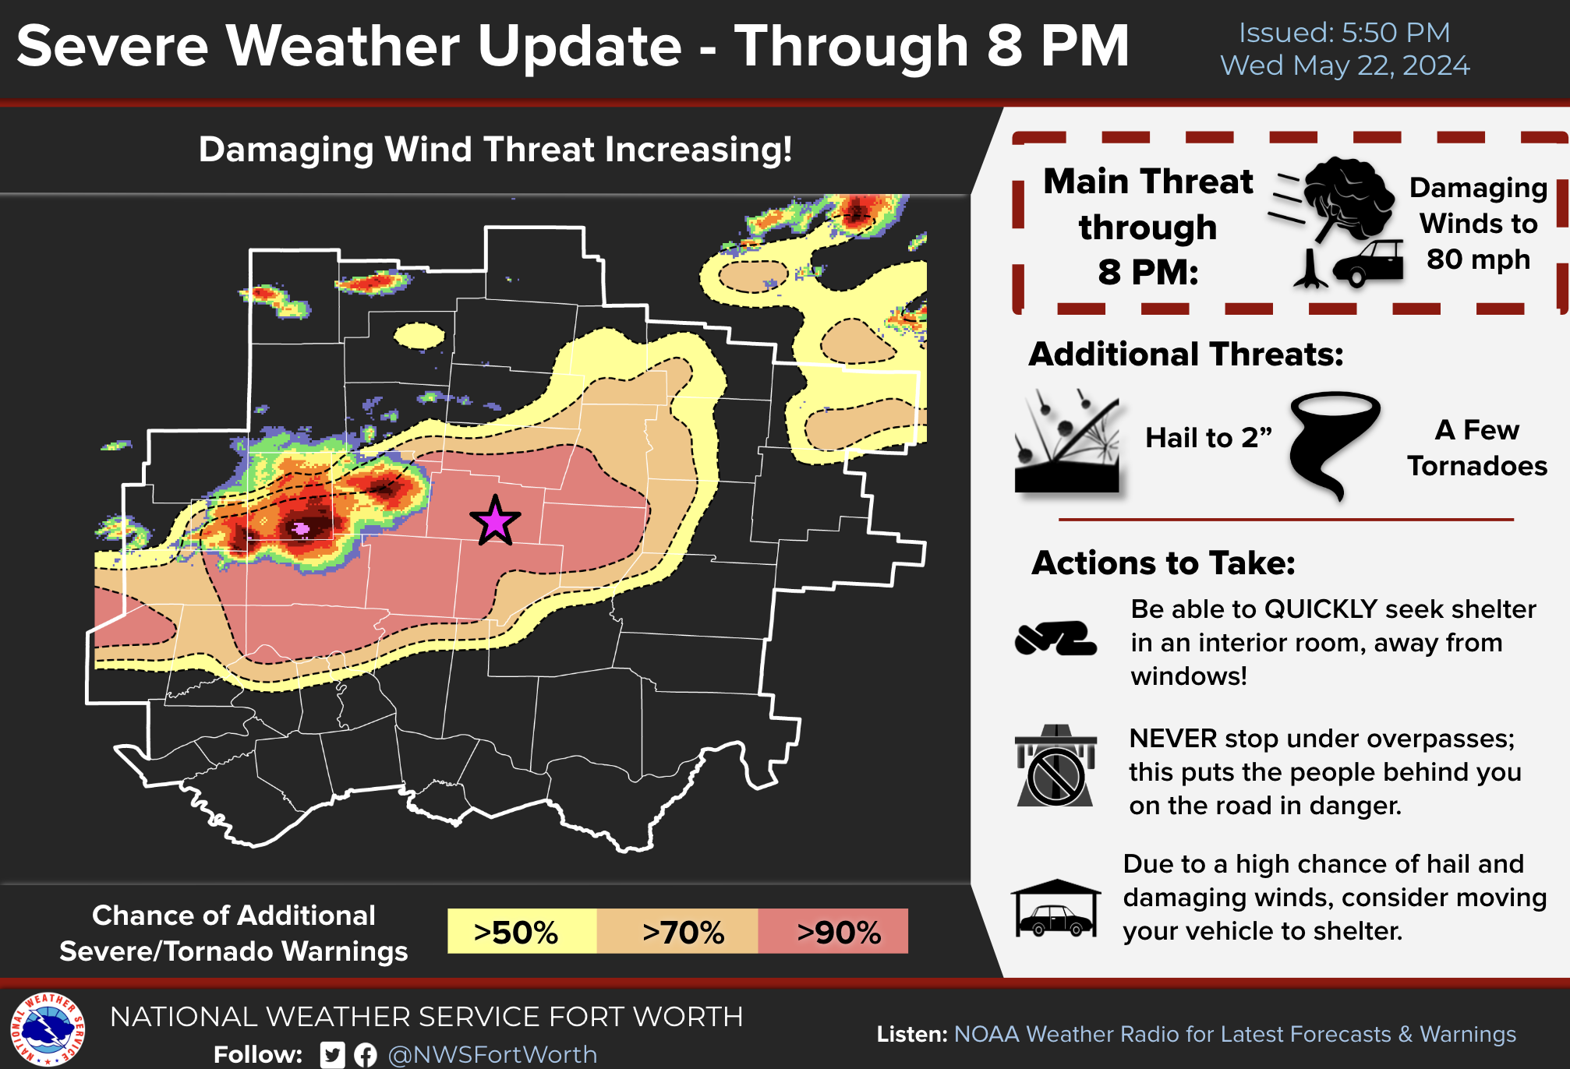
- Given your location, what is your chance of additional severe/Tornado Warnings? [select one]
  - Less than 50%
  - Greater than 50%
  - Greater than 70%
  - Greater than 90%
  - I do not know
- Until when will the threat last? [select one]
  - 6pm
  - 8pm
  - 11pm
  - I do not know
- What direction do you think these showers and storms are moving? [select one]
  - Southeast to Northwest
  - Northeast to Southwest
  - Southwest to Northeast
  - Northwest to Southeast
  - I do not know

[SKIP LOGIC - ONLY TO EMs/Broadcast]
On a scale of 1 to 5 with 1 being strongly disagree and 5 being strongly agree, how much do you agree with the following statement: I feel comfortable sharing this graphic, with no changes, with my organization’s decision-makers.
- Strongly disagree
- Disagree
- Neutral
- Agree
- Strongly Agree

On a scale of 1 to 5 with 1 being strongly disagree and 5 being strongly agree, how much do you agree with the following statement: I feel comfortable sharing this graphic, with no changes, with the public.
  - Strongly disagree
  - Disagree
  - Neutral
  - Agree
  - Strongly Agree

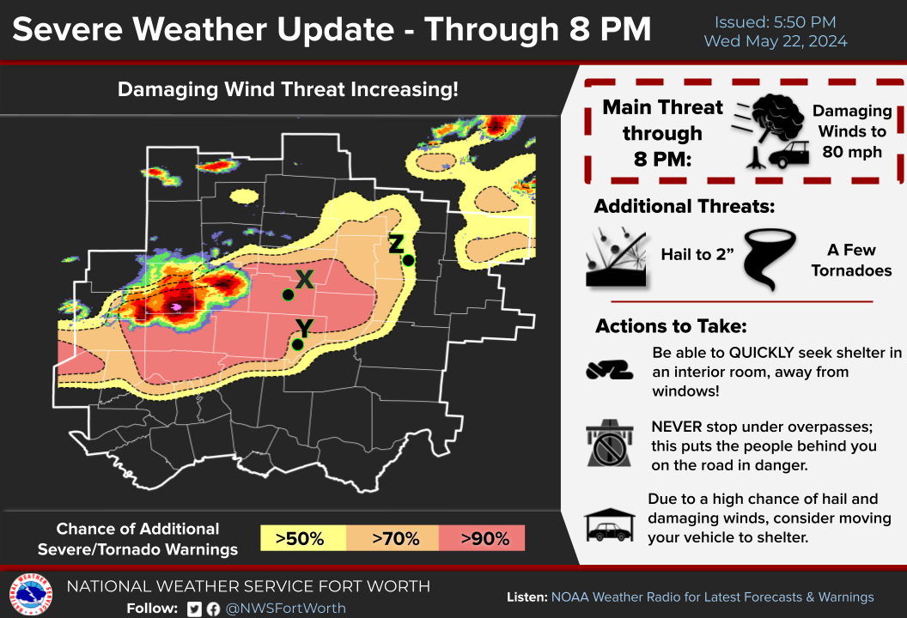

[NEW GRAPHIC] Who has the greatest threat of having a tornado warning: Point X, Y, or Z? [select one]
1 - Point X
2 - Point Y
3 - Point Z
4 - I do not know

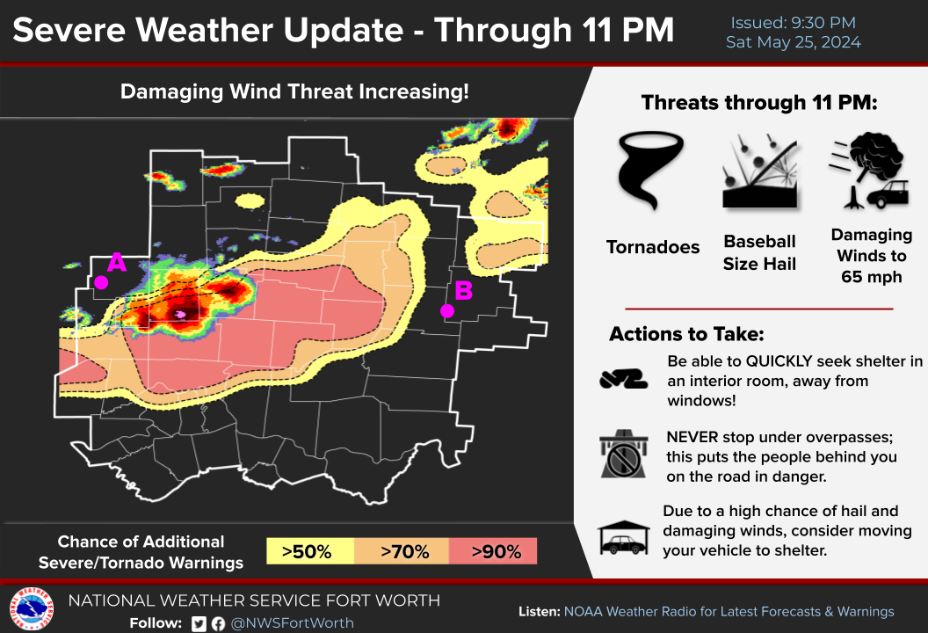

[NEW GRAPHIC] This map shows the potential for additional Tornado and Severe Thunderstorm Warnings through 11 PM. At 1 AM, do you think Point A or Point B have a higher chance of severe weather? [select one]
1 - Point A
2 - Point B
3 - Neither and/or the same concern
4 - I do not know

7. [NEW Scenario and GRAPHIC] The following day presents yet another severe weather event, with a Severe Thunderstorm Watch in effect through 10 PM. Your local NWS office sends you this new graphic on NWSChat.

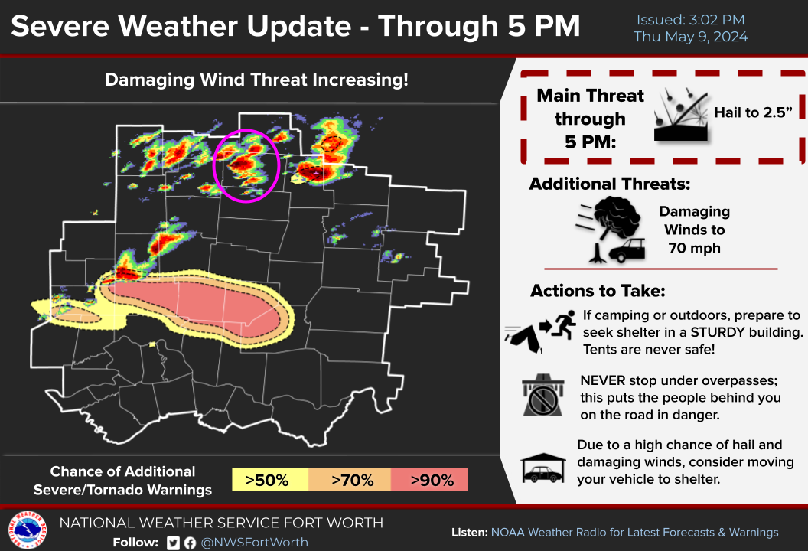

- How would you read this graphic for the storm in the circled region? [select one]
1 - This storm has no chance of becoming severe.
2 - This storm is forecast to weaken or dissipate.
3 - This storm could become severe but it is unlikely.
4 - This storm will likely become severe.
5 -I don’t know.

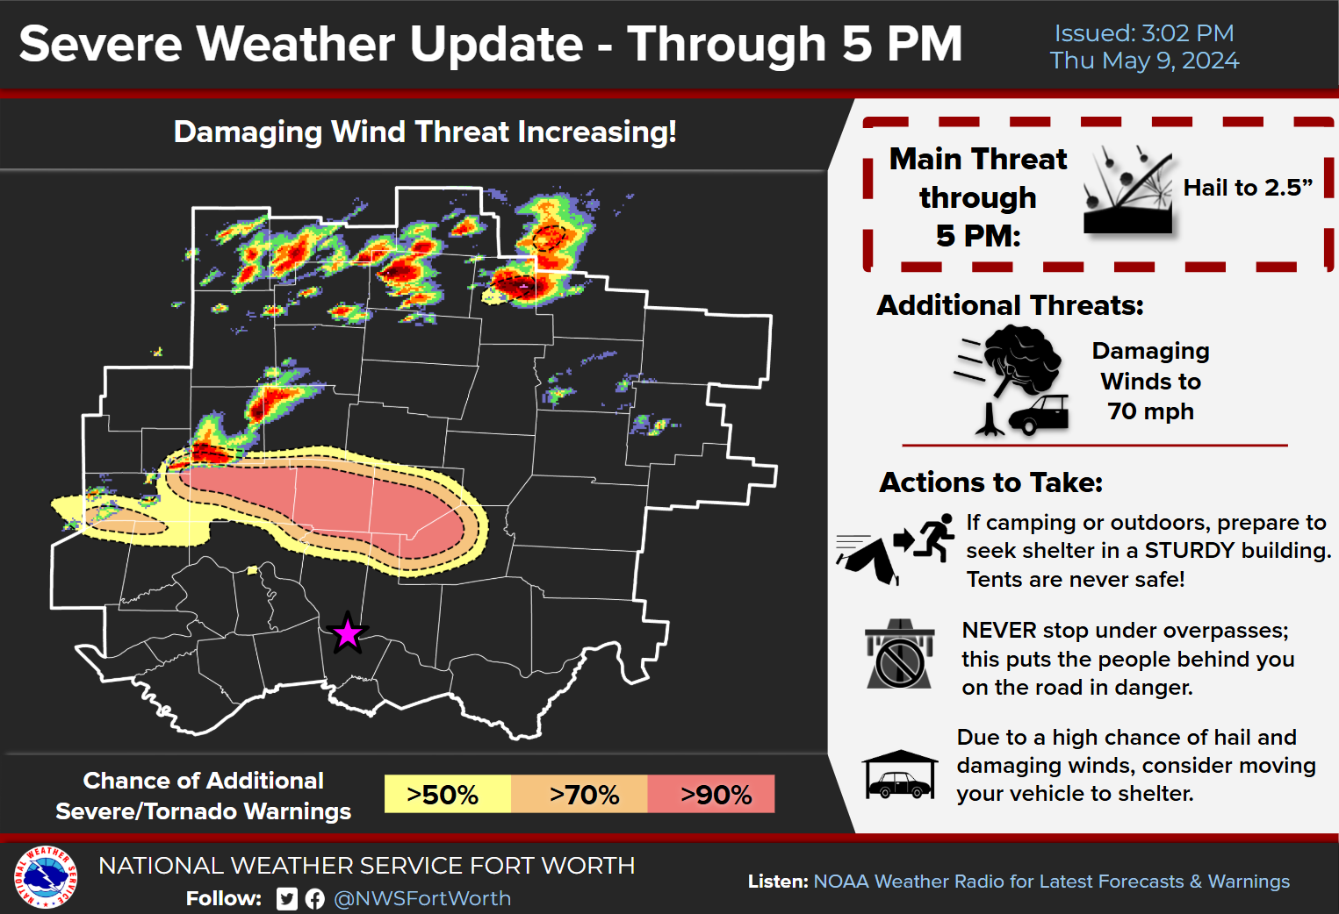

- [NEW GRAPHIC] What statement do you think best describes the severe weather threat at the starred location? [select one]
1- There is no severe weather threat now through 5 pm.
2- There is a low chance (10% to 40%) of severe weather warnings now through 5 pm.
3 - There is a low to moderate chance (10% to 70%) of severe weather warnings now through 10 pm
4 - I don’t know.

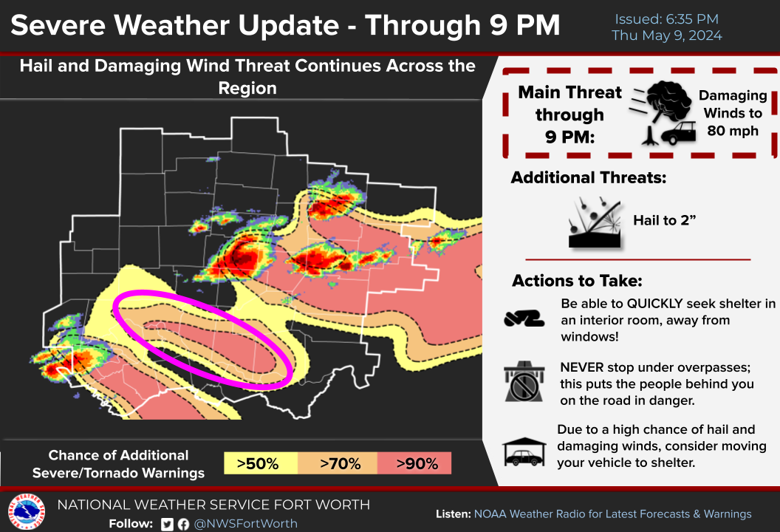

- [NEW GRAPHIC] It’s now later in the day and your NWS office has updated NWSChat with the latest graphic. How would you interpret the threat within the circled area? [select one]
1 - The forecast is wrong and/or untrustworthy.
2 - I expect a storm to develop and become severe in the circled area.
3 - One of the existing storms is expected to move into the circled area.
4 - I would have to seek additional information to understand the forecast.

8. The next section will focus on your preferences regarding the style and content of the graphics displayed.

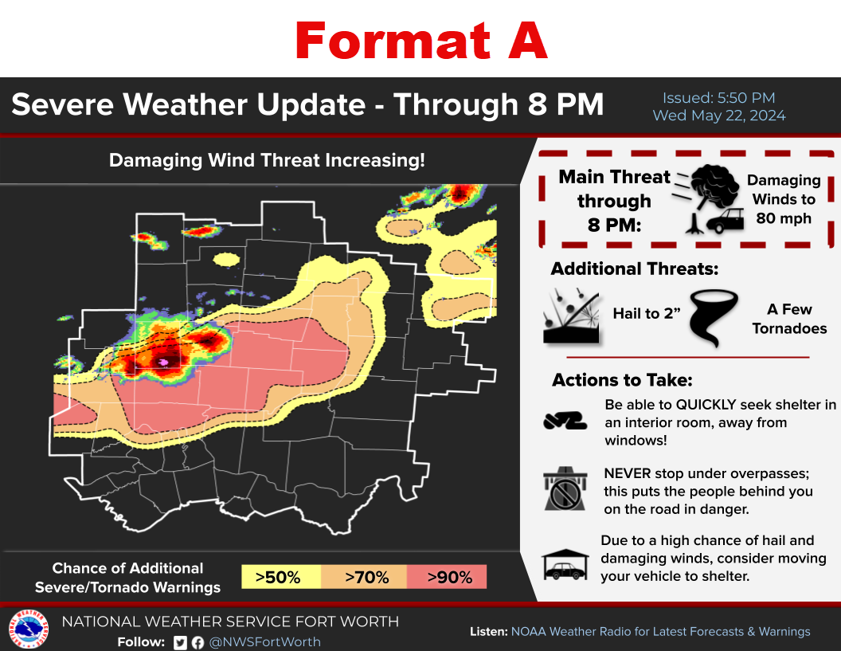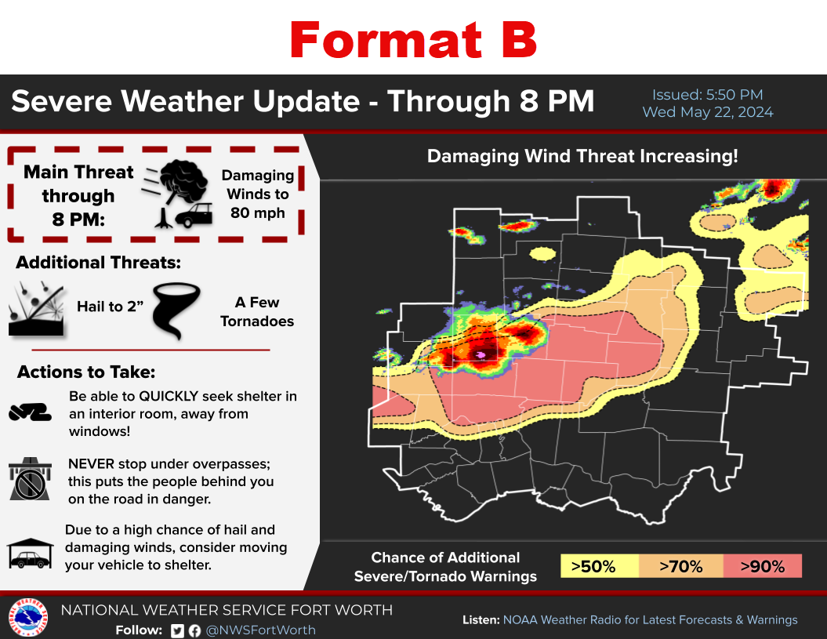

- Do you prefer Format A or Format B?
1 - Format A: The map on the left [Go to Q3]
2 - Format B: The map on the right [Go to Q4]
3 - No preference

- In one or two sentences, please provide any additional comments or concerns you have about the information contained in these graphics:
[Open Ended - Optional]

