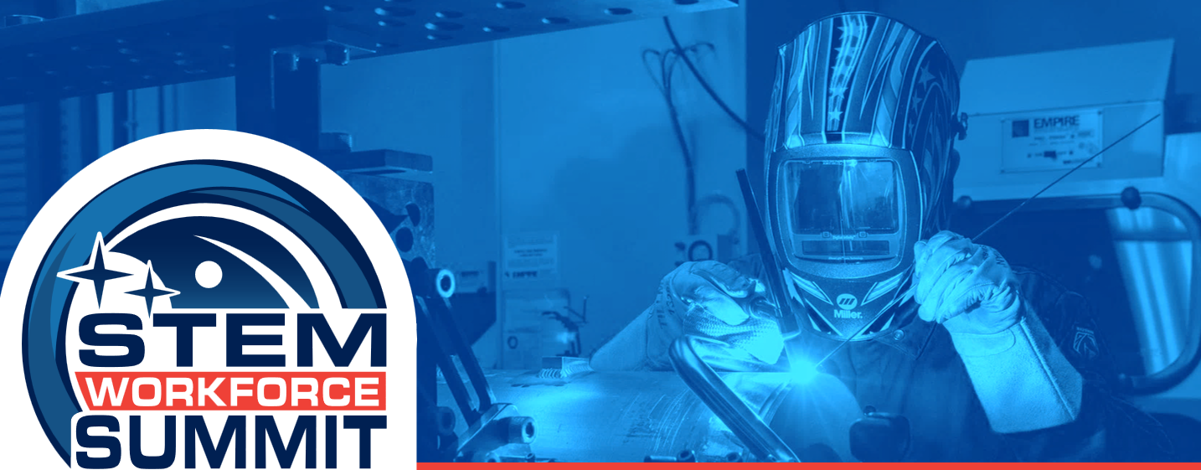
Thank you so much for your participation in the 2025 STEM Workforce Summit! We hope you had ample opportunities to learn, engage and grow in STEM with representatives from Institutions of Higher Education, Aerospace Industry, Aerospace Hubs, informal education, and OSTEM colleagues, grantees and stakeholders. Now that you’ve had some time to process and reflect on your 2025 STEM Workforce Summit experience, we would greatly appreciate one more opportunity to learn from you!
Your feedback and reflections on this event are very important to us! Please spend a few minutes to complete a short reflections form: 2025 SWS End of Meeting Participant Reflections Form
We will host a post -summit webinar in December and invite all attendees to join. If you have questions about the Summit or upcoming webinar, please reach out to
hq-workforcesummit@mail.nasa.gov with questions. As always, if you have more general questions, please reach out to HQ-STEM-Engagement@mail.nasa.gov
Best Regards,
2025 STEM Workforce Summit Planning Team
WHAT ACTIONS SHOULD YOU TAKE NOW?
- Complete the 2025 SWS End of Meeting Participant Reflections Form no later than Friday, October 3, 2025
- Continue to learn from and engage with folks you connected with during the STEM Workforce Summit!

