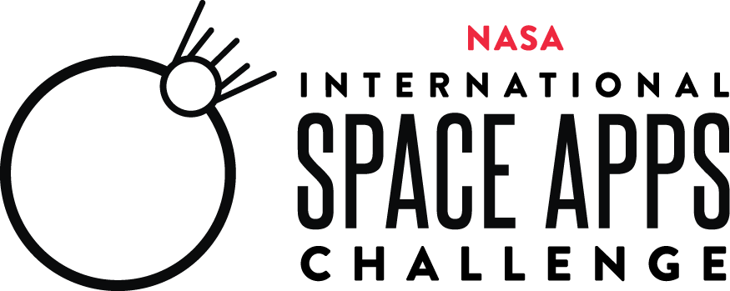
2021 Registrant Satisfaction Survey

Thank you for participating in NASA’s International Space Apps Challenge. In order to provide an amazing experience for our Space Apps community we are asking for your feedback on the October 2-3, 2021 event. Please complete this short survey by October 18, 2021.

This information collection meets the requirements of 44 U.S.C 3507, as amended by section 2 of the Paperwork Reduction Act of 1995. The OMB control number for this information collection is 2700-0153 and it expires on September 30, 2021. We estimate this survey will take 10 minutes. You may send comments on our time estimate to hq-spaceapps@mail.nasa.gov.

- Have you participated in a NASA International Space Apps Challenge before? (Select one)*
  - Yes, I participate in the NASA International Space Apps Challenges as much as possible! (participated in 8 or more events in the past).
  - Yes, I have participated in the NASA International Space Apps Challenges a bunch of times (participated in 5-7 events in the past).
  - Yes, I have participated in the NASA International Space Apps Challenge in the past (participated in 2-4 events in the past).
  - No, this is my first time.

- This year’s NASA International Space Apps Challenge was produced with quality. (Select one)*

Strongly Disagree | Disagree | Neither Agree Nor Disagree | Agree | Strongly Agree

- How did you learn about the 2021 NASA International Space Apps Challenge? (Select all that apply)*
  - Facebook
  - Twitter
  - LinkedIn
  - Instagram
  - My school or place of work
  - Organization outside of school or work (club, professional association, etc.)
  - Local Lead
  - Word of Mouth (family, friend, etc.)
  - Other (please specify) ________________________

- Why did you participate in the 2021 NASA International Space Apps Challenge? (Select all that apply)*

  - I have participated in previous NASA International Space Apps Challenges and have enjoyed them.
  - I want to help solve real-world problems.
  - I enjoy meeting team members from around the globe.
  - I want to understand and learn more about the innovation process.
  - I want to be a part of a community.
  - A friend/teacher/mentor asked me to join.
  - It was easy to participate in because it was virtual.
  - The prizes are motivating.
  - It was led by NASA.
  - My country's space agency was a partner.
  - Other (please specify) ______________________

- Please rate your level of satisfaction with the following aspects of the NASA International Space Apps Challenge (Select one for each aspect)*

 | Strongly Disagree | Disagree | Neither Agree Nor Disagree | Agree | Strongly Agree
I was able to easily find/ form teams on the NASA International Space Apps Challenge website.
I was inspired by the challenge statements.
I found the data/resources included with each challenge on the challenge page to be helpful.
I thought the technical support provided during the NASA International Space Apps Challenge was helpful in solving my technical issue(s).
I thought the project submission process was clear.
I thought the support provided by my Local Lead was helpful.

- How would you improve any of the above aspects of the NASA International Space Apps Challenge? (Open answers) (Optional)

- Which of these participant resources on the NASA International Space Apps Challenge website did you find helpful? (Select all that apply)*
  - Participant FAQ
  - Virtual Bootcamp Videos
  - Team Formation Guide
  - Chat Guide
  - Judging and Awards Guide
  - Project Submission Guide
  - Global Opening Ceremony
  - Other

- When and where would NASA International Space Apps Challenge communications be most helpful? (Select all that apply)*

 | Email/Dashboard Messages | Social Media | Website | Communication from my Local Lead
The weeks leading up to the NASA International Space Apps Challenge
When creating or looking for a team
When working on the solution to our challenge
When submitting my project
The weeks immediately after the hackathon (during the judging process)

- Other, please specify (Open answers) (optional)

- What did you use the NASA International Space Apps Challenge Chat Channels for? (Select all that apply)*
      - I had a question(s) for a Subject Matter Expert (SME) about my challenge
      - I had a question(s) for the NASA International Space Apps Challenge Organizing Team
      - I wanted to find teammates/a team to join
      - I wanted to chat with people from my region/who speak my language
      - I did not use the NASA International Space Apps Challenge Chat Channels
      - Other, please specify (Open answers)

- If you did not use the NASA International Space Apps Challenge Chat Channels, why not? (optional)*
      - I did not know that NASA International Space Apps Challenge Chat Channels were available.
      - I did not find the NASA International Space Apps Challenge Chat Channels to be convenient to use.
      - I did not find the NASA International Space Apps Challenge Chat Channels easy to use.
      - I did not need support from the NASA International Space Apps Challenge chat Channels, but I knew they were an option.
      - Other

- Please select “Yes” or “No” for each of the following questions about your participation in the 2021 NASA International Space Apps Challenge.*

 | Yes | No
Signed up for a NASA International Space Apps Challenge account (or had a previous account)
Registered for a location or the Universal Event
Formed a team with more than one teammate
Participated in the hackathon but did not complete a project
Participated in the NASA International Space Apps Challenge, completed a project, but did not submit a project to be judged
Submitted a project to be judged
Other (please specify)

- If you did not submit a project to be judged, why not? (Select all that apply.) (those who submitted a project to be judged, should skip this question)
      - Did not complete project in time
      - Issues with joining team
      - Lack of support and/or understanding
      - Personal Issue (technical, medical, work, etc.)
      - Other

- Based on your experience in the 2021 NASA International Space Apps Challenge, what is the likelihood you will participate in future NASA International Space Apps Challenges? (Select one)*

Not Likely | Somewhat Likely | Very Likely

- I believe that overall, individuals within the NASA International Space Apps Challenge community conduct themselves with professionalism. (Select one)*

Strongly Disagree | Disagree | Neither Agree Nor Disagree | Agree | Strongly Agree

- Please provide us with any other comments or elaborate as needed on any of your previous answers. <open answers text box>

