Survey would be available here: https://forms.office.com/g/FyACcZcYFb
An email from our Center Director’s office would go out to AFRC-Public (all civil servant and contractor employees at NASA), and it would look like this:
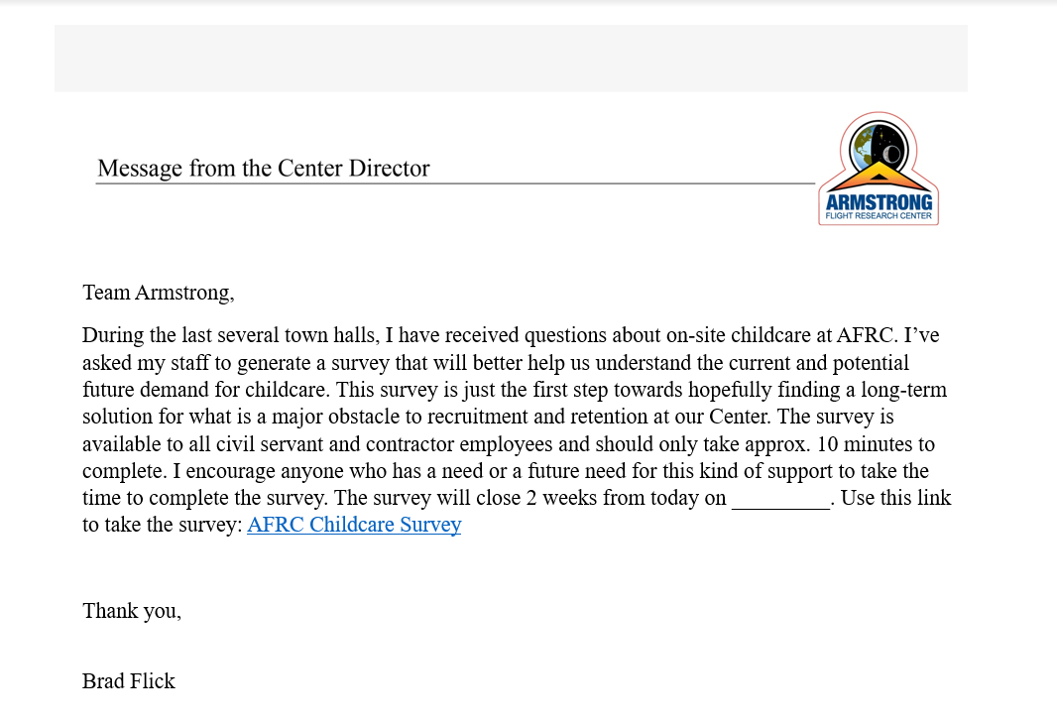
The survey would be posted on our internal NASA Armstrong site, Inside Armstrong, under Center Announcements:

