ARC Electric Vehicle Survey

1. Contents - Text

Ames is investigating potential personal EV charging opportunities and looking to survey center employees to determine quantity and placement of desired EV chargers
Paperwork Reduction Act Statement: This information collection meets the requirements of 44 U.S.C 3507, as amended by section 2 of the Paperwork Reduction Act of 1995. You do not need to answer these questions unless we display a valid Office of Management and Budget control number. The OMB control number for this information collection is 2700-0153 and it expires on 07/31/2024. We estimate that it will take about 2 minutes to read the instructions, gather the facts, and answer the questions. You may send comments on our time estimate above to lauren.e.wibe@nasa.gov. Send only comments relating to our time estimate to this address.
- Do you own an electric vehicle?
  - Yes
  - No
- On average, how many days per week do you come on center
  - Drop down selection: 1-7
- What type of charger would you use?
  - Level 2
  - Level 3
  - Tesla
- What building number do you work in?
  - Type in number only: ###
- Other building that you would like to see EV chargers by? (Besides B3 SpaceBar/NACC and N235 MegaBites)
  - Type in number only: ###

2. Content - Screenshots

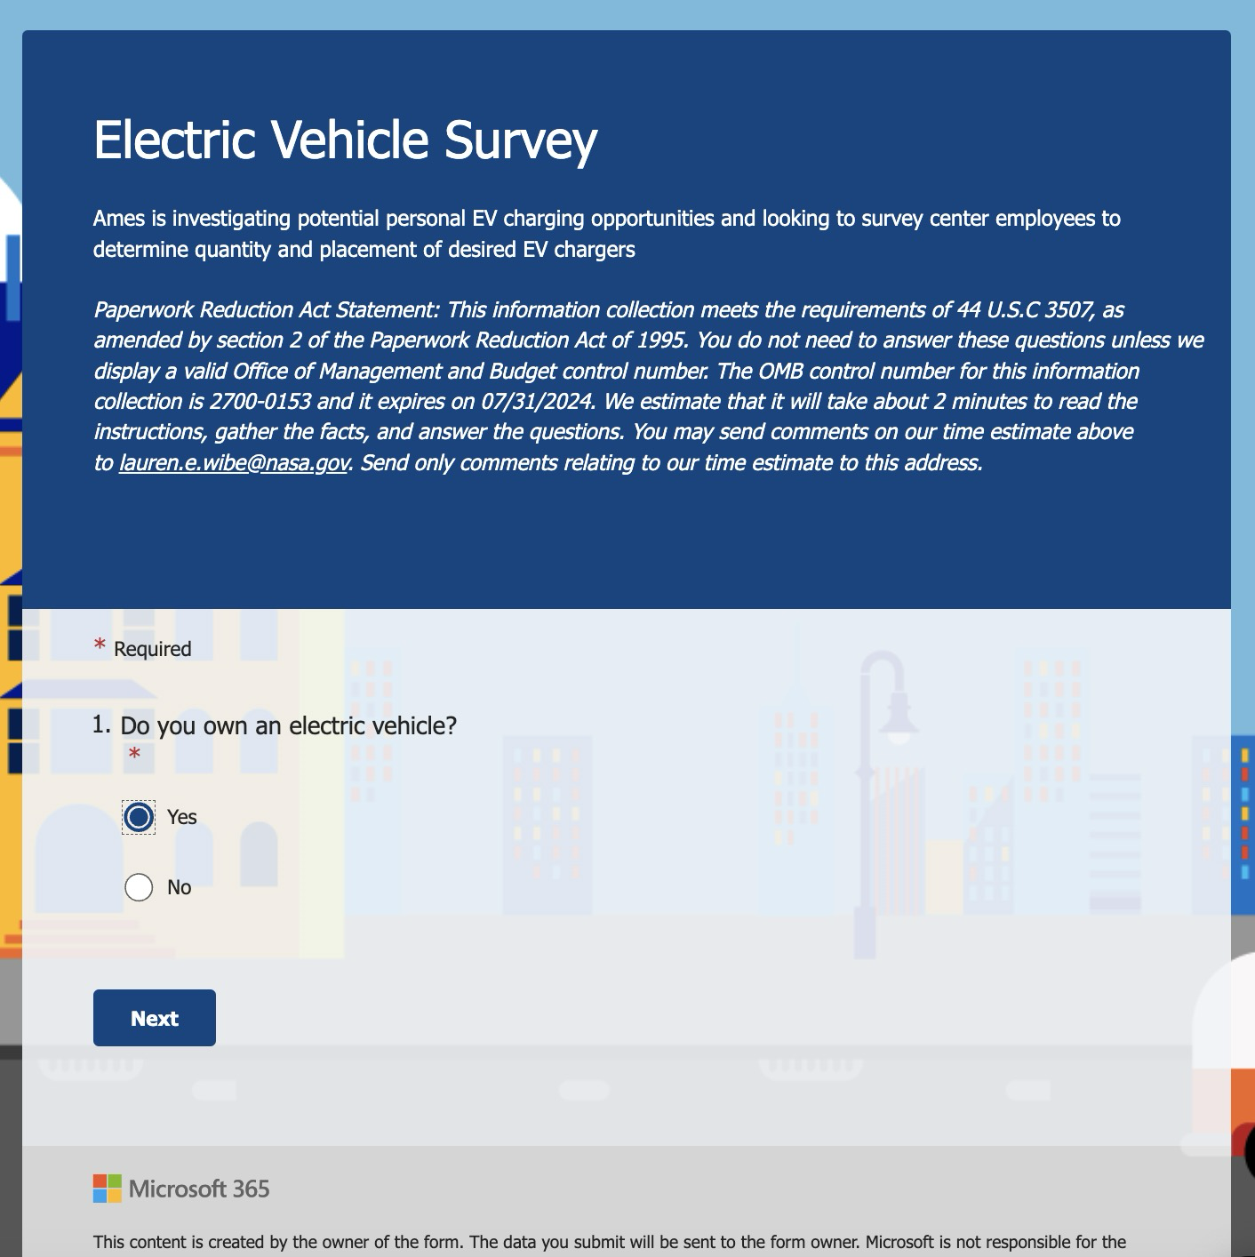
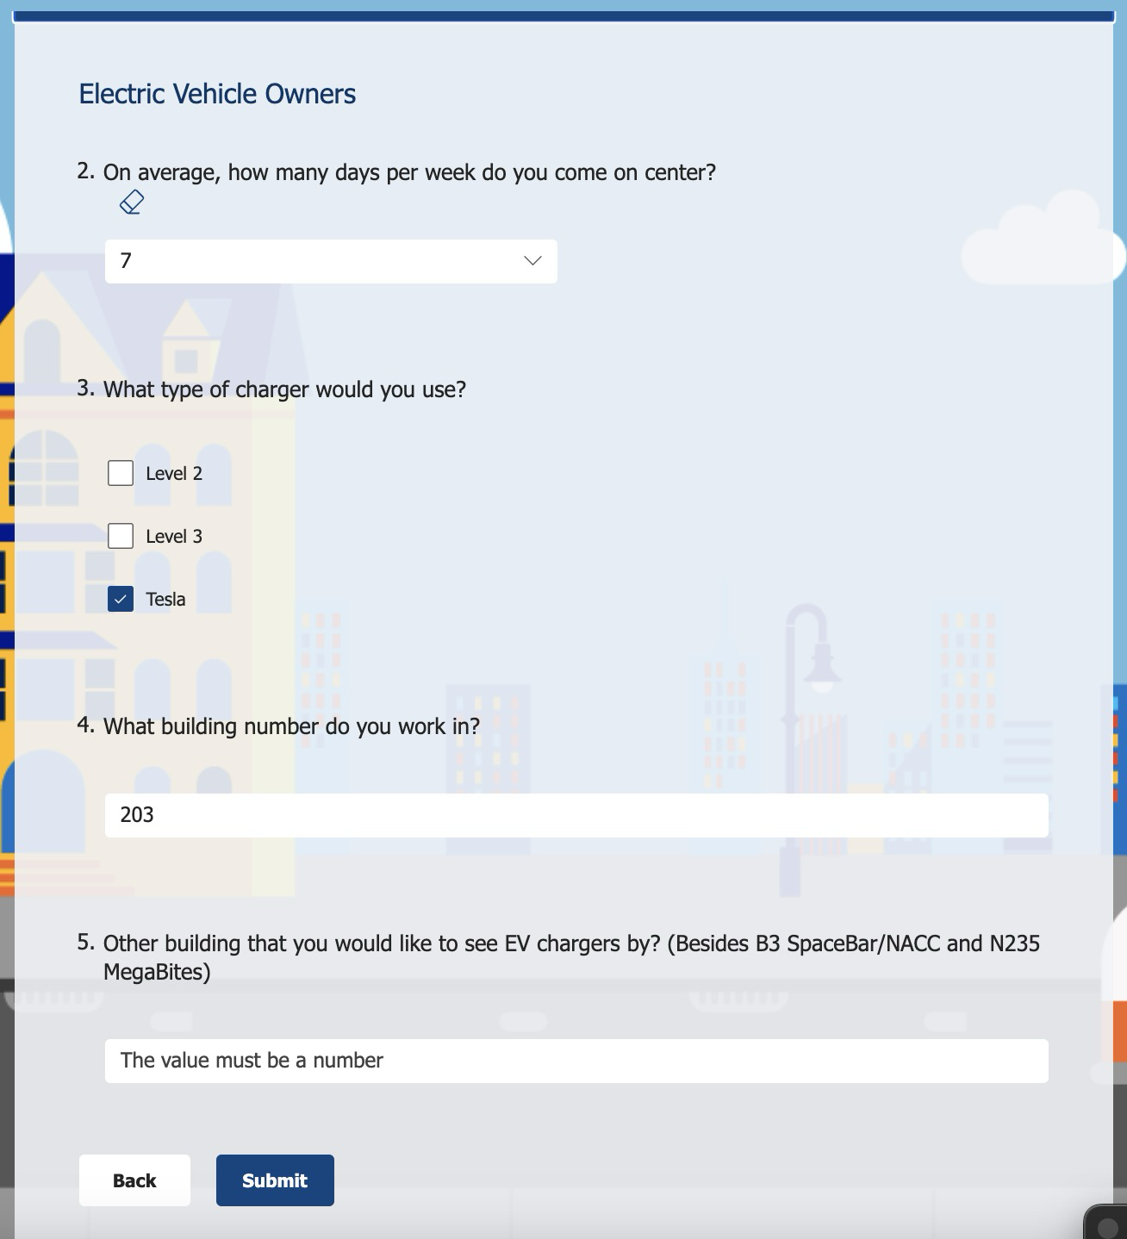

3. Copy of the centerwide announcement

ARC is exploring options for electric vehicle charging stations that will allow personal vehicle charging. Please take a minute to fill out this survey to help us estimate the number of chargers and potential locations so that we can best optimize our strategy for the center. This survey is open to both civil servants and contractors, will be anonymous, and is estimated to only take 2 minutes.
https://forms.office.com/g/1a1bxeMhnY

