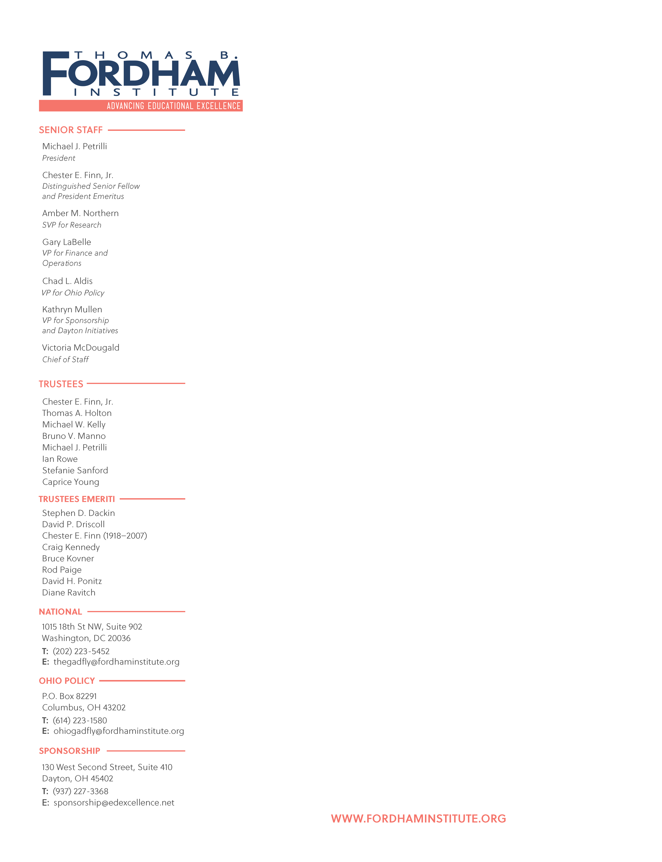
June 20, 2025
Stephanie Valentine
PRA Coordinator
Strategic Collections and Clearance, Governance and Strategy Division
Office of Chief Data Officer, Office of Planning, Evaluation and Policy Development
U.S. Department of Education
400 Maryland Avenue, SW, LBJ, Room 4C210
Washington, DC 20202

Re: Agency Information Collection Activities; Comment Request; EDFacts Data Collection School Years 2025-26, 2026-27, and 2027-28

Dear Coordinator Valentine:

I am writing in support of the proposed changes to the EDFacts data collection that would provide detailed information on how students are performing academically. Specifically, I write in support of the change in reporting to EDFacts that would have states report detailed information on the performance levels of students on federally required math and reading tests in grades 4 and 8.

Benefits to Advanced Students
Collecting school-level achievement results at all performance levels, not just the percentage of students who reach “proficient,” would, among other benefits, permit us to know how many students in each school in the country are achieving at an advanced level. American education has long neglected these children, to the detriment of both them and the country in general. And this change at the federal level would help us reverse that neglect and harm by showing us where the education of these students is failing and, therefore, where improvement is needed.

Focusing on these pupils, in addition to their peers who perform at lower levels, is important for a few reasons.

First, each and every child deserves an education that meets their needs and enhances their futures, and advanced students are no different. They have their own legitimate claim on our conscience, our sense of fairness, our policy priorities, and our education budgets.

What’s more, many of them also face such challenges as disability, poverty, ill-educated parents, and tough neighborhoods. It’s advanced students from these backgrounds who most need extra focus—such as through programs tailored to their needs and abilities—but they’re also the least likely to receive it. For example, a 2018 study by the Thomas B. Fordham Institute, where I’m president, found that students in low-poverty schools are more than twice as likely to participate in programs designed for advanced students than their peers attending higher-poverty schools.

The second big reason for more and better focus on these students is that the country needs these children to be highly educated to ensure its long-term competitiveness, security, and innovation. They’re the young people most apt to become tomorrow’s leaders, scientists, and inventors, and to solve our current and future critical challenges.

But the U.S. and its schools have long underperformed many of our competitor countries, according to two respected international metrics: the OECD’s Program for International Student Assessment (PISA) and the Trends in International Mathematics and Science Study (TIMSS), in which dozens of countries participate. On these tests, when looking at the percentage of students who score at advanced levels, the U.S. trails almost three-dozen country, including much of Asia and Europe.

The problem, of course, is not that the United States lacks smart children. It’s that such kids aren’t getting the education they need to realize their potential, allowing other countries like China to forge ahead. The good news is that we have evidence-based methods for reversing these trends: acceleration, ability grouping, and enrichment programs. When well-designed and carefully implemented, these interventions have long proven to boost the achievement of advanced students. But first, we have to know where these efforts are most needed. And that is why it’s so important the U.S. Department of Education collect school-level achievement results at all performance levels, including “advanced.”

Other Reasons to Support Multiple Performance Levels in EDFacts Reporting
The reporting of the number of students in each of multiple performance categories from 2009-2019 allowed researchers, such as those at the Educational Opportunity Project to use this detailed information housed in EDFacts to produce publicly available measures of school quality and school improvement for nearly every school and school district in the U.S. This included a comparison of performance and gains in school districts relative to national performance and socioeconomically similar districts. This allowed families, educators, local, state, and federal policy makers and officials, researchers, and the public to monitor the quality of public schools and track their improvements and areas of need over the last decade.

Another key benefit of the EDFacts data initiative was that the detailed performance level data that was reported prior to 2019 made it possible for the education research community to measure and monitor local rates of learning progression (also known as learning rates) from one grade level to the next. The publication of multiple performance levels in the database allowed for an analysis of how students’ academic skills were improving over time -- allowing for valuable data to be gleaned about learning rates for students by location and subgroup (i.e. income status, race/ethnicity, English learner status, students with disabilities, students experiencing homelessness, foster care status, migratory status, military connected status), the closing of gaps between different subgroups of students, and where targeted supports and services to accelerate student learning could be best deployed. Without centralized reporting by multiple performance levels, these analyses are not possible.

At the Educational Opportunity Project alone, the measures of school and district academic performance and learning rates based on the 2009-2019 EDFacts reporting have been downloaded more than 30,000 times by educators, education researchers, state education officials and staff, and journalists. The data have been used in dozens of academic research papers and news stories. The dataset provided through the EDFacts has even reached the military, where the Air Force has used the data to assess school quality near air force bases to provide information in making decisions about base locations. Moreover, this information was being used as part of an effort to improve the health and well-being of cities across the country through the City Health Dashboard.

As the country rebuilds and recovers from the impacts of the pandemic – which includes lost instructional time, declines and disparities in student achievement, and the need to accelerate learning – it is important that key data on student learning is easily available.

Sincerely,
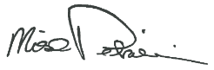
Michael J. Petrilli
President
Thomas B. Fordham Institute

