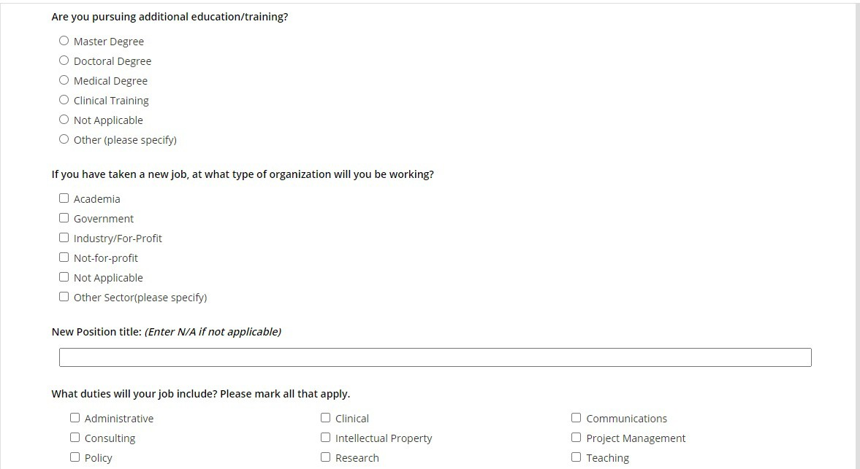
Data Collection Tool: NEI Exit Survey for Trainees Part 1
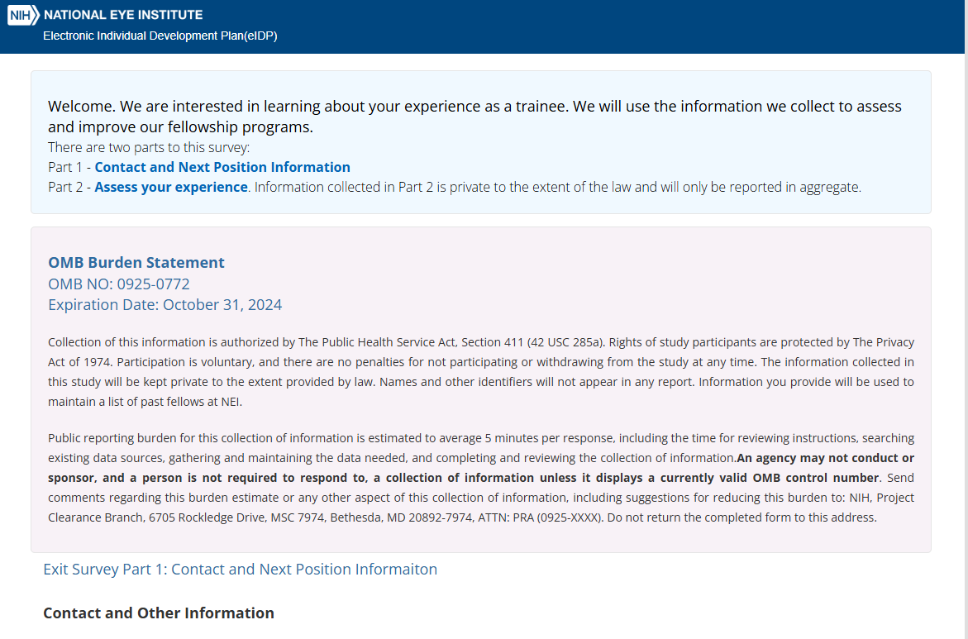

If you have taken a new job. at what type of organization will you be working?
0 Academia
0 Government
D Industry/For-Profit D Not-for-profit
0 Not Applicable
D other Sector(please specify)

New Position title: {Enter NIA if not applicable)

What duties will your job include? Please mark all that apply.

0 Administrative
D Consulting D Policy
0 Not Applicable
D Clinical
D Intellectual Property D Research
D Other (please specify)
0 Communications
0 Project Management
D Teaching


ls there anything that you would like to share with your training director about your experience at NEI?

"
max,mum charaaers 3000
Ill

Decline to Answer

