Respiratory Virus Response (RVR) Data Dashboard cdc.gov feedback survey collection: Screenshots

Screenshot: Survey Invite
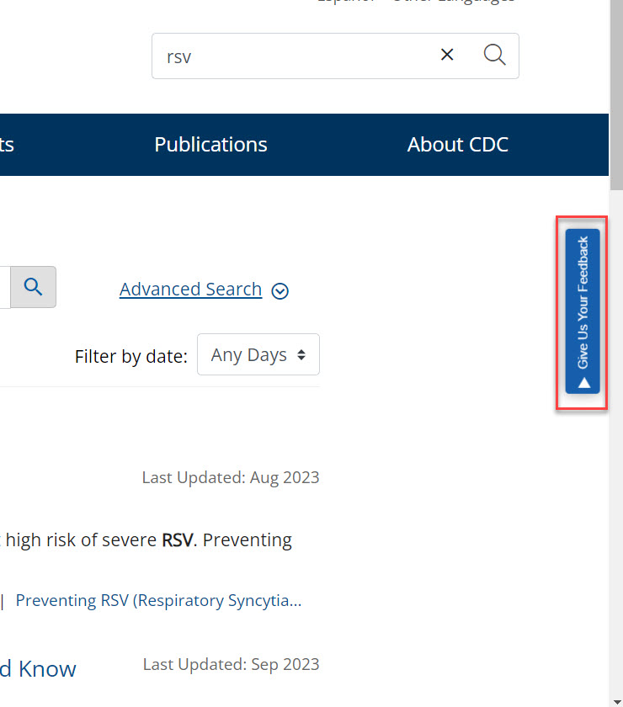
Screenshot: Survey on the website
