ATTACHMENT 8h

Usability Survey:

Online, English

WEB SURVEY APPEARANCE
Optimization for best viewing and ease of use on multiple devices (desktop, laptop, tablet, smartphone)
Header Text: Prostate Cancer Screening Evaluation
Footer Text: If you have any questions about the study, please email our study coordinator at danielle.nielsen@icf.com
Logo: planning to add a CDC logo when approved by client
Prompt for required questions:
Please complete all the questions on this page before moving on.
PROMPT FOR ALL OTHER QUESTIONS IF RESPONDENT TRIES TO SKIP
You have not answered all the questions on this page. Please consider responding to all questions. If you are choosing not to answer a question(s), click next.
Survey Completion text: Thank you for completing the survey. If you have any additional questions, you can email the study coordinator at danielle.nielsen@icf.com >
Termination text: Thank you for your time and interest. You do not qualify for this survey at this time.

Imported Sample Variables
DATE
IMPORTED SAMPLE VARIABLE: Date of upcoming scheduled doctor visit
[TEXT BOX]

[ASK ALL]
LANG.
In what language would you like to complete this survey?
¿En qué idioma le gustaría completar esta encuesta?
01 English
02 Español
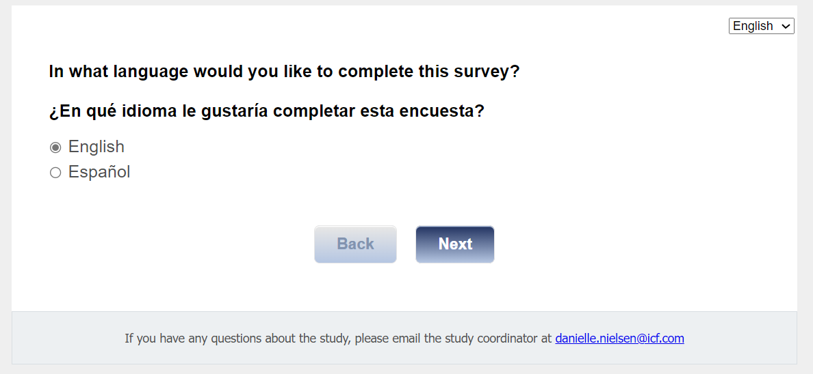

[ASK ALL]
[REQUIRED]
C2CONSENT.

Informed Consent
Thank you for participating in this study. The purpose of this survey is to better understand whether CDC’s Talk to Nathan About Prostate Cancer Screening helps men make decisions about the harms and benefits of prostate cancer screening. Specifically, we want to know whether this interactive decision aid is useable, accessible, and acceptable. If you complete this survey, you will receive a $25 gift code.

Who is sending this survey? ICF is a consulting firm that is working with the Division of Cancer Prevention and Control (DCPC) at the Centers for Disease Control and Prevention (CDC) to evaluate different prostate cancer screening decision aids and their ability to help men between the ages of 55-69 years make a decision whether to get a prostate-specific antigen (PSA) test. A PSA test is a blood test that measures the level of PSA in the blood. PSA is a substance made by the prostate.

How long will it take? This survey will take no longer than 15 minutes. Your participation in this study is 100% voluntary which means you can choose whether you want to take part this survey.

What are the risks and benefits of doing the survey? As a respondent to this survey, there is a minimal risk related to your privacy and/or confidentiality, but steps have been taken to remove your personal information so that you cannot be identified. Only members of the research team will have access to study information. Remember, your participation is completely voluntary.

How will my information be shared outside of the study? Your personal responses will not be shared outside of the study. Summaries of survey results that are not linked to your name or clinic will be shared with CDC and/or may be published in a professional journal.

Who do I call about problems or questions? If you have questions about or concerns about your participation in this project, please contact the ICF project manager - Danielle Nielsen at Danielle.Nielsen@icf.com. For questions regarding your rights as a study participant, you can contact ICF’s Institutional Review Board (IRB) representative Christine Walrath at (646) 695-8154 or Christine.Walrath@icf.com.

If you agree to participate in this study, please click “Begin Survey.”

If you do not agree to participate, please click, “I decline.”
01 Begin survey
02 I decline
[TERMINATE IF C2=02]
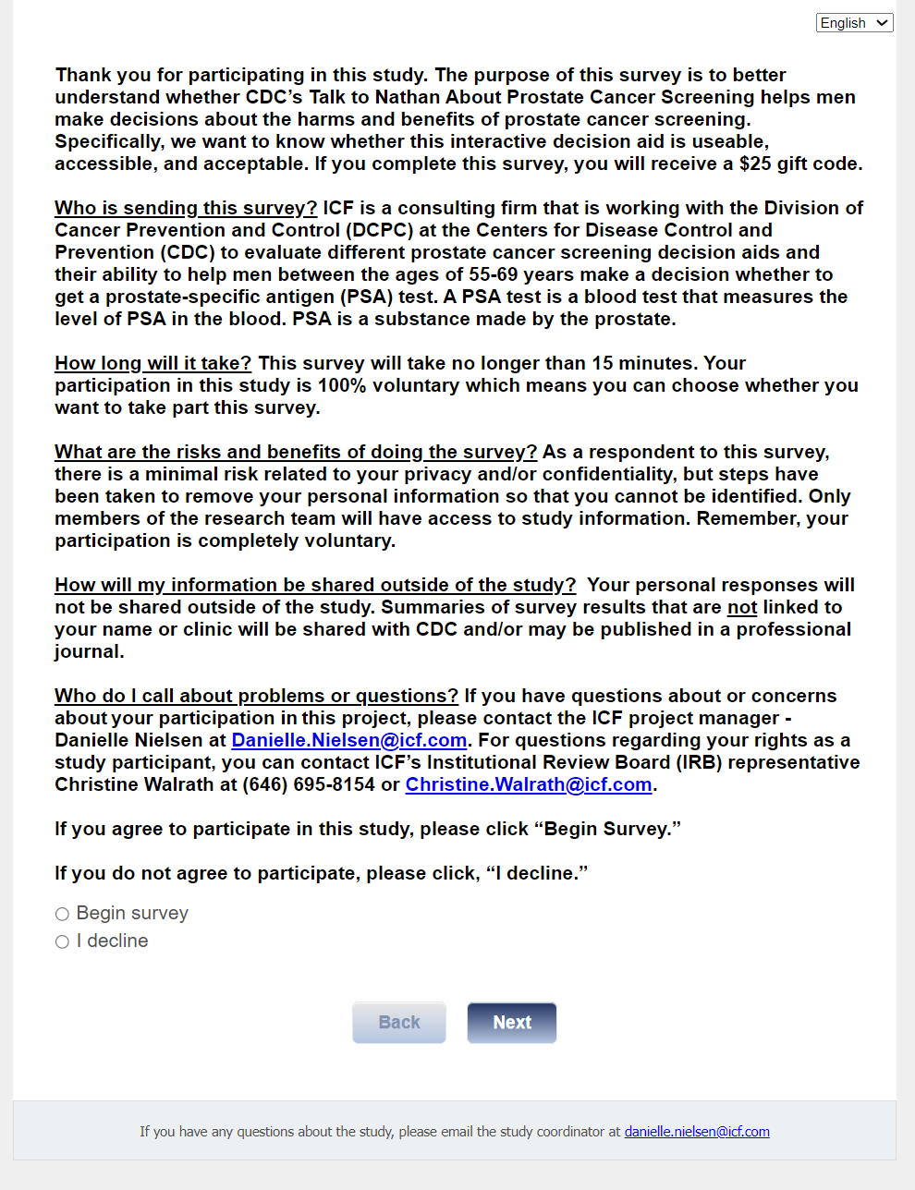

Section 1: Nathan Dosage
[ASK ALL]
[REQUIRED]
Q1.
For this first set of questions, we would like to know what you think about the Talk to Nathan decision aid.

How much time did you spend reviewing the Talk to Nathan decision aid?
01 Less than 5 minutes
02 5 to 10 minutes
03 10 to 15 minutes
04 15 to 25 minutes
05 25 or more
06 None
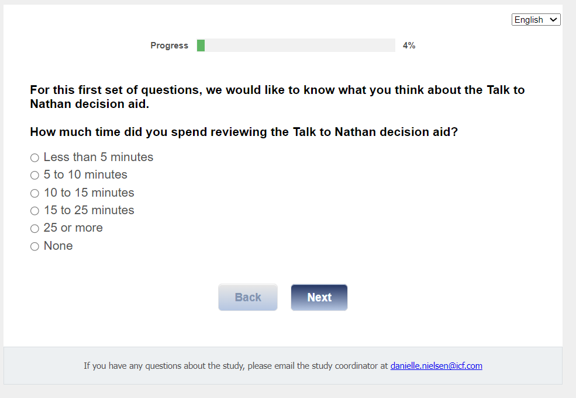

[ASK IF Q1=06,97,99]
TERM2.
Thank you for your time and interest. You do not qualify for this survey at this time.
01 Terminate [DISPO AS S1]

[ASK IF Q1=01-05]
Q1a.
Did you complete the Nathan decision aid? Completing Nathan means that you reached the “Come back any time!” screen.
01 Yes
02 No

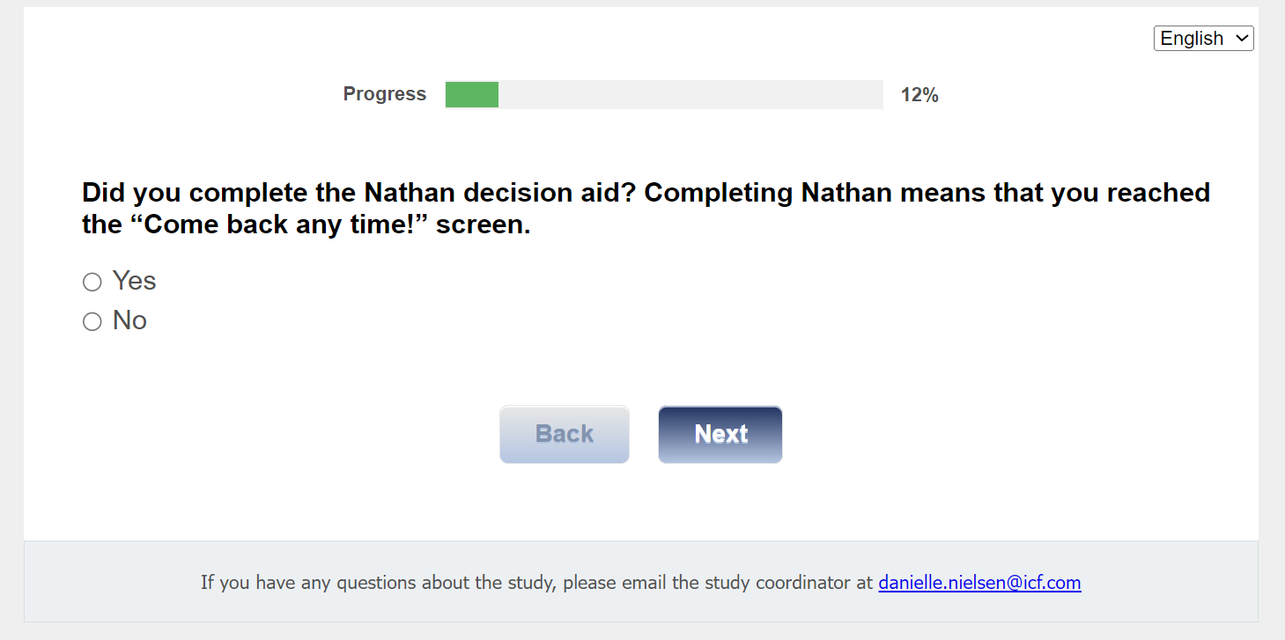

Section 2: Help Needed to Review Nathan
[ASK ALL]
Q1b.
Did anyone else review the Talk to Nathan decision aid with you?
01 Yes
02 No

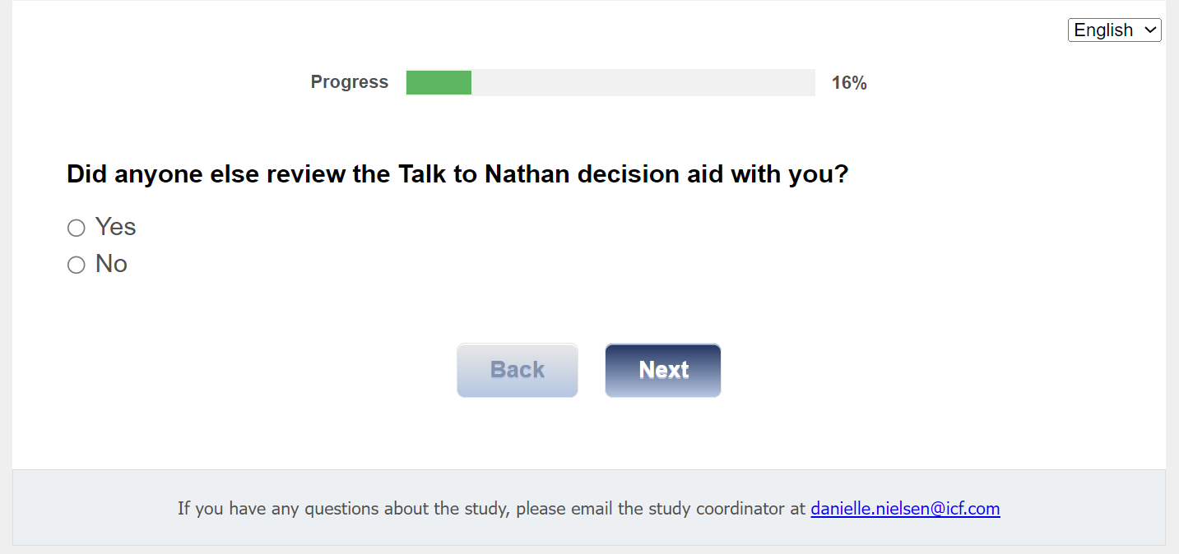
[ASK ALL]
Q1c.
Did you ask someone to help you in reviewing the Talk to Nathan decision aid?
01 Yes
02 No
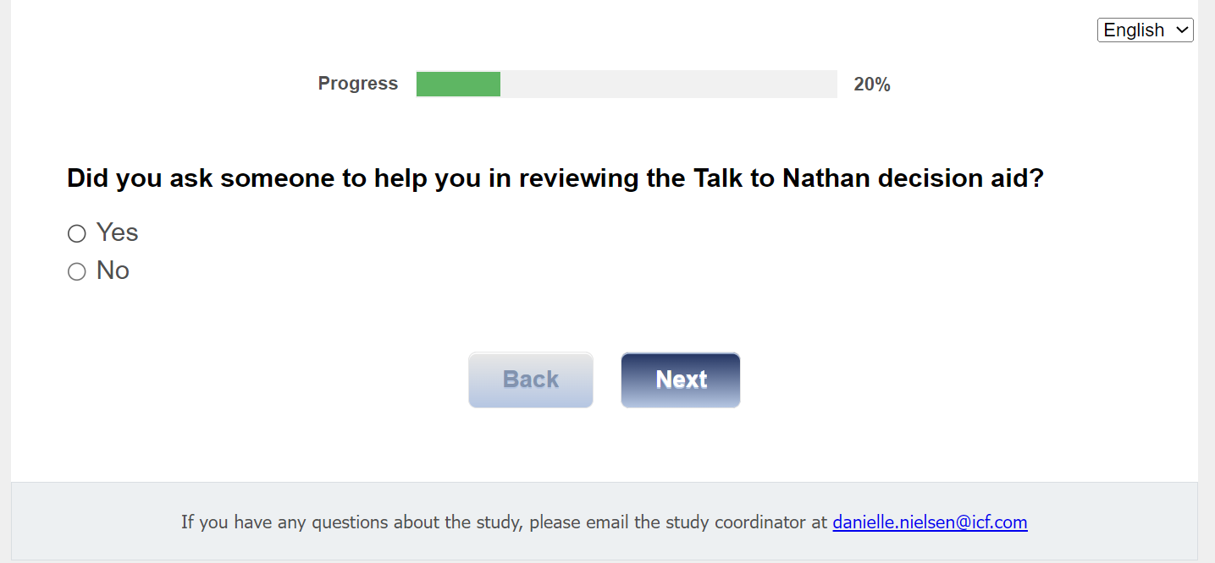

[ASK IF Q1c=01]
Q1d.
How much help did you need?
01 A lot of help
02 Some help
03 A little help
04 No help
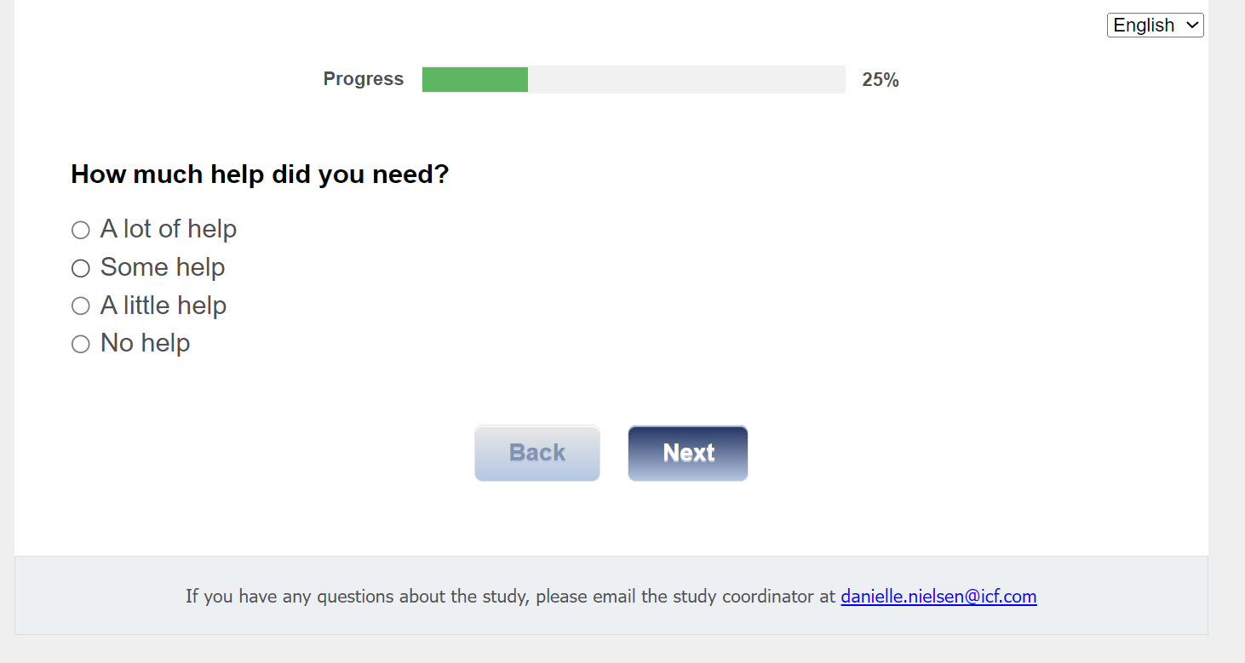

[ASK IF Q1c=01]
[MUL 6]
Q1e.
What kind of help did you need? Check all that apply:
01 Help to use the computer/internet
02 Help to find/access the Talk to Nathan decision aid
03 Help to use the Talk to Nathan decision aid
04 Help to read the information in Talk to Nathan
05 Help to understand the information in Talk to Nathan
06 Other (specify) [TEXT BOX]
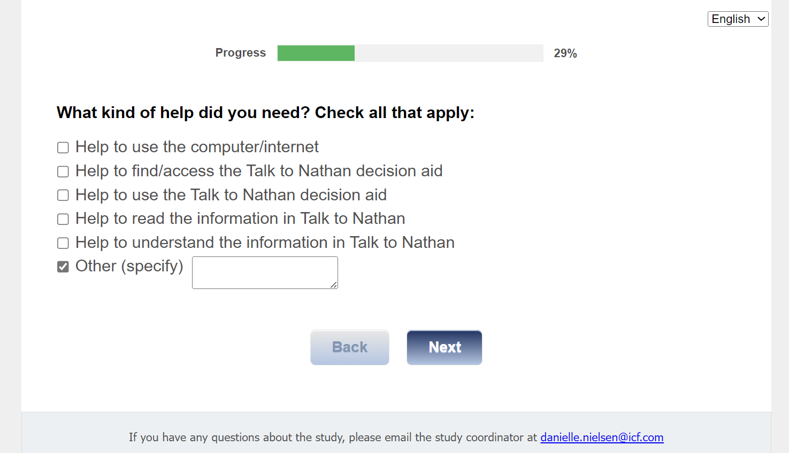

Section 3: Acceptability of Nathan
[ASK ALL]
Q2.
For this next set of questions, we would like to know what you think about the Talk to Nathan decision aid.

Please rate each section, by checking ‘poor’, ‘fair’, ‘good’, or ‘excellent’ to show what you think about the way the information was presented on:

 | 01 Poor | 02 Fair | 03 Good | 04 Excellent
Q2A. Prostate health
Q2B. Risks for prostate cancer
Q2C. Screening options
Q2D. Talking to your provider

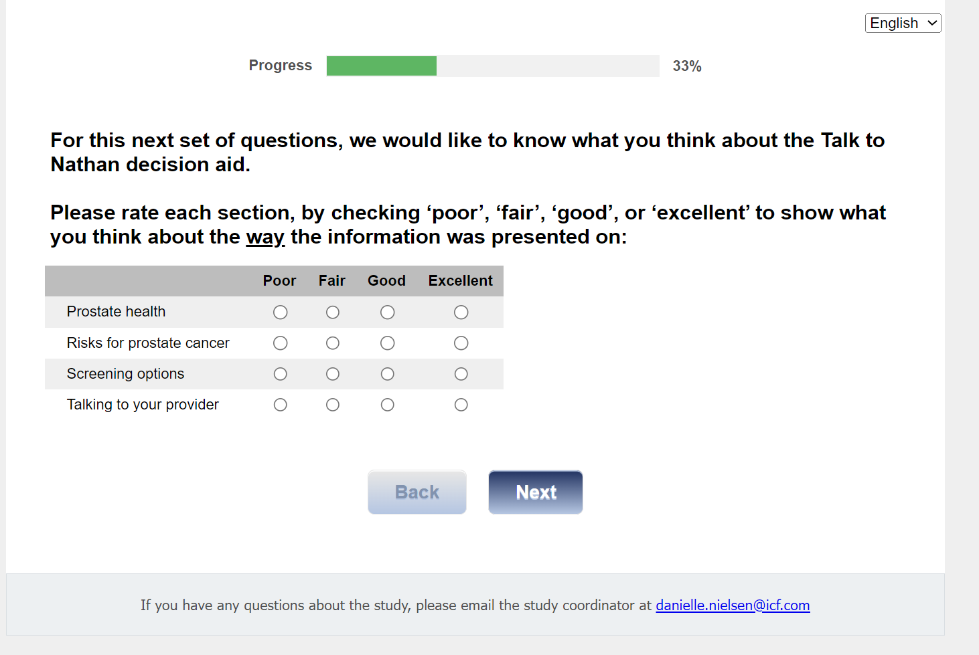

[ASK ALL]
Q3.
The length of decision aid was:
01 Too long
02 Too short
03 Just right
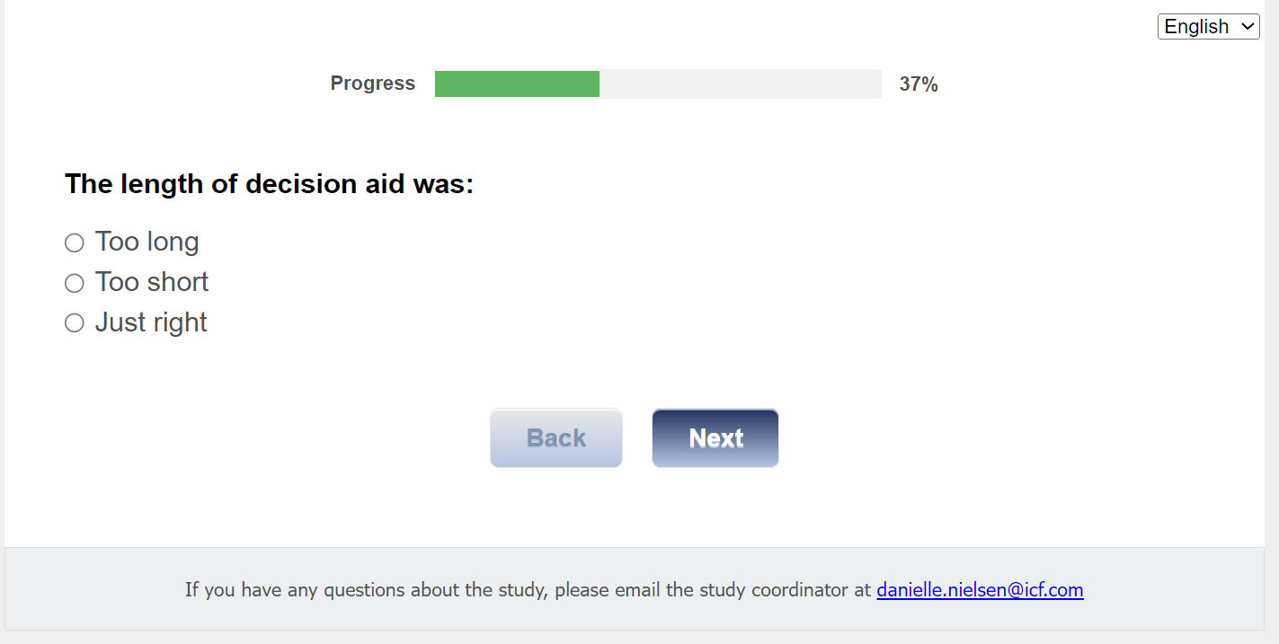

[ASK ALL]
Q4.
The amount of information included was:
01 Too much information
02 Too little information
03 Just right
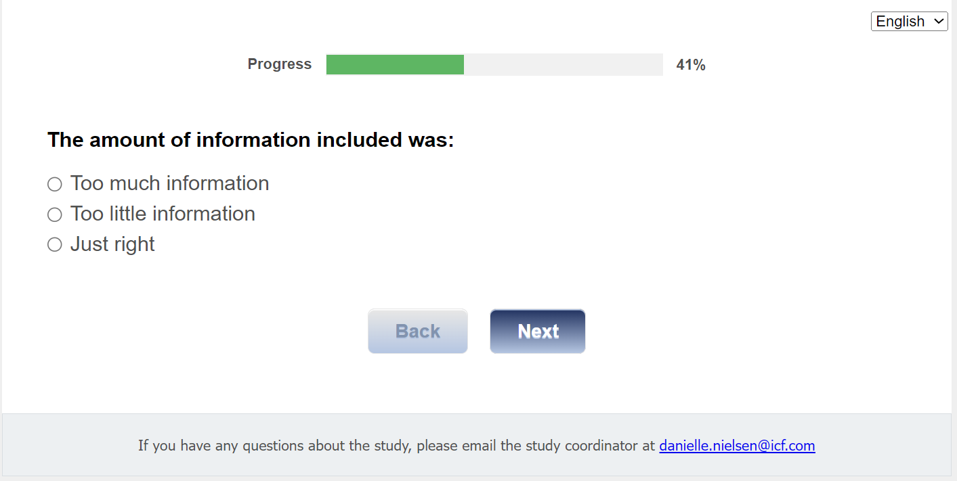

[ASK ALL]
Q5.
Would you find this decision aid useful when you are making your decision about getting screened for prostate cancer?
01 Yes
02 No, Please explain: [TEXT BOX]
[TEXT BOX CHARACTER LIMIT OF 200 CHARACTERS]

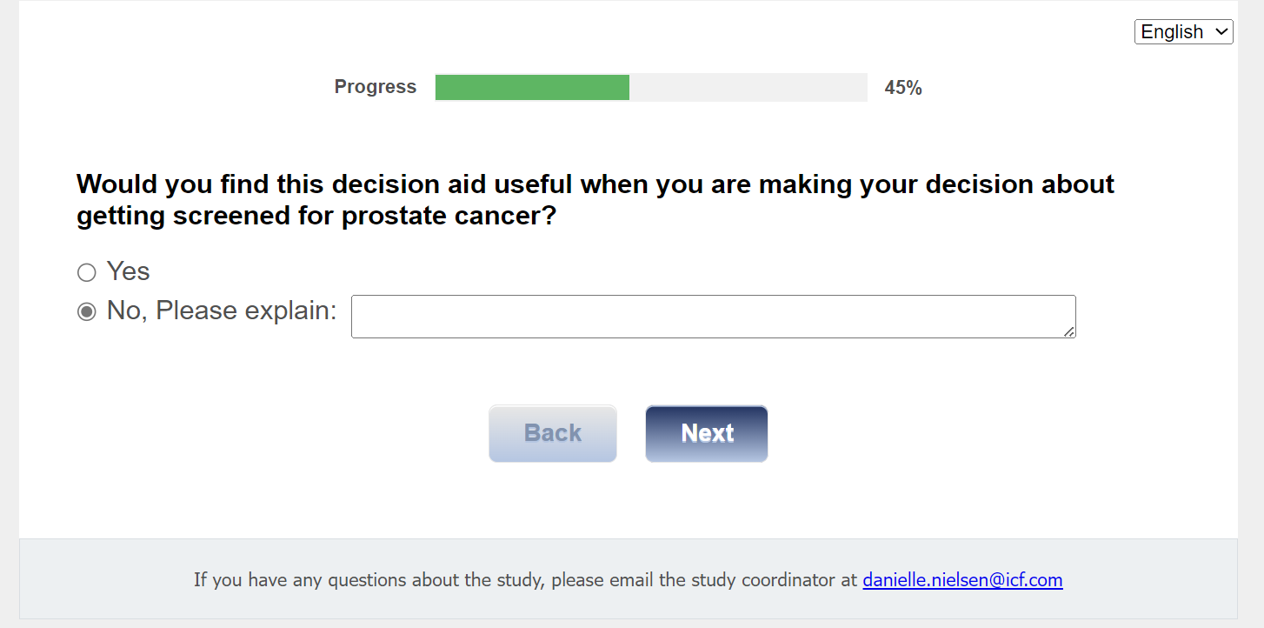

[ASK ALL]
Q6.
Do you think the decision aid included enough information to help you decide whether to get screened for prostate cancer?
01 Yes
02 No, Please explain: [TEXT BOX]

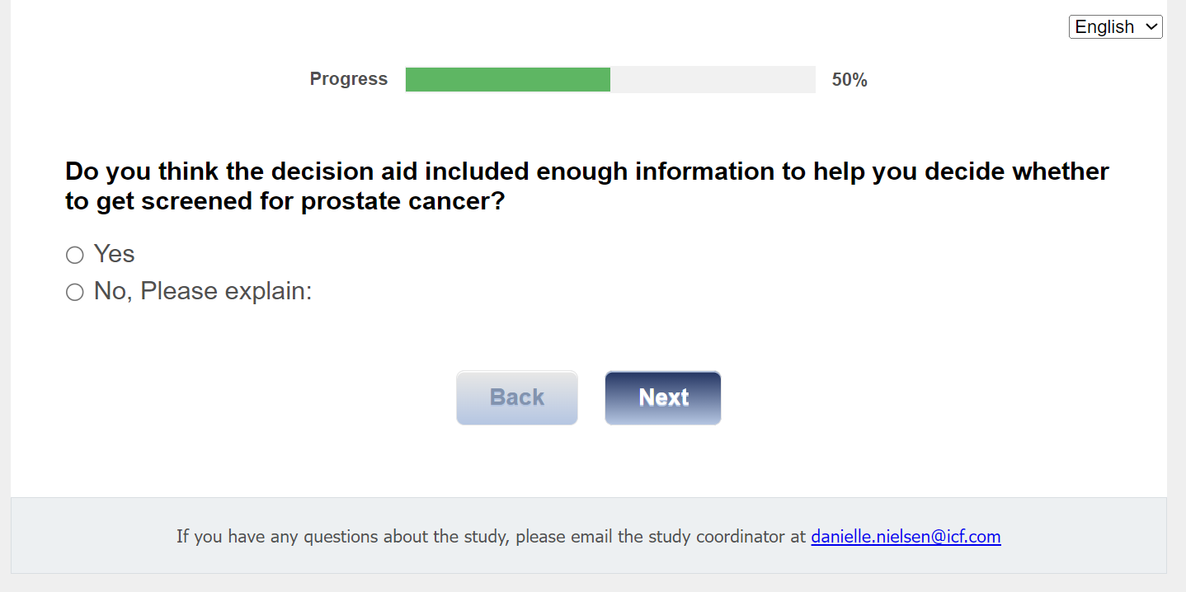

Section 4: Perceived Fit of Nathan
[ASK ALL]
Q7.
Next, please let us know whether you agree with each of the following statements about the Talk to Nathan decision aid. Please note the order of the response options for each statement: completely disagree, disagree, neither disagree nor agree, agree, completely agree.
 | 01 Completely Disagree | 02 Disagree | 03 Neither agree nor disagree | 04 Agree | 05 Completely Agree
Q7A. The Talk to Nathan decision aid seems fit for helping people make decisions about prostate cancer screening.
Q7B. The Talk to Nathan decision aid seems suitable for helping people make decisions about prostate cancer screening.
Q7C. The Talk to Nathan decision aid seems applicable for helping people make decisions about prostate cancer screening.
Q7D. The Talk to Nathan decision aid seems like a good match for helping people make decisions about prostate cancer screening.

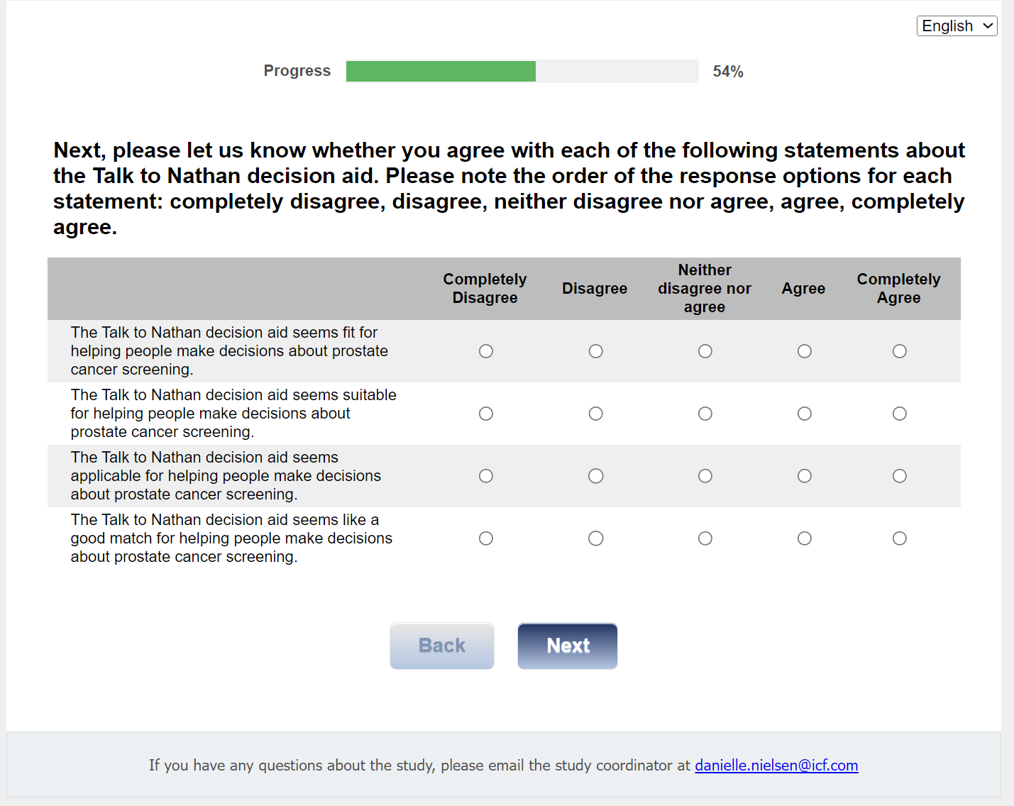

Section 5: Usability of Nathan
[ASK ALL]
Q8.
For this next set of statements about the Talk to Nathan decision aid, tell us how usable the decision aid was for you. Please note the order of the response options for each statement: strongly disagree, disagree, neither disagree nor agree, agree, strongly agree.
 | 01 Strongly Disagree | 02 Disagree | 03 Neither agree nor disagree | 04 Agree | 05 Strongly Agree
Q8A. I think that I would like to use the Talk to Nathan decision aid frequently.
Q8B. I found the Talk to Nathan decision aid unnecessarily complex.
Q8C. I thought the Talk to Nathan decision aid was easy to use.
Q8D. I think that I would need the support of a technical person to be able to use the Talk to Nathan decision aid.
Q8E. I found the various functions in the Talk to Nathan decision aid were well integrated.
Q8F. I thought there was too much inconsistency in the Talk to Nathan decision aid.
Q8G. I would imagine that most people would learn to use the Talk to Nathan decision aid very quickly.
Q8H. I found the Talk to Nathan decision aid very hard to use.
Q8I. I felt very confident using the Talk to Nathan decision aid.
Q8J. I needed to learn a lot of things before I could get going with the Talk to Nathan decision aid.

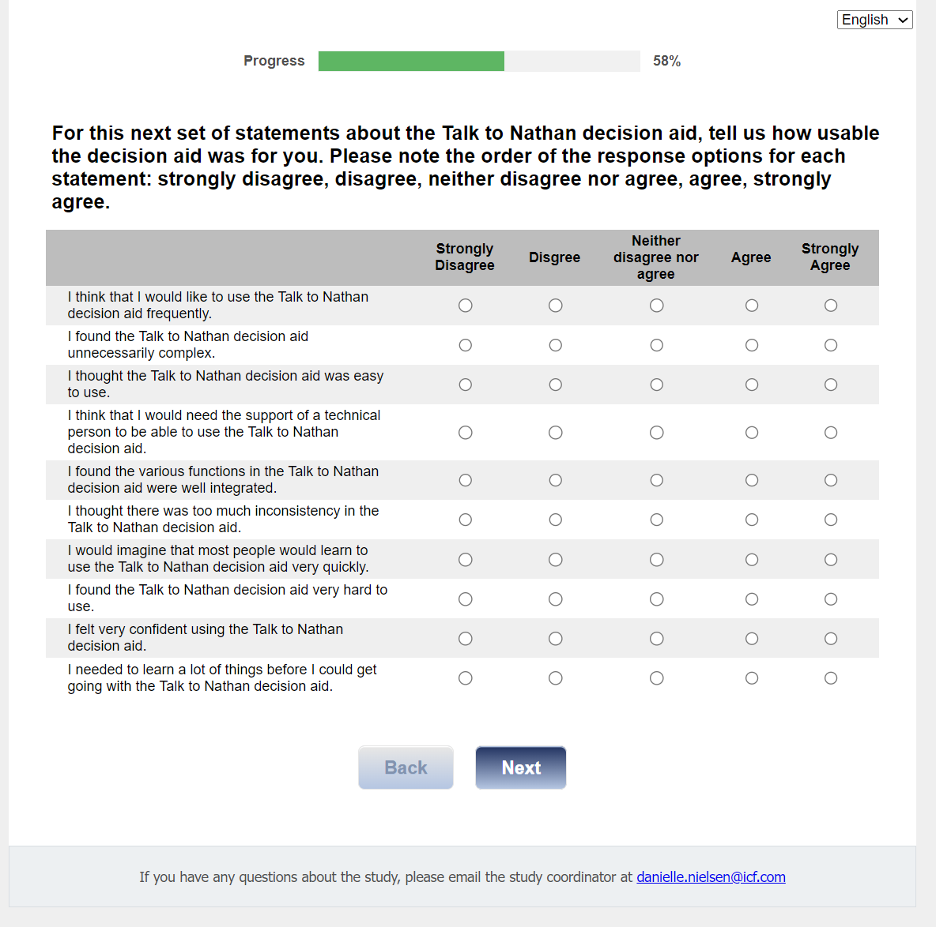

Section 6: Technology Acceptance
[ASK ALL]
Q9.
For this next set of statements about the Talk to Nathan decision aid, tell us how helpful the decision aid was for you. Please note the order of the response options for each statement: strongly agree, agree, neither agree nor disagree, disagree, or strongly disagree.

 | 01 Strongly agree | 02 Agree | 03 Neither agree or disagree | 04 Disagree | 05 Strongly disagree
Q9A. Using the Talk to Nathan decision aid will improve my ability to learn about prostate cancer screening.
Q9B. Using the Talk to Nathan decision aid will increase my effectiveness to talk to a health care provider about prostate cancer screening.
Q9C. The Talk to Nathan decision aid will be useful for me.
Q9D. Using the Talk to Nathan decision aid is a good idea.
Q9E. I would recommend using the Talk to Nathan decision aid.
Q9F. I will continue to use the Talk to Nathan decision aid.

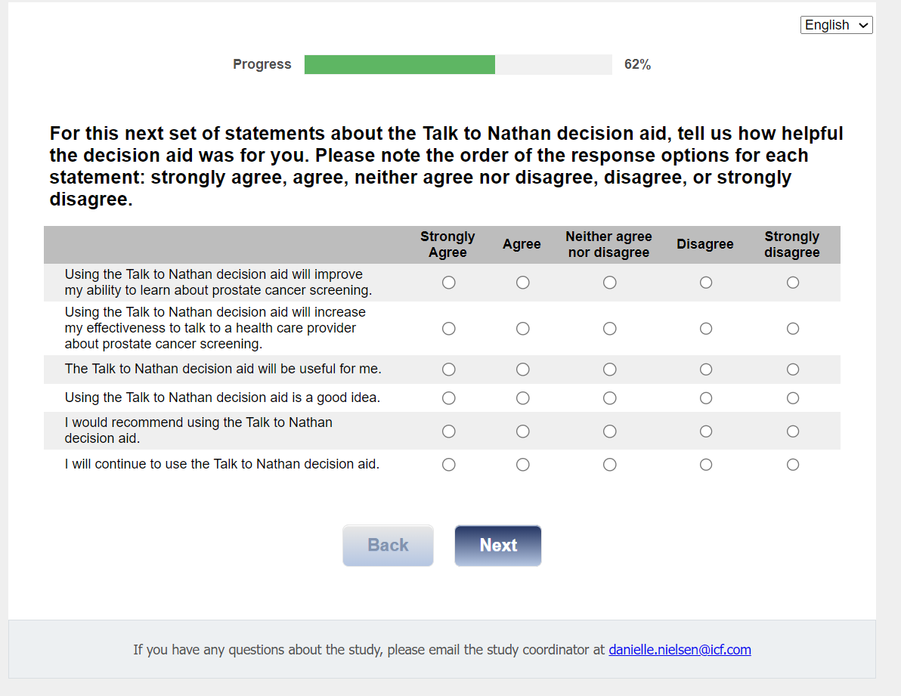

Section 7: COVID-19 Impact and Telemedicine
[ASK ALL]
COVID1
Did the COVID-19 pandemic affect your ability to have a discussion with your provider about prostate cancer screening?
01 Yes
02 No

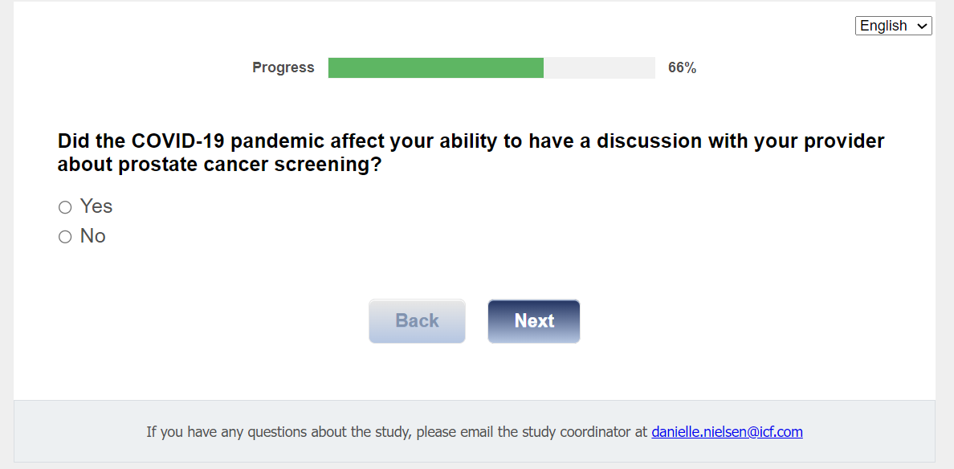

[ASK ALL]
COVID2
Would the Talk to Nathan decision aid have been useful to you during the COVID-19 pandemic?
01 Yes
02 No
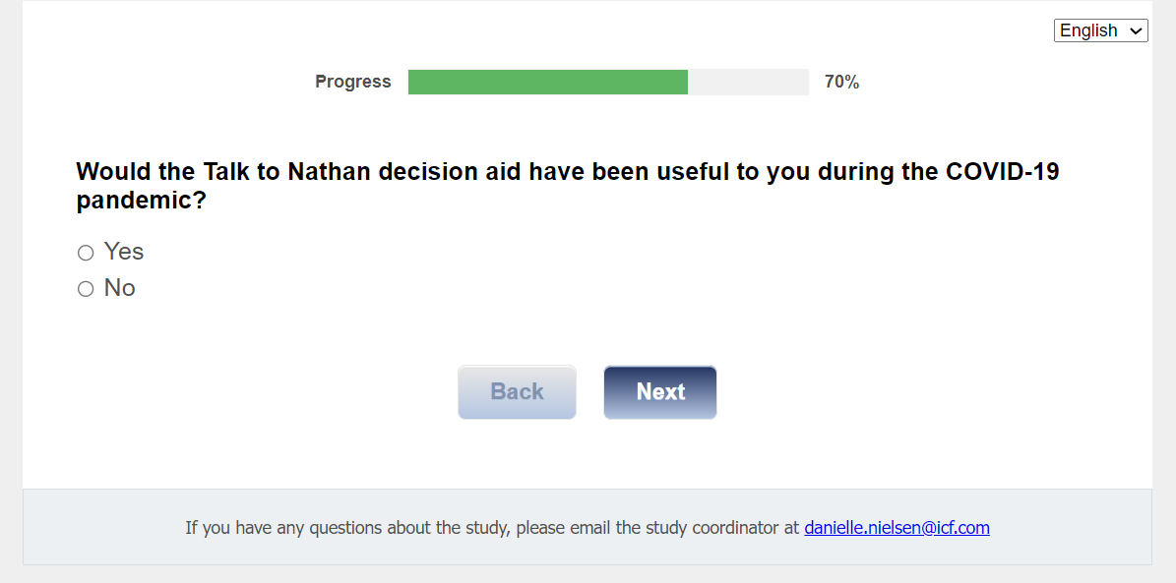

[ASK ALL]
COVID3
How likely are you to have primary care visits through telemedicine?
01 Not likely
02 Somewhat likely
03 Very likely
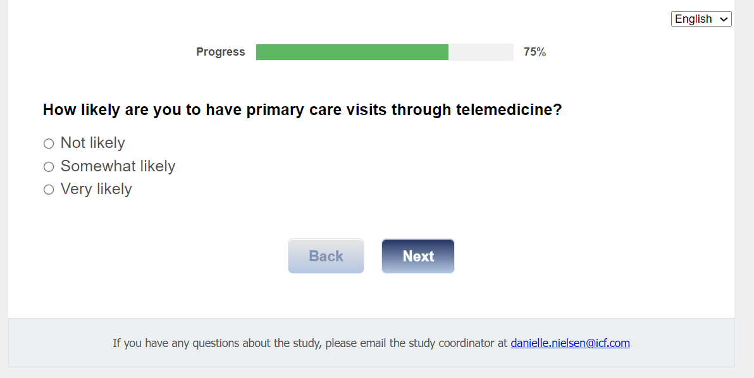

[ASK ALL]
COVID4
If you were to have a telemedicine visit with your provider, would the Talk to Nathan decision aid be helpful to you?
01 Yes
02 No

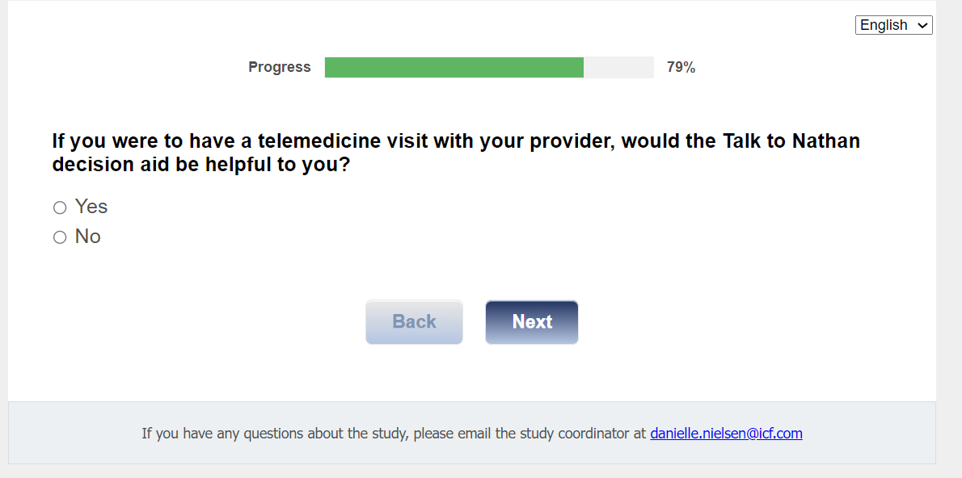

Section 8: Recommendations for Nathan Improvements
[ASK ALL]
Q10.
Finally, please provide any recommendations you have for improving the Talk to Nathan decision aid.
[TEXT BOX]
[200 CHARACTERS MAX]

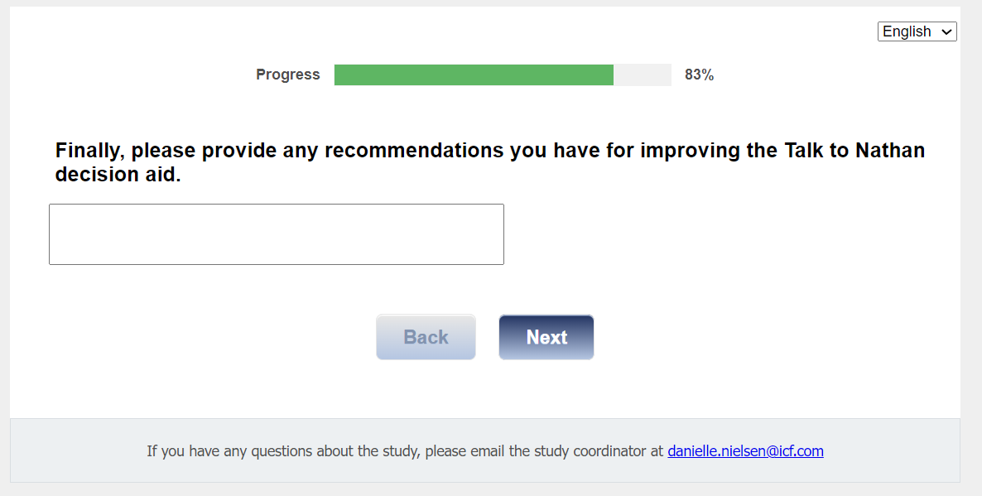

Section 9: Gift Code
[ASK ALL]
[REQUIRED]
J1int. In appreciation for the time you have spent answering our questions, we would like to give you a $25 Amazon gift code. Would you like the gift code?

01 Yes
02 No

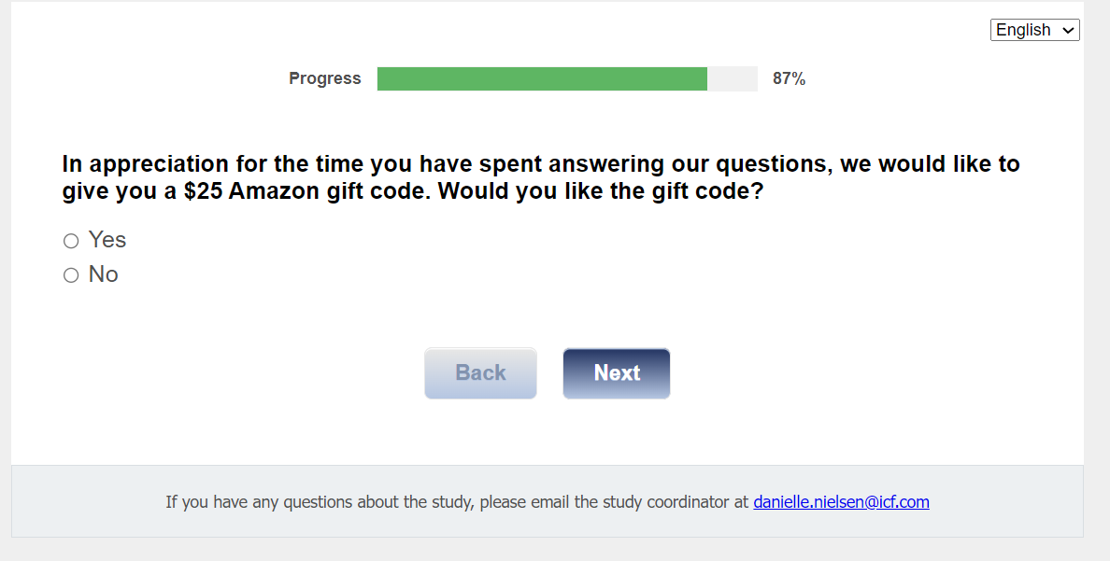

[ASK if J1int=01]
J1.
Thank you for completing this survey. Your $25 Amazon gift code is displayed below. You will also receive an email with this $25 gift code for your records.

<insert GIFT_CODE>

The code is a unique number you can use to purchase items online at Amazon.com. You may enter the code online when you are ready to make a purchase at Amazon.com. There is no expiration date.

Also, within the next week, you will receive an email with a weblink to information about prostate cancer screening for your review. The email will also include a weblink to a survey for your completion.

If you have any questions, please contact the project manager, Danielle Nielsen at Danielle.Nielsen@icf.com.

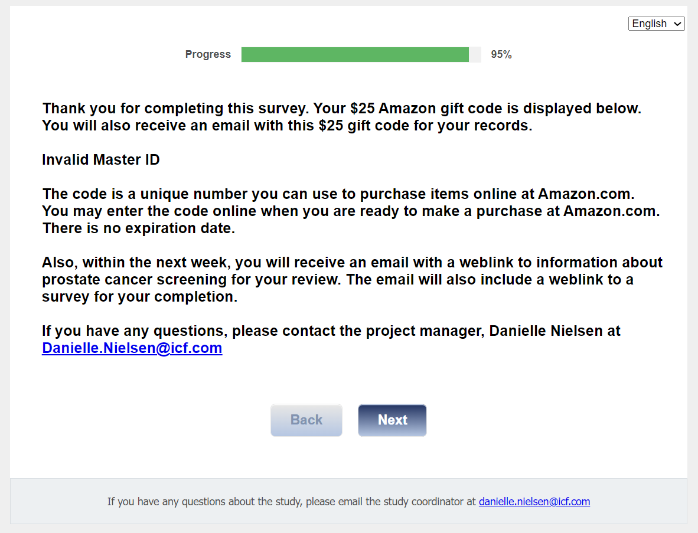
Send <gcode email> to <Email1> from <CDCSurvey@icfsurvey.com>
GCode_Email
To Receive your code via email, please enter your email address here:
[TEXTBOX]
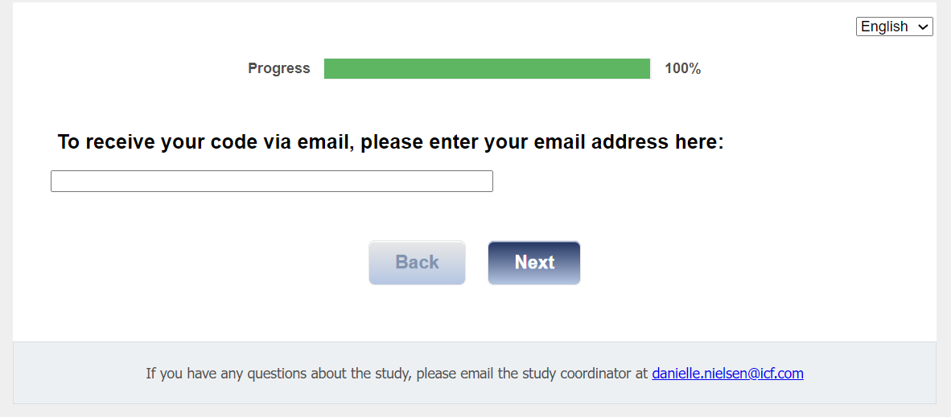

Email text:

Hello!
Thank you for completing this survey for the CDC Prostate Cancer Evaluation Study!
Here is your Amazon gift code for $25:

<GIFT_CODE>

HOW TO USE YOUR AMAZON GIFT CODE
The code is a unique number you can use to purchase items online at amazon.com. You may enter the code online when you are ready to make a purchase at amazon.com. There is no expiration date.
Save this code in a safe space until you are ready to use it. Some ideas to keep it safe are:
- Write it down on a sheet of paper and keep it in a safe and hidden location.
- Take a photo of the code with your phone.
- Save the code in your Amazon.com account. If you have an amazon.com account, you can save your code in your account until you are ready to spend it.
Type in this link: https://www.amazon.com/gc/redeem/
Or, follow these instructions:
- Go to amazon.com
- In the blue banner, click on "Gift Cards & Registry"
- On the gift cards page, choose "redeem a gift card"
- Type or copy/paste the gift code into the "Enter claim code" field

Thank you once again for your time and feedback!

regards,
Debbie Krugipudi
CDC Prostate Evaluation Study Support Staff

[ASK ALL]
CLOSE.
Thank you for completing this survey. We may also contact you to request your participation in a 60-minute discussion about your experience in using Talk to Nathan.

Also, within one week after your visit with your health care provider on [DATE], you will receive an email with a weblink to the final survey for this study.

If you have any questions, please contact the project manager, Danielle Nielsen at Danielle.Nielsen@icf.com.

