OMB Control Number: 0648-0829
Expiration Date

York River Outdoor Recreation Survey:
Understanding Visitor Experiences, Motivations, and Barriers
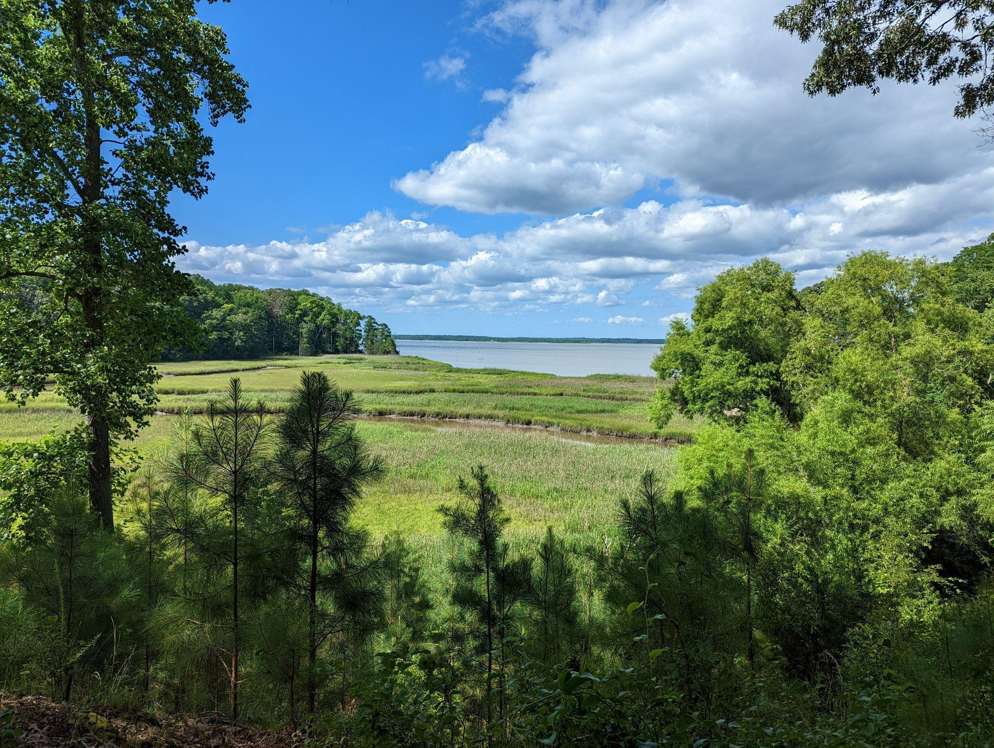




We are interested in learning about your outdoor experiences in and around the York River (see map on next page). This survey will ask about what motivates you to engage in outdoor recreation, any challenges you might have encountered, and details about your most recent trip to the York River and surrounding areas. Your responses will help local policy makers, including park managers and municipalities, improve outdoor recreation experiences in and around the York River.
By completing the survey, you are consenting to participate in this research. Although we hope that you will answer every question, you are free to skip any questions. Your participation is voluntary, and you may withdraw your consent and discontinue participation at any time. The survey will take approximately 10 minutes to complete.
You will not be individually identified, and your responses will be used for statistical purposes only. Data collection will be managed by an external vendor who will not collect or store names. Mailing addresses will be used exclusively by the vendor for distributing survey materials and will not be linked to individual responses. Additionally, NOAA will not have access to or retain any mailing address information.
Public Burden Statement
The public reporting burden for this information collection is estimated at 10 minutes per response. This burden estimate includes time for reading the instructions, reviewing the questions, and completing the survey instrument. Send comments regarding the accuracy of this burden estimate and any suggestions for reducing the burden to: noaa.nccos.sstex@noaa.gov. You are not required to respond to this collection of information unless a valid OMB control number is displayed.
To be completed by the adult (age 18 and over) in your
household who has the next upcoming birthday.

This is a map of the York River and surrounding parks and natural areas.
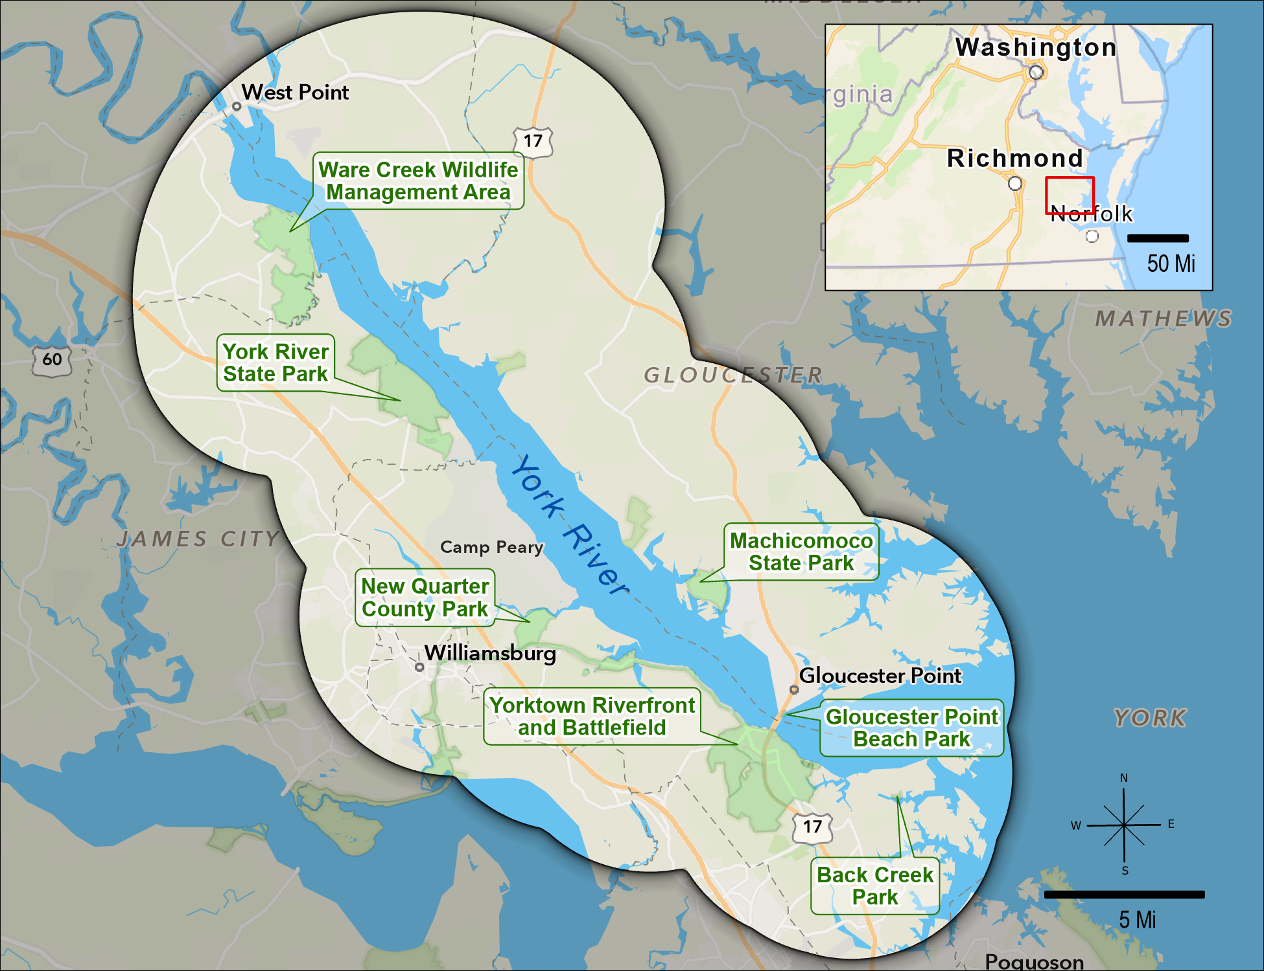
- Looking at the map above, did you take any trips to the York River or any surrounding park or natural area for outdoor recreation within the last 12 months?
A trip is defined as an intentional visit where at least 10 minutes are spent on-site. Same-day reentries are considered to be a single trip. Trips may include overnight stays.
- Yes
- No → SKIP to PAGE 7 (Q21)
- Unsure → SKIP to PAGE 7 (Q21)
- Approximately, how many trips did you take to the York River or any surrounding park or natural area for outdoor recreation within the last 12 months? ____ number of trips
- When was the last time you took a trip to the York River or any surrounding park or natural area for outdoor recreation? __/___ (MM/YYYY)

Please only consider your most recent trip to the York River or any surrounding park or natural area for outdoor recreation when answering questions on this page.

- What type of group were you traveling with on this trip? Please select all that apply.
  - Alone
  - Family
  - Friends
  - Organized group
- Including yourself, how many people were in your personal group on this trip? ____ number of people
Your personal group is defined as you and anyone with whom you visited the York River or any surrounding park or natural area on this trip, such as a spouse, family, and friends. This does not include the larger or organized group that you might have traveled with, such as a school, church, scout, or tour group.
- Including yourself, how many people in your personal group were of each of the following age categories?
4 years old or younger | _______number of people
5-17 years old | _______number of people
18-64 years old | _______number of people
65 years old or older | _______number of people
- Approximately, how much time did you spend specifically within the York River or any surrounding park or natural area during this trip?
Day trip:
- Less than an hour
- 1-2 hours
- 2-3 hours
- 3-4 hours
- 4-8 hours
- 8-12 hours

_____ Number of days if longer than 1 day
- Referring to the map on page 2, did you visit any of the following locations on this trip?
 | Yes | No | Unsure
Ware Creek Wildlife Management Area
York River State Park
New Quarter Park
Yorktown Riverfront/Battlefield
Back Creek Park
Gloucester Point Beach Park
Machicomoco State Park

Please only consider your most recent trip to the York River or any surrounding park or natural area for outdoor recreation when answering questions on this page.

- Did you participate in any of the following activities within the York River or any surrounding park or natural area during this trip?
 | Yes | No
Walking, hiking, or running
Nature photography
Viewing wildlife, including birdwatching
Hunting
Swimming or wading
Sunbathing/relaxing on a beach
Fishing
Boating (motorized and non-motorized)
Paddle sports (for example, canoeing and kayaking)
Educational/interpretive program
- When participating in water-based activities, such as swimming, kayaking, or boating, did you bring a mobile device, such as a smartphone, tablet, or smartwatch, with you?
  - Yes, and I kept it on
  - Yes, but I turned it off
  - No
  - I did not participate in water-based activities on this trip
- When participating in land-based activities, did you bring a mobile device, such as a smartphone, tablet, or smartwatch, with you?
  - Yes, and I kept it on
  - Yes, but I turned it off
  - No
  - I did not participate in land-based activities on this trip
- If you brought a mobile device and kept it on, did you use it for any of the following reasons?
 | Yes | No
Safety/In case of emergency
Navigation
Social media
Photography
Learn about the park
Other, please specify
  - I didn’t bring a mobile device and/or keep it on

Please only consider your most recent trip to the York River or any surrounding park or natural area for outdoor recreation when answering questions on this page.

- Did you use any of the following forms of transportation to reach your primary destination on this trip?
 | Yes | No
Walking
Personal vehicle, including watercraft
Bicycle, including electric
Public transportation (for example, bus, rail, or ferry)
Rental car
Taxi or rideshare (for example, Uber or Lyft)
- Did you purchase a Virginia State Park annual pass in the last 12 months?
  - Yes
  - No → SKIP to Q16
- How much did you spend on your Virginia State Park annual pass in the last 12 months? $____
- Did you purchase a Virginia hunting or fishing license in the last 12 months?
  - Yes
  - No → SKIP to Q18
- How much did you spend on your Virginia hunting or fishing license(s) in the last 12 months? $____
- Please estimate the amount you spent on each of the following items during this trip, and indicate how many people, including yourself, shared those expenses.
If you didn’t spend any money on an item, please mark it as $0 for the estimated amount. If you paid for yourself only, please mark it as 1 for the number of people.
 | Estimated Amount | Number of People
Gas | $_________
Tolls | $_________
Public transportation, taxi, or rideshare fare | $_________
Entrance fees (excluding annual passes) | $_________
Parking fees (excluding annual passes) | $_________
Bait and tackle | $_________
Equipment rental fees | $_________
Tour or guide fees | $_________
Lodging (for example, hotel or campground) fees | $_________

Please only consider your most recent trip to the York River or any surrounding park or natural area for outdoor recreation when answering questions on this page.

- How important to you were the following features when deciding to take this trip?
 | Not at all  important | Somewhat  important | Very  important | Extremely  important
Designated walking/hiking trails
Designated blueways/kayak trails
Access to water (e.g. rivers and lakes)
Restrooms
Picnic areas
Fishing areas
Parking areas
Internet or cell service
Educational/interpretive program
Educational/interpretive signage
Directional signage
Personal/personal group safety
Access for people with disabilities
Equipment/gear rentals
Other, please specify
- Looking at this same list of features, how satisfied were you with the quality of each of the following features on this trip?
 | Not at all  satisfied | Somewhat  satisfied | Very  satisfied | Extremely  satisfied | Not applicable
Designated walking/hiking trails
Designated blueways/kayak trails
Access to water (e.g. rivers and lakes)
Restrooms
Picnic areas
Fishing areas
Parking areas
Internet or cell service
Educational/interpretive program
Educational/interpretive signage
Directional signage
Personal/personal group safety
Access for people with disabilities
Equipment/gear rentals
Other, please specify

- Do you intend to visit the York River or any surrounding parks or natural areas for outdoor recreation in the future?
- Yes, within the next 12 months
- Yes, but not within the next 12 months
- No
- Unsure
- Regardless of how you answered the question above, which of the following are reasons why you may not visit the York River or surrounding areas for outdoor recreation in the next 12 months?
 | Not a reason | Minor reason | Major reason
Trails poorly maintained
Limited/no blueways/kayak trails
Limited/no water access (e.g. rivers and lakes)
Limited/no restrooms
Limited/no picnic areas
Limited/no fishing areas
Limited/no parking areas
Limited/no internet or cell service
Limited/no educational/interpretive programs
Limited/no information on available facilities, amenities, or activities
Signs are not in my preferred language
Park staff does not speak in my preferred language
Concerns about safety or security
Discrimination/do not feel welcome
Limited/no access for people with disabilities
Limited/no equipment/gear
Not enough time
Too expensive
Too far to travel
Limited/no public transportation
No one to go with
Not interested in outdoor recreation
Other, please specify

This is the final section of the survey. The following questions ensure that all groups are fairly represented.
All answers are confidential.

- Are you…?
  - Male
  - Female
- What is your race and/or ethnicity? Please select all that apply and enter additional details in the spaces below.
- American Indian or Alaska Native- Enter, for example, Navajo Nation, Blackfeet Tribe of the Blackfeet Indian Reservation of Montana, Native Village of Barrow Inupiat Traditional Government, Nome Eskimo Community, Aztec, Maya, etc. ______________________________________________
- Asian-Provide details below.

    - Chinese
    - Asian Indian
    - Filipino
    - Vietnamese
    - Korean
    - Japanese

    - Enter, for example, Pakistani, Hmong, Afghan, etc. ________________________
- Black or African American-Provide details below.

    - African American
    - Jamaican
    - Haitian
    - Nigerian
    - Ethiopian
    - Somali

    - Enter, for example, Trinidadian and Tobagonian, Ghanaian, Congolese, etc. ________
- Hispanic or Latino-Provide details below.

    - Mexican
    - Puerto Rican
    - Salvadoran
    - Cuban
    - Dominican
    - Guatemalan

    - Enter, for example, Colombian, Honduran, Spaniard, etc. ___________
- Middle Eastern or North African-Provide details below.

    - Lebanese
    - Iranian
    - Egyptian
    - Syrian
    - Iraqi
    - Israeli

    - Enter, for example, Moroccan, Yemeni, Kurdish, etc. _______________
- Native Hawaiian or Pacific Islander-Provide details below.

    - Native Hawaiian
    - Samoan
    - Chamorro
    - Tongan
    - Fijian
    - Marshallese

    - Enter, for example, Chuukese, Palauan, Tahitian, etc. _____________
- White-Provide details below.

    - English
    - German
    - Irish
    - Italian
    - Polish
    - Scottish

    - Enter, for example, French, Swedish, Norwegian, etc. _____________
- In what year were you born? _____ YYYY
- When visiting an area for outdoor recreation, what language do you prefer information to be in? Please select all that apply.
- English
- Arabic
- Chinese
- Korean
- Spanish
- Vietnamese
- Other (please specify) _____
- What is the highest degree or level of school you have completed? Please check only one.
  - Less than high school
  - Some high school, no diploma
  - High school graduate/GED
  - Vocational/trade school certificate
  - Some college, no diploma
  - Two-year college degree
  - Four-year college degree
  - Graduate or professional degree
  - Prefer not to answer
- Do you own or rent this residence (where this survey was mailed to)?
- Own
- Rent
- Other
- Is this your primary residence?
  - Yes
  - No
- How long have you been a resident of your current town? _____ number of years
- How long have you been a Virginia resident? _____ number of years
- How many people, including yourself, live in your household? ____ number of people
- How many of these people are at least 18 years old? ____ number of people at least 18
- Which best describes your current employment status? Please check only one.
- Unemployed
- Employed full-time
- Employed part-time
- Retired
- Student
- Homemaker
- Prefer not to answer
- What was your annual household income in 202X, before taxes? Please check only one.
- Less than $25,000
- $25,000 to $49,999
- $50,000 to $74,999
- $75,000 to $99,999
- $100,000 to $149,999
- $150,000 to $199,999
- $200,000 or more
- Prefer not to answer
Thank you very much for taking the time to complete our survey. If you have any additional comments, please feel free to include them in the space provided below.

Thank you! That’s our last question. Please place this completed questionnaire in the postage-paid envelope provided and drop it off in the mail.

