UNITED STATES ENVIRONMENTAL PROTECTION AGENCY
WASHINGTON, D.C. 20460

May 23, 2025

OFFICE OF
AIR AND RADIATION

Dominic Mancini
Acting Administrator
Office of Information and Regulatory Affairs
Office of Management and Budget

Re: Emergency Extension of the Information Collection Request for the Air Emissions Reporting Requirements (AERR)

Pursuant to the Office of Management and Budget (OMB) procedures established in 5 C.F.R Part 1320, Controlling Paperwork Burdens on the Public, the Environmental Protection Agency (EPA) is requesting that the proposed information collection, the Air Emissions Reporting Requirements (AERR), be processed as an Emergency Clearance Information Collection Request (ICR) as referenced in 5 C.F.R. § 1320.13, Emergency processing. The ICR collects air emissions and related data from state and local agencies for use by EPA’s Office of Air and Radiation (OAR) Office of Air Quality Planning and Standards (OAQPS) to create the National Emissions Inventory (NEI).
The AERR requires States to submit air emissions data to the EPA, with the most recent deadline occurring on 12/31/2024. However, the EPA gives various grace periods to States when they are unable to submit at that time, including informal deadlines occurring on 1/15/2025 and 3/31/2025.
In July 2023, EPA published proposed updates to the AERR but this proposed revision to the AERR, along with its new ICR, was not finalized by the Biden Administration. The OAQPS rule developers raised the need to renew the ICR for the existing AERR through an emergency extension request, realizing it would not be able to replace the ICR with a new rule in time for the expiration of that ICR on 1/31/25.
EPA’s request for an emergency approval would allow us to continue our normal data collection processes, with ongoing interactions with States to quality assure their data and complete data corrections. To cover the time period of the new ICR process, the EPA is requesting the maximum 6-month extension of the current ICR.
Please have your staff contact Marc Houyoux (919-541-3649) if they need additional information.

Sincerely,
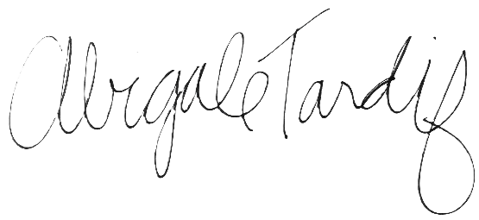
Abigale Tardif
Principal Deputy Assistant Administrator

