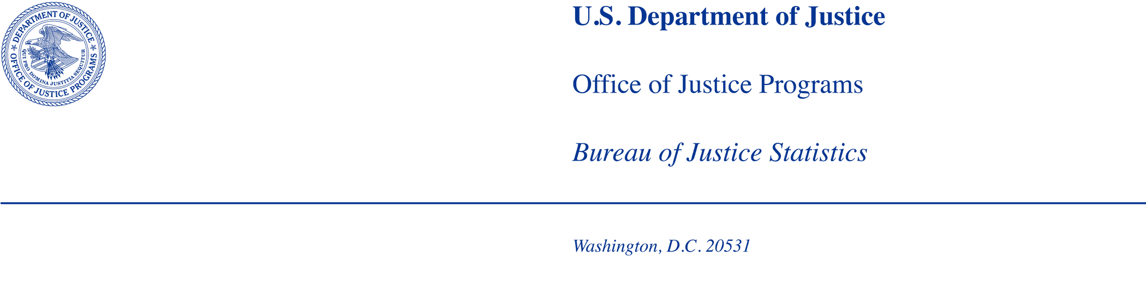

MEMORANDUM

TO: Office of Statistical and Science Policy
Office of Management and Budget

FROM: Bureau of Justice Statistics

DATE: January 23, 2026

SUBJECT: BJS request to contact state sentencing commissions, under the OMB generic clearance agreement (OMB Number 1121-0339).

Summary of Current Request
BJS requests clearance under its generic clearance agreement (OMB Control Number 1121-0339, exp. 01/31/2028) to contact up to 22 state sentencing commissions to assess, review, and summarize the types of data that are and are not publicly available. Currently, there is a significant gap in standardized, comparable state sentencing data at the national level. With a broader goal of improving the ability to collect and generate state court sentencing statistics, this project will take an initial step by investigating the availability and accessibility of state sentencing data through direct outreach to the 22 state sentencing commissions identified by BJS as active in 2025. In addition, BJS will request felony sentencing data from calendar year 2024 or the latest year available. The purpose of the data collection is solely to determine its usability, uniformity, and the potential burden of cleaning and conforming the data for analysis. The data may be provided at either the aggregate or individual level, depending on availability. Data will not be used for public dissemination.

Introduction
Under the current generic clearance request, BJS proposes a pilot to contact 22 state sentencing commissions to request state sentencing commission data and to document the availability of and steps required to access these data.

Background and History of the Collection
BJS has collected sentencing information from state courts in the past; the National Judicial Reporting Program (NJRP) collected data on felony convictions and sentencing in state courts from 1986 to 2006, using a two-stage sample of counties (stage 1) and cases within counties (stage 2). BJS has initiated a review of the NJRP design in light of societal, demographic, and technological changes since its inception. The latest iterations of NJRP found that sentencing and conviction data are increasingly stored in centralized systems at the state level, covering all or most of a state. This suggests that sizable gains in both cost and statistical efficiency could be realized by gathering sentencing and conviction data for entire states rather than from samples of counties within those states. To support the redesign of NJRP, BJS included a survey of the state sentencing commissions in 2016 to assess the data capacity and feasibility of reporting, given that many state sentencing commissions are known to collect and maintain data relevant to the assessment of sentencing patterns within their states (National Judicial Reporting Program Sentencing Commission Survey, OMB Control Number 1129-0339). However, that survey is now a decade old. In 2025, the Criminal Cases in State Courts (CCSC) data collection found that 70% of cases from the 56 jurisdictions that provided data were missing sentencing outcomes (OMB Control Number 1121-0371). Most data came from state or county court administrators. Kansas was the only jurisdiction where the sentencing data came from the sentencing commission and was done as an alternative approach because the state court administrator did not provide data. Current information on state sentencing information remains limited and warrants further examination of alternative data sources, including whether state sentencing commissions could serve as a potential source for addressing gaps in state sentencing information.

The results of the proposed study will be used to develop recommendations for how BJS can obtain sentencing data, as it remains a significant gap in our state court data. Data collection strategies will be assessed in terms of burden placed on data providers, data quality, data accessibility, and potential to inform future state sentencing data collection and reporting efforts. BJS’s data collection agent for this project, RTI International (hereafter referred to as “RTI”), will conduct the outreach from approximately May 1, 2026, to July 10, 2026. BJS and RTI will work together to contact up to 22 state sentencing commissions to request data and gather contextual information about the quality, structure, and accessibility of felony sentencing data.

Study Rationale and Research Questions
The primary goal of this project is to better understand current data availability and reporting conditions across states as a foundational step toward developing a national sentencing data collection. Currently, there is a gap in standardized, comparable data at the state level. NJRP was discontinued in 2006 and 70% of cases from the 56 jurisdictions provided data mostly by courts for CCSC did not have information on the sentencing outcomes. This indicates that current understanding of state sentencing information is limited, and alternative sources, such as state sentencing commissions, may warrant further exploration to fill these gaps. BJS conducted a state sentencing commission survey in 2016 that identified substantial variability in data availability and accessibility across state sentencing commissions. However, no sentencing data were collected. The survey simply gathered information about what data the state sentencing commissions collected at that time and ten years have passed since its completion. The proposed study will test the feasibility of collecting sentencing data from state sentencing commissions through a combination of public data review and direct outreach. The goal is to assess each agency’s capacity to provide data to BJS, identify potential barriers to access, and inform future data collection strategies.

The project team considered potential respondent burden, data validity and availability of records, with the goal of assessing the following research questions:

- What types of data (e.g. case-level, summary, administrative) are maintained by state commissions?
- What are the procedural, legal, or technical barriers to accessing data?
- Are commissions statutorily required to collect or report sentencing data? And if so, which ones?
- What mechanisms exist for accessing data (e.g. public download, restricted request)?
- How does the availability and accessibility of state sentencing data support the existing data collection or help establish a new data series?
- What are the protocols in place when commissions respond to direct outreach inquiries about data availability (e.g., referrals to other staff, internal approvals, formalized request, etc.)?

Testing Procedures

Methodology
To assess the availability and accessibility of state sentencing data several steps will be undertaken. First, RTI will systematically review the 22 state sentencing commission websites and public dashboards to identify available data portals, downloadable or scrapeable datasets, and supporting documentation, such as codebooks or data dictionaries. All accessible resources will be saved and catalogued to inform our understanding of each commission’s data capacity. Subsequently, RTI will implement a multi-phase research project combining structured data collection and nonresponse follow-up (NRFU) (e.g., standardized initial outreach to the commissions, such as sending the same prenotification letter and formal data request and follow-up communications), tailoring conversations to individual scenarios if commissions request further conversation after initial outreach.

Following the web review and upon receipt of OMB Generic Clearance approval, RTI will conduct outreach to each commission using a structured protocol designed to maximize engagement and facilitate data access. The initial outreach will begin with a prenotification email, followed by formal requests for sentencing data or data products covering the period from January 1 to December 31, 2024, or the most recent year available. RTI will also take steps to fulfill any data access requirements identified by the agencies, including executing Memoranda of Understanding (MOUs), or submitting official data request forms. All communications will offer respondents the opportunity to schedule a phone or video call to further explain the project, address questions, and clarify any issues to support data sharing.

The contact schedule will occur over a 10-week period, including initial outreach and subsequent follow-up communications. For commissions that do not respond to the initial request, RTI will implement an NRFU protocol involving email and phone outreach. This follow-up effort is not only intended to encourage response but also to verify the original contact information. Any agencies that explicitly decline or remain unresponsive after the follow-up period or do not respond after NRFU will be classified as a refusal. A final email will be sent acknowledging the agency’s decision of nonparticipation or lack of response and will include a list of common participation barriers (e.g., legal, technical, or resource-based), with an encouragement for recipients to optionally select or elaborate on their decision, given their experiences.

Frame and Sample Selection
The current study frame consists of 22 active state sentencing commissions identified by BJS in 2025. Active commissions were identified through a systematic review of publicly available sources, including the National Association of Sentencing Commissions’ website and reports, as well as the official websites of individual state sentencing commissions. Points of contact for these commissions were compiled based on the information available through these sources. The study aims to contact all identified active commissions; therefore, no sampling procedures will be used. The identified 22 states sentencing commissions include:

- Alabama Sentencing Commission
- Alaska Judicial Council
- Arkansas Sentencing Commission
- Connecticut Sentencing Commission
- Delaware Sentencing Accountability Commission
- DC Sentencing Commission
- Illinois Sentencing Policy Advisory Council
- Kansas Sentencing Commission
- Maryland State Commission on Criminal Sentencing Policy
- Massachusetts Sentencing Commission
- Minnesota Sentencing Guidelines Commission
- Missouri Sentencing Advisory Commission
- Nevada Department of Sentencing Policy
- New Mexico Sentencing Commission
- North Carolina Sentencing & Policy Advisory Commission
- Ohio Criminal Sentencing Commission
- Oregon Criminal Justice Commission
- Pennsylvania Commission on Sentencing
- Utah Sentencing Commission
- Virginia Criminal Sentencing Commission
- Washington State Sentencing Guidelines Commission, Office of Financial Management
- West Virginia Sentencing Commission

Recruitment and Screening
BJS will provide RTI with a list of identified points of contact for 22 state sentencing commissions to participate in the pilot study. Outreach will be conducted through a combination of email and scheduled video (via Zoom or Microsoft Teams) or phone calls. In week 1, recruitment will begin with a prenotification email (Attachment A) outlining the purpose of the study and notifying recipients of the forthcoming request. In week 2, RTI will send a formal data request via email (Attachment B); Respondents can email the research team publicly available data or upload internal data to a secure FTP site. For the latter, RTI will provide the agency with credentials to access its secure FTP (SFTP) server. Within 3 business days. RTI will then transfer the data from the SFTP to the FIPS moderate project share where other data are stored. If the agency is unable to access RTI’s secure FTP server, RTI will request access to the agency’s secure FTP server, retrieve the data, and move them immediately to the project share. If neither of these options are available, RTI will ask BJS to arrange a secure file transfer using OJP’s approved BOX system.

Commissions will be offered the opportunity to schedule a video call (via Zoom or Microsoft Teams) or phone conversation to discuss the request. If there is no response, RTI will follow up with non-respondents by email in week 4 and by phone in weeks 5-10. During a follow-up call, RTI will use a semi-structured script to ask a few questions about reasons for non-participation, data availability and accessibility, and reporting mandates to understand any potential barriers to participation (Attachment C). Commissions that explicitly decline or do not respond after follow-up will receive one final email with one question to indicate reasons for non-participation (Attachment D), closing out the outreach process. The complete recruitment process is shown in Figure 1, and the outreach schedule is shown in Table 1.

Figure 1. Recruitment Process

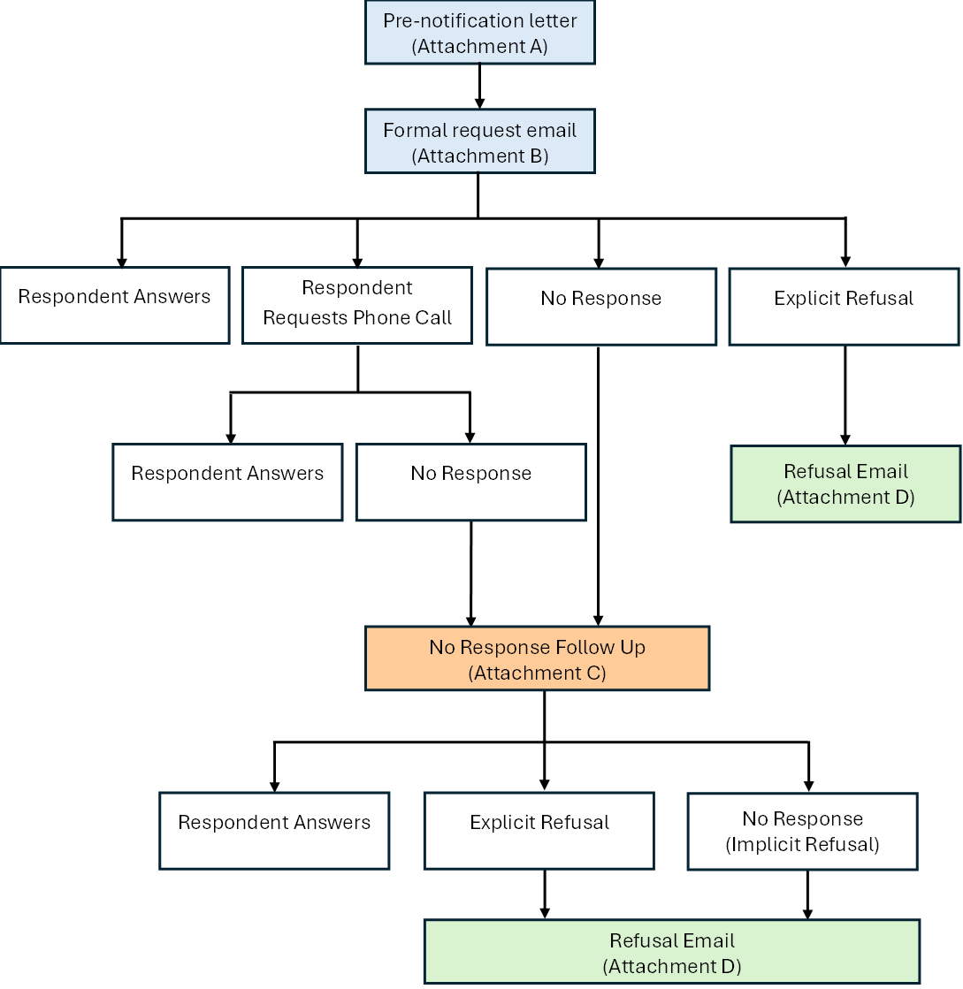

Table 1. Recruitment Outreach Schedule

Week | Contact Description | Method | Number of Participants
1 | Prenotification | Email | 22
2 | Formal request | Email | 22
4 | Nonrespondent Follow-up | Email | Up to 22
5-10 | Nonrespondent Follow-up | Phone | Up to 22
2-10 | Closeout email to refusals and nonrespondents | Email | Up to 22

If a contact attempt is unsuccessful at any point during recruitment (e.g., an email bounces back or a call goes to a disconnected phone number), the project team will verify contact information, such as phone numbers and email addresses. If needed, the project team will seek an updated point of contact for the agency(ies). All research on appropriate points of contact will be done online using publicly sourced information. Sources will include (1) webpages, (2) official governmental reports, and (3) news reports/articles from reputable sources.

Data Collection Process
Data will be collected directly from the commissions through multiple mechanisms. Commissions may share data by providing a URL to their publicly available reports, dashboards, data files, and codebooks; uploading internal files to a secure link provided by RTI; or establishing a Memorandum of Understanding (MOU) for aggregate data (Attachment E), when applicable. Commissions will have the opportunity to schedule a video or phone call to discuss the data request. For non-respondents, email and phone follow-ups will be conducted; during follow-up calls, a few questions will be asked to identify and document barriers to providing data (Attachment C). For commissions that explicitly refuse to participate or still did not respond after nonresponse follow-up, the project team will send an email containing a brief question asking them to indicate reasons for non-participation (Attachment D) to maintain structured responses.
The project team will systematically record field notes and document decision-making processes throughout data collection. All responses will be documented in a structured tracking file, including the outcome of each contact attempt, key information provided by the agency, and any relevant follow-up actions. The use of a consistent script and data logging protocol will allow the project team to identify patterns across agencies and produce replicable, high-quality qualitative data on the data request process. BJS staff may observe data collection calls and will be included in communications as needed.

Justification for Sensitive Questions
The data collection does not include questions of a sensitive nature.

Timeline
Following is the initially intended project timeline.

Milestone | Start Date | End Date
Obtain OMB generic clearance | 01/31/26 | 04/30/26
Outreach and data collection period | 05/01/26 | 07/10/26
Data analysis and submission | 07/11/26 | 08/11/26
Final report and recommendation | 08/12/26 | 09/30/26

Burden Hours
As shown in Table 2, BJS estimates the respondent burden to be 42 hours. The project team expects that email contacts, including the initial outreach, follow-up, and closeout emails to refusals and nonrespondents will take five minutes per participant, and that phone nonresponse follow-up will take 15 minutes per participant. Most outreach would be conducted by RTI; however, BJS may participate in the middle email and phone outreach, depending on response to the earlier NRFU attempts by RTI. Commissions are expected to spend approximately 45 minutes preparing and submitting data. Additional time for inquiry and logistics calls to coordinate the data submission is estimated at approximately 30 minutes.

Table 2: Burden Associated with Planned Testing
Category of Respondent & Activity | Maximum # of Respondents | Participation Time  (minutes) | Burden (hours, rounded)
State or local governments: Commission prenotification email | 22 | 5 | 2
State or local governments: Commission formal request email | 22 | 5 | 2
State or local governments: Commission pulling and submitting data | 22 | 45 | 17
State or local governments: Commission nonrespondent follow-up via email | 22 | 5 | 2
State or local governments: Commission nonrespondent follow-up via phone | 22 | 15 | 6
State or local governments: Commission closeout email to refusals and nonrespondents | 22 | 5 | 2
State or local governments: Commission inquiry/logistics calls | 22 | 30 | 11
Total | 22 | - | 42

Paying Respondents/Participants
Respondents/participants will not be compensated for their involvement in this research.

Cost to the Federal Government
The estimated annual cost to the Federal government is $128,736 for the RTI portion of the work and an estimated $1,236 for 20 hours of the GS-12 project manager’s work, resulting in a total estimated cost of $129,972.

Analysis and Reporting
RTI’s analysis and reporting activities will include 1) submitted datasets and access documentation, 2) non-response and data unavailability documentation, 3) communication logs, 4) key decision point memos, and 5) final data capacity report.

Throughout the data collection process, RTI will maintain detailed communication logs capturing all outreach efforts, contact outcomes, and key project decisions. At critical points—such as refusals by commissions, procedural adjustments, or identification of access barriers—RTI will produce internal memos documenting these developments and recommending next steps. These materials will ensure transparency, support ongoing project management and reporting, and could inform a future data collection strategy involving commissions.

Following data collection, RTI will compile the data by cleaning, organizing, and validating all received datasets, metadata, and accompanying documentation. Each dataset will be reviewed for completeness, structure, consistency to determine the potential utility, for future statistical reporting or research use, of state sentencing commission data. Data will not be used for public dissemination. The project team will document the outcome of each dataset review regarding quality (e.g., missing or incomplete data fields) and types and scopes of data included. Using this information and the engagement from sentencing commission officials, RTI will assess the data capacity for each state sentencing commission. Core indicators – including statutory data collection mandates, relevant IT infrastructure, mechanisms for data delivery (e.g., public portals, secure transfers), and staff or technical resource availability – will be used to categorize states along a data capacity typology. RTI will identify cross-cutting themes and structural patterns among the sentencing commissions, which may include common challenges related to legal authorities, data standardization, or IT systems that influence data availability and access.
Finally, RTI will produce a comprehensive, actionable final report structured around the project’s key components: study purpose, data collection methods, summary of findings, limitations, and targeted recommendations. The report will document and assess each state sentencing commission’s data capacity and identify opportunities and barriers to support a national-level sentencing data collection. It will include state-by-state data availability, data access mechanisms and conditions, common barriers to access, and specific recommendations to support future engagement.

Data Confidentiality and Security
BJS is authorized to conduct this data collection under 34 U.S.C. § 10132. BJS may use the information it collects only for statistical and research purposes and must gather it in a manner that precludes its use for law enforcement or any purpose relating to a private person or public agency other than statistical or research purposes [Title 34 U.S.C. § 10134]. By law, BJS is required to protect the confidentiality of information identifiable to a private person and safeguard it against unauthorized disclosure or misuse. [Title 34 U.S.C. § 10134 and 10231]

The BJS Data Protection Guidelines provide more detailed information on how BJS and its data collection agents will use and protect data collected under BJS’s authority.

Testing will collect identifying information including the name of the state sentencing commission, address, email, and telephone number. All information related to the recruitment activities, datasets, and other documentation will be stored on a secure drive at RTI with restricted access to those staff members who are directly involved in testing. To protect the identities of the respondents, no identifying information will be kept in the final data file.

All project staff are required to sign a pledge of confidentiality and privacy certificate which confirms the maintaining of data and following the procedures outlined above. Furthermore, all sentencing commission recruitment and associated outreach will be conducted by project staff at RTI, who must complete official security training.

Protection of Human Subjects
RTI’s Institutional Review Board (IRB), which has Federal-wide assurance, reviewed the project per 28 CFR 46 and determined that all aspects of the project do not meet the definition of human subjects research (Attachment F).

Contact Information
Questions regarding any aspect of this project can be directed to:

Judicial Statistics Unit
Statistical Collections Division
Bureau of Justice Statistics
U.S. Department of Justice
999 North Capitol Street, NE
Washington, DC 20002
Office Phone: (202) 307-0765
E-mail: ASKBJS@usdoj.gov

Attachments
Attachment A: Pre-notification email
Attachment B: Formal request email
Attachment C: Nonresponse email and phone follow-up scripts
Attachment D: Refusal email
Attachment E: MOU template
Attachment F: RTI IRB determination letter

