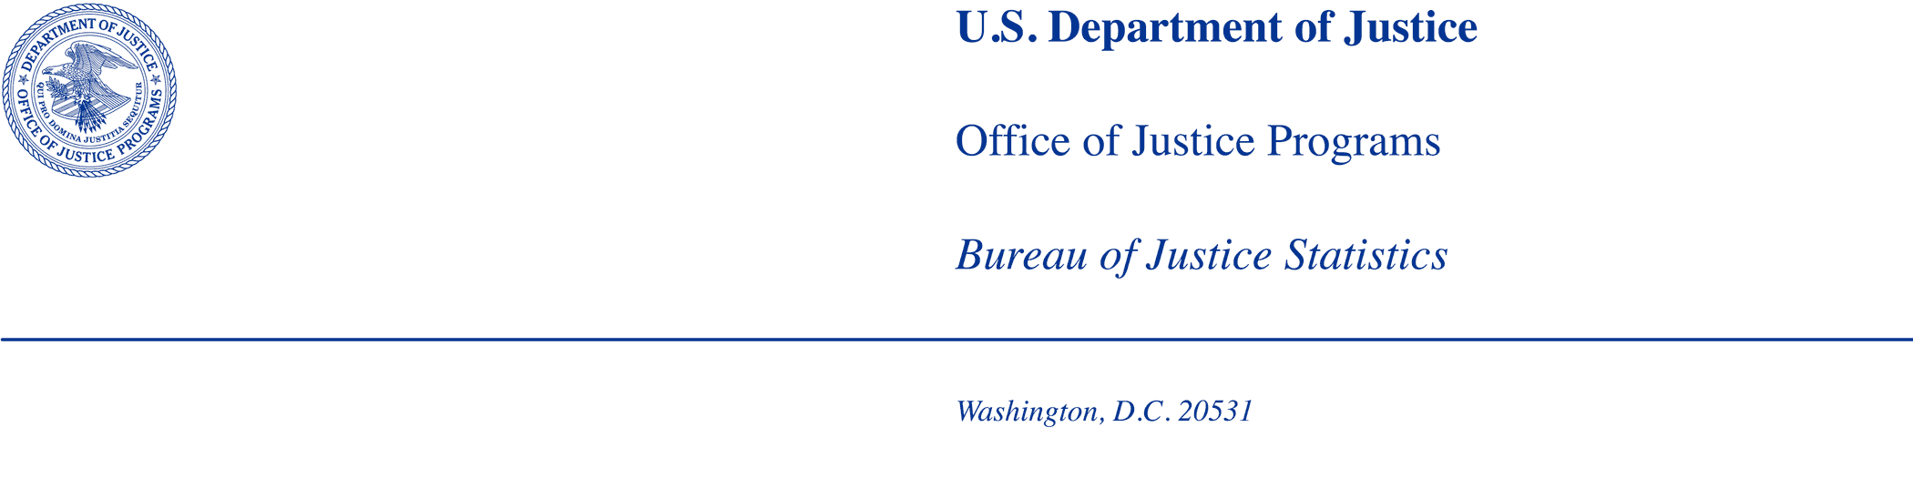

MEMORANDUM

TO: Office of Statistical and Science Policy
Office of Management and Budget

FROM: Bureau of Justice Statistics

DATE: 06/24/2025

SUBJECT: BJS request to cognitively test for the 2025 Survey of State Parole Agencies on Reentry Services (SSPARS), under the OMB generic clearance agreement (OMB Number 1121-0339, Expiration: 01/31/2028).

Summary of Current Request
The Bureau of Justice Statistics (BJS) is requesting clearance under the OMB generic clearance agreement (OMB Control #1121-0339, Expiration: 01/31/2028) to conduct cognitive testing of the questions on the newly developed Survey of State Parole Agencies on Reentry Services (SSPARS).

Introduction
BJS requests clearance to: 1) contact up to 7 leaders of parole and reentry services agencies to participate in cognitive testing of the new SSPARS instrument; 2) contact up to 7 replacement agencies to replace non-responses or refusals; and 3) conduct cognitive testing interviews with up to 15 individuals from the responding agencies. The results of this study will be used to refine the content of the SSPARS instrument with regard to question wording, feasibility and availability of information collected by the survey instrument, burden placed on data providers, and potential to inform a range of related policy questions. The goal of the cognitive testing is to better understand the data availability, burden of instrument questions, and instrument design to pursue a national collection.
BJS’s data collection agent for this project, Justice Information Resource Network (JIRN), will conduct the cognitive testing September through approximately December of 2025. BJS will work together with JIRN to recruit up to 7 state parole and reentry agencies across varying types of sizes and locations to participate in the testing interviews to learn about the quality and challenges related to providing reentry services information to BJS. The total burden is estimated at a maximum of 60 minutes per interview.

Background and History of the Collection
State parole agencies play a key role in reintegrating persons into society after their release from prison. These agencies can provide insight on the extent that persons use reentry services in their state while under community supervision. This includes whether persons under the agency’s jurisdiction are enrolled in drug, sex offender, mental health, or other treatment programs and whether the agency had programs to help persons obtain housing or employment.

BJS through a cooperative agreement with JIRN, in collaboration with the American Probation and Parole Association (APPA), is preparing to administer the Survey of State Parole Agencies on Reentry Services (SSPARS) in 2026. The goal of the survey is to generate national- and state-level statistics on the types of treatment programs, housing and employment assistance, and other reentry services received by adults on community supervision post-release from state prisons in the 50 states and the District of Columbia.
In planning with the project team and subject matter experts (SMEs), a survey has been drafted to collect this information. However, it is essential that the content feasibility of the items are refined and wording of the questions by testing this survey with practitioners in the field. BJS is requesting clearance to conduct cognitive interviews with approximately 15 state parole professionals in 5-7 states prior to the 2026 administration.

Study Rationale and Research Questions

While BJS collects data each year on the characteristics of persons supervised on parole, and how they move onto and off community supervision through the Annual Parole Survey, it last collected data on reentry services in 2006, through the Census of Adult Parole Supervising Agencies (CAPSA). Twenty-one parole agencies were able to report counts of persons enrolled in treatment programs to CAPSA, whose results were published in Characteristics of State Parole Supervising Agencies, 2006 (NCJ 222180, BJS, August 2008). A new data collection will provide policymakers and practitioners with important statistics on current issues of reentry and to understand how the availability and use of reentry services have changed since 2006.

The 2026 SSPARS data collection seeks to provide state- and national-level statistics on the types of reentry services available to individuals following their release from state prisons. The cognitive testing will assist BJS in refining questions and question wording. Further, the cognitive testing will assist BJS in identifying the feasibility of collecting the data and information needed to answer the proposed survey questions along with the level of burden placed on states to complete the survey.

Proposed survey instrument questions
The project team reviewed surveys and instruments related to parole and/or reentry services including the 2006 CAPSA instrument, the National Criminal Justice Treatment Practices Survey - Survey of Administrators (S3A), the Co-Occurring Substance Use and Mental Disorders (COD) Program Activity Survey, the BJS Substance Abuse and Treatment of State and Federal Prisoners survey, and the Juvenile Justice Assessment Planning and Referral Placement (JAPRP) survey, along with articles and white papers on establishment survey best practices. The team plans to use three of the organization questions from the CAPSA instrument in the new survey. The remaining survey questions are original and have been developed with subject matter experts and practitioners in the parole and reentry fields (Attachment A).

BJS proposes testing these items to ensure clarity and response validity before seeking OMB approval to implement and administer a final version of the instrument. The testing will include cognitive interviews as described in the sections below.

Testing procedures
Cognitive interviews are important for evaluating respondent understanding and ability to accurately answer survey questions, along with gauging the response burden of any given question or the survey overall.

Methodology

Cognitive interviews involve an interviewer administering the survey questions to a participant and asking probing questions on how they interpreted the question, how difficult it was to answer, and their process for formulating an answer. Cognitive interviews are generally conducted prior to fielding BJS survey instruments that are new or have been substantively revised. Cognitive testing is a means of mitigating measurement error. Without such testing, the survey could yield a large quantity of incomplete information (because respondents will not be able to finish it or will not respond due to confusion or burden) or responses that are not uniform from one respondent to the next (e.g., what it means to “offer” a service). Finally, without cognitive testing, the survey could place undue burden on the respondents.

Frame and Sample Selection

State community supervision organizations will be targeted for recruitment based on a variety of factors like size, data availability, type of post release supervision, and complexity of agency structure. Project team members from BJS will recruit up to 15 state parole professionals from 5-7 states via a standard recruitment email (Attachment B). If follow-up emails are necessary, they will come from a member at APPA (Attachment C). If a second follow-up is necessary, the email will come from JIRN (Attachment D).

Contacts in state community supervision agencies have been identified through agencies’ publicly available websites and through the APPA’s database. Preliminary research suggests that agencies have one person who will be able to oversee the survey, but can distribute or facilitate introductions to subject matter experts who may better serve the interview process.

Recruitment and Screening

States with large populations, tribal populations, and unique organizational structures have been chosen specifically for cognitive testing to ensure that respondents from these types of systems can feasibly answer questions regardless of the composition of the state’s paroling authorities. Additionally, states that have abolished parole and use alternatives have been purposefully selected for cognitive testing to ensure the survey items are still applicable in this setting. Each state will be asked to have a respondent participate in 2 or 3 topical module interviews. The goal will for each module to have 2 or 3 interviews each.

Parole officials who agree to participate in cognitive testing will be connected to a staff member at JIRN, who will schedule the interview. Participants will be informed that they should allow approximately one hour to participate in the interview via a Microsoft Teams video call. JIRN will follow-up with respondents who agree to participate every 3 to 5 days to schedule the interview.

Exhibit 1. SSPARS cognitive interview recruitment protocol

Data Collection Process

Cognitive interviews will be conducted during September and October of 2025. The cognitive interviews will explore all questions, with each interview session lasting approximately 60 minutes and covering a selected subset of questions. The survey instrument will be divided into four parts to reduce the burden on the participants and only certain subsets of questions will be asked of any given participant (Exhibit 2). The four parts of the survey are: A) Survey introduction, which consists of the introduction and consent, participant role and agency characteristics, and introductory instructions; B) Organizational questions; C) Survey content modules consisting of topical modules; and D) Debrief. Each participant will receive all questions and activities in Parts A and B. Participants will then receive one of 5 modules in Part C. Finally, all participants will be debriefed (Part D).

Exhibit 2. Cognitive interviewing survey organization

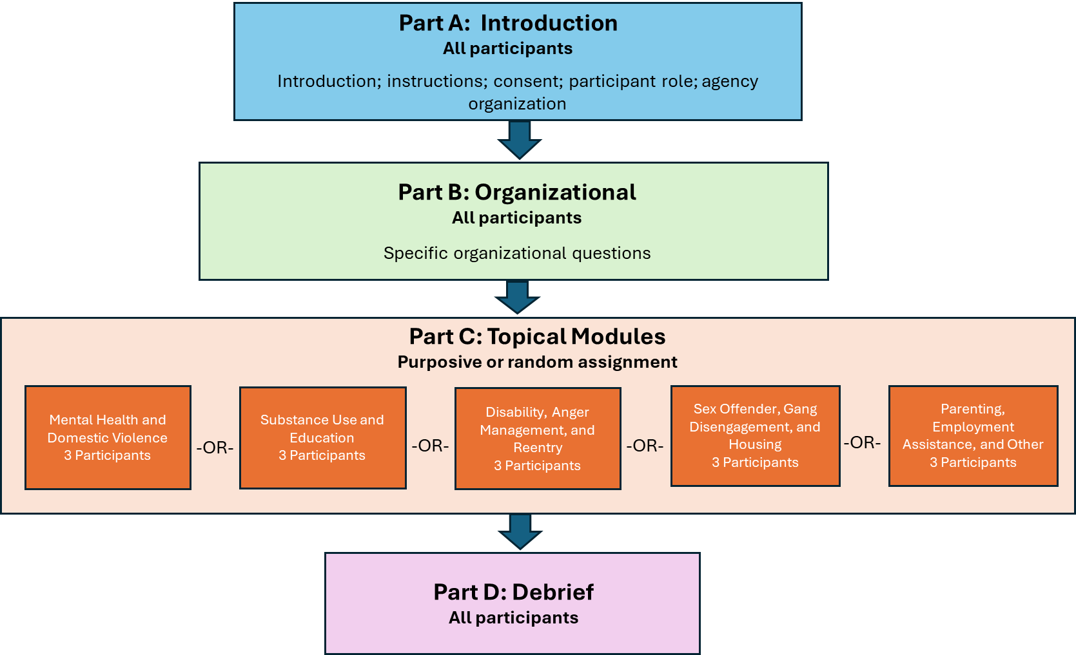

The organization of the parts and modules was designed to ensure adequate coverage of all aspects of the survey while keeping to the 60-minute maximum interviewing time per participant. Assignment of participants will be both random and purposive. Some will be selected to receive specific content modules (Part C) based on their positions or agency characteristics. Those without unique characteristics will be randomly assigned a Part C module.

We aim to recruit 15 participants and test each subset of the survey with 3-5 people, depending on the part and module.

Interviews will be conducted virtually using Microsoft Teams and exclusively in English. The interviewer will display one or two questions at a time on the screen (Attachment F). Participants will be asked to read the question. The cognitive interviewer will follow a specific script which will explore such elements as the participant’s grasp of the meaning of each question, the ability to answer each question, the degree of burden, and the appropriateness of data provided in response to specific questions (Attachment G). Interviews will be recorded with the participants’ permission to ensure answers are accurately captured.

The goals of this cognitive interviewing are to:
- Identify any items that cause excessive burden for the respondents;
- Identify items that have an insufficient number of response options;
- Assess comprehension issues associated with any of the questions, including whether respondents interpret questions consistently;
- Refine the wording of questions so that respondents to the final survey receive the clearest instructions possible concerning which services to report on; and
- Assess the data availability and accessibility to respond to the questions.

Informed Consent

The email invitations (Attachment B, Attachment C, and Attachment D), the introduction to the survey, and the cognitive interview script read to participants at the beginning of the interview provide the elements of informed consent. The initial invitation provides the purpose of the SSPARS, the voluntary nature of the study, how the participant was selected, and information about whom to contact with questions about the study. The initial email invitation will include a copy of the informed consent form (Attachment E) with the instruction for the participant to complete and return the form prior to the interview. Note that consent to participate and consent to record are captured as two separate elements. Participants that consent to be interviewed but do not consent to recording are still eligible to be interviewed.

The introduction to the survey and the script read to participants at the beginning of the virtual cognitive interview will again provide information about the purpose of the SSPARS, the voluntary nature of the study, and information about whom to contact with questions about the study. It will announce the estimated length of the interview in advance, allowing the participant an opportunity to decline if the burden would be unacceptable.

Justification for Sensitive Questions

While BJS may collect limited personally identifiable information (PII) as part of this information collection, the survey does not include questions of a sensitive nature.

Timeline

Analysis will commence while interviews are still underway. Table 1, below, shows the proposed timeline.

Table 1. Proposed timeline for cognitive interviewing activities
Milestone | Start Date | Time (approx.)
Obtain OMB generic clearance | Early summer 2025 | Six weeks
Recruitment and testing period | Summer 2025 | Eight weeks
Analyze data and develop instrument recommendations | Summer/Fall 2025 | Ten weeks
Draft final report | Fall 2025 | Four weeks

Burden Hours

As shown in Table 2, BJS estimated the participant burden to be 22.5 hours. Up to 15 state supervision agency professionals may be contacted and asked to participate in cognitive interviewing. Estimated burden of the initial contact and scheduling will take approximately 30 minutes per participant (initial recruitment email: 5 minutes; follow-up emails and phone calls, and scheduling: 15 minutes; informed consent review: 10 minutes). The cognitive testing itself will take approximately 60 minutes for 15 participants.
Table 2: Burden Associated with Planned Testing
Category of Activity | Maximum # of participants | Participation Time  (minutes) | Burden (hours)
Initial contact and scheduling for cognitive interviews | 15 | 30 | 7.5
Cognitive testing | 15 | 60 | 15
Total | 15 | 90 | 22.5 hours

Paying Respondents/Participants

Respondents/participants will not be compensated for their involvement in this research.

Cost to the Federal Government

The estimated annual cost to the Federal government is $7,225 for the JIRN portion of the work and an estimated $1,770 for the GS-12 and GS-13 project managers’ work, resulting in a total estimated cost of $8,995.

Analysis and Reporting

Upon completion of the cognitive interviewing, JIRN will provide BJS with a report describing the findings and including final recommendations. It will include any suggested changes to the instrument based on the cognitive interviewing. The report will provide detailed information on the testing methodology, respondent characteristics, and findings related to the new or revised questions tested. The report will be reviewed for disclosure avoidance by the BJS Disclosure Avoidance Officer prior to public release.

Data Confidentiality and Security
BJS is authorized to conduct this data collection under 34 U.S.C. § 10132. BJS may use the information it collects only for statistical and research purposes and must gather it in a manner the precludes its use for law enforcement or any purpose relating to a private person or public agency other than statistical or research purposes [Title 34 U.S.C. Section 10134]. By law, BJS is required to protect the confidentiality of information identifiable to a private person and safeguard it against unauthorized disclosure or misuse. [Title 34 United States Code Sections 10134 and 10231]

The BJS Data Protection Guidelines provide more detailed information on how BJS and its data collection agents will use and protect data collected under BJS’s authority.

The testing will collect identifying information including the name of the participating organization, address, email, and telephone number as well as participant name and email address.

All information related to the cognitive interviews, including the recordings of interviews, will be stored on a secure drive at JIRN with restricted access to those staff members who are directly involved in cognitive testing. To protect the identities of the respondents, no identifying information will be kept in the final data file. In addition, the recorded conversations of the interviews will be erased upon completion of the cognitive testing report, a maximum of six months after the pretest has ended. Once the instrument is revised and the summary report completed, all copies of the cognitive interview data will be destroyed. The summary report will be reviewed for disclosure avoidance by the BJS Disclosure Avoidance Officer prior to any public release.

All project staff are required to sign a pledge of confidentiality and privacy certificate which confirms the maintaining of data and following the procedures outlined above. Furthermore, all cognitive interviews will be conducted by project staff at JIRN, who must complete official security training.

BJS is required to protect information identifiable to a private person from unauthorized disclosure and may not publicly release data in a way that could reasonably identify a specific private person [34 U.S.C. § 10231 and 28 CFR Part 22]. Any person who violates these provisions may be punished by a fine up to $10,000, in addition to any other penalties imposed by law. Further, per the Cybersecurity Enhancement Act of 2015, federal information systems are protected from malicious activities through cybersecurity screening of transmitted data.

Protection of Human Subjects
JIRN’s Institutional Review Board (IRB), which has Federal-wide assurance, reviewed the project per 28 CFR 46 and determined that the project does not meet the definition of human subjects research (Attachment H).
Contact Information
Questions regarding any aspect of this project can be directed to:

Statistical Collections Division
Bureau of Justice Statistics
U.S. Department of Justice
810 7th Street, NW
Washington, DC 20531
Office Phone: (202) 307-0765
E-mail: ASKBJS@usdoj.gov

Attachments
Attachment A: Survey of State Parole Agencies on Reentry Services (SSPARS) survey
Attachment B: Cognitive Interviewing Recruitment Email from BJS
Attachment C: Cognitive Interviewing Recruitment Email from APPA
Attachment D: Cognitive Interviewing Recruitment Email from JIRN
Attachment E: Informed Consent Form
Attachment F: Cognitive Interviewing Slides
Attachment G: Cognitive Interviewing Protocol
Attachment H: IRB Determination of Exemption

