Appendices A – D:
Center for Indigenous Research Collaborations and Learning for Home Visiting (CIRCLE-HV) Outreach Documents

Table of Contents
ATTACHMENT A: CENTER FOR INDIGENOUS RESEARCH COLLABORATION AND LEARNING FOR HOME VISITING (CIRCLE-HV) RESEARCH FLYER LANGUAGE 3
ATTACHMENT B: CENTER FOR INDIGENOUS RESEARCH COLLABORATION AND LEARNING FOR HOME VISITING (CIRCLE-HV) Email to Share Contact Information 5
ATTACHMENT C: CENTER FOR INDIGENOUS RESEARCH COLLABORATION AND LEARNING FOR HOME VISITING (CIRCLE-HV) INTERVIEW INVITATION EMAIL SCRIPT 7
ATTACHMENT D: CENTER FOR INDIGENOUS RESEARCH COLLABORATION AND LEARNING FOR HOME VISITING (CIRCLE-HV) INTERVIEW INVITATION PHONE SCRIPT 10

ATTACHMENT A: CENTER FOR INDIGENOUS RESEARCH COLLABORATION AND LEARNING FOR HOME VISITING (CIRCLE-HV) RESEARCH FLYER LANGUAGE

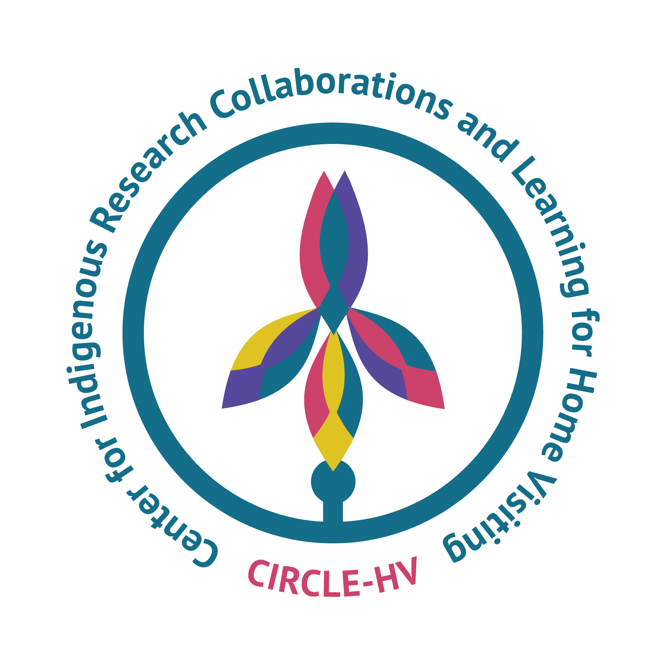
The Center for Indigenous Research Collaborations and Learning for Home Visiting

What is CIRCLE-HV?
CIRCLE-HV is building evidence and understanding about home visiting through partnerships with programs that serve Indigenous children and families.

This study focuses on the values, outcomes, and practices that influence and are important to Indigenous families participating in home visiting.

Who is involved?
To be eligible to participate, you must be either
- a caregiver enrolled in a home visiting program or
- a home visitor or
- an individual who manages, coordinates or administers a home visiting program

Eligible participants will be working or enrolled at one of the programs involved in the study.
These home visiting programs 1) directly serve American Indian, Alaska Native, Native Hawaiian, or other Indigenous populations in the United States or U.S. territories, including programs run by Tribes, consortia of Tribes, urban organizations, Native Hawaiian programs, U.S. territories, and nonprofit organizations, and 2) have been providing services to families for at least one year, and 3) volunteered to participate and have shaped the study design and approach through collaborative planning with the research team.

What does study participation look like?
Study participation will involve completing a survey and may also include participating in an in-person interview. The online survey will take 20-25 minutes to complete. The interview will last up to 90 minutes and be conducted in person.

Who is conducting the study?
The study is conducted by James Bell Associates and the Centers for American Indian and Alaska Native Health at the University of Colorado Anschutz on behalf of the Administration for Children and Families.

The Study Team has extensive experience conducting home visiting research and research in partnership with Tribal communities.
If you have any questions about this study, please email Erin Geary at geary@jbassoc.com

ATTACHMENT B: CENTER FOR INDIGENOUS RESEARCH COLLABORATION AND LEARNING FOR HOME VISITING (CIRCLE-HV) Email to Share Contact Information

Dear [Caregiver/Staff Member],
You may have recently seen a flyer about the CIRCLE-HV research study (also attached to this email) or heard me discuss this study. The study is about home visiting programs serving Indigenous families and the values that matter most to communities. [Program Name] has been actively involved in this study from the very beginning, working closely with the CIRCLE-HV research team to make sure this research reflects what matters most to our program and families.
What We're Asking: We would like to share your email address and phone number with our research team so they can contact you about participating in a brief survey. Once you receive the survey, you can decide whether to complete it. Your participation is completely voluntary, and you can decline at any time without affecting your relationship with [Program Name] or the services you receive.
Your Choice Matters: If you do not want your contact information shared with the research team, please reply to this email or contact [Insert Point of Contact Here] by [Date: two weeks from email] to let us know if you would not like your information shared.
If you have questions about this study, please don't hesitate to contact:
[Point of Contact at Site] or Erin Geary at geary@jbassoc.com
Sincerely,
[Program Point of Contact]

ATTACHMENT C: CENTER FOR INDIGENOUS RESEARCH COLLABORATION AND LEARNING FOR HOME VISITING (CIRCLE-HV) INTERVIEW INVITATION EMAIL SCRIPT

CIRCLE-HV Interview Invitation Email Script

Subject: Invitation to Participate in an Interview for Home Visiting Study

Dear [respondent name],

My name is [name], and I work with staff from [program name] on the CIRCLE-HV study. Thank you for completing the survey portion of our research earlier. We are now reaching out as you indicated interest in participating in the second part of our study which is a follow-up interview.

We are planning a visit to [site name] this [month], and I am writing to see if you might still be interested in participating in an interview.

For families: During the interview, we will revisit the content from the survey you completed earlier. You may recognize some of the same topics, and we would like to explore them a little deeper to better understand what is important to you as you participate in [program name] and what you hope to get out of home visiting.

For home visiting staff: During the interview, we will revisit some of the content from the survey you completed earlier. You may recognize some of the same topics, and we would like to explore them a little deeper. This means we will be asking questions about your values you bring to your work, the practices you draw on, and ultimately how your work impacts Indigenous families you serve.

Interviews will be conducted in person and will take about an hour and a half. Taking part in the interview is voluntary. If you are willing, we would be interested in hearing about your experience. We will offer you $75 for your participation. If you are unable to meet in person while we are on site, we can offer a virtual option to complete the interview via the platform Zoom.

I am including some potential interview times, but if none of these times work for you, please feel free to offer some alternatives.

[list of dates and times]

If you have any questions, please feel free to contact me anytime either by email or by phone [number]. Someone from our study team may also contact you by phone.

We are looking forward to hearing from you.

[signature]

[CIRCLE-HV team member name]

ATTACHMENT D: CENTER FOR INDIGENOUS RESEARCH COLLABORATION AND LEARNING FOR HOME VISITING (CIRCLE-HV) INTERVIEW INVITATION PHONE SCRIPT

Hello [name],

My name is [name], and I work with staff from [Program Name] on the CIRCLE-HV study. Thank you for completing the survey portion of our research earlier. I’m reaching out because you indicated interest in participating in a follow-up interview.

We are planning a visit to [site name] this [month], and I am calling you today to see if you might still be interested in being interviewed.

The interview is completely voluntary, so please don’t feel any pressure. But, if you are willing, we would be really interested in hearing about your experience. Also, we will offer you $75 for your participation.

For families: During the interview, we will revisit the content from the survey you completed earlier. You may recognize some of the same topics, and we would like to explore them a little deeper to better understand what is important to you as you participate in [program name] and what you hope to get out of home visiting

For home visiting staff: During the interview, we will revisit some of the content from the survey you completed earlier. You may recognize some of the same topics, and we would like to explore them a little deeper. This means we will be asking questions about your values you bring to your work, the practices you draw on, and ultimately how your work impacts Indigenous families you serve.

Interviews will be conducted in-person and will take about an hour and a half. If you are not available while we are on site, we can offer a virtual interview option using the Zoom platform.

Do you have any questions about the interview? Anything else?

Do you think you might be interested in doing an interview?

If no: No problem. If you think about it and change your mind, please give me a call at [phone number]. Like I said, we would love to be able to include your experience in what we learn about home visiting in Tribal communities. Have a great day.

If yes: Great. We are looking forward to hearing more about your experience with home visiting. We will be coming out to visit [Program Name] and do interviews the week of [date]. What day/time [if necessary give windows] that week would work best for you? [Depending on plan set in place during the site visit planning call, establish a private location to conduct interviews and arrange location with interviewee] Thank you so much for your willingness to consider taking part in the CIRCLE-HV interviews. See you soon!

