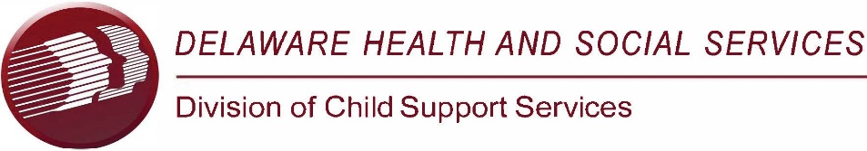
Office of the Director
84A Christiana Road, New Castle, DE 19720 Phone 302-395-6520

November 4, 2024
Office of Child Support Services
Attention: Director of Policy and Training
330 C Street SW
Washington, DC 20201

RE: OMB No. 0970-0223- State Self-Assessment Report

To Whom It May Concern:

On behalf of the state of Delaware, I am writing to express the following proposed changes that should be made to the State Self-Assessment Report. We hope that the Federal Office of Child Support Services (OCSS) will consider the following comments, and implement regulatory changes that will assist the states with any updates made to the State Self-Assessment Reporting process. First, and most importantly, my team in Delaware recommends, that OCSS give heavy consideration to completely removing the State Self-Assessment Report, all together, as a requirement for each state’s annual submission.
The State Self-Assessment Report takes a tremendous amount of time, with multiple employees, in multiple counties, in order for completion to be achieved. The number of DCSS employees reviewing the sample of cases have expressed that the completion of the State Self-Assessment Report is extremely time consuming. On average, it takes the Delaware employees five months to complete the State Self-Assessment Report.
The case workers, who are pulled to assist with the completion and review of over 825 cases, would be better utilized directly assisting Delaware’s constituents with the continued processing, establishment, and enforcement of their child support orders and cases. In addition, by the time the report is completed and submitted to OCSS, there is not enough time in between each annual State Self-Assessment Report, to conduct a thorough analysis and develop a training that would make the actual completion of the Self-Assessment Report a meaningful exercise that could be shared with all DCSS employees.
Secondly, if OCSS will not eliminate the State Self-Assessment Report, in its entirety, Delaware strongly recommends, as an alternative, that the sample number of cases, needing to be reviewed, be minimized.

Lastly, again, if eliminating the State Self-Assessment report is not an option, Delaware proposes streamlining the State Self-Assessment Report. For example, Delaware believes that the State Self-Assessment Report will allow each state to prepare and utilize the results of the report for employment and training opportunities that lead to program enhancements and improvements.
In addition, Delaware feels that the State Self-Assessment Report contains unneeded, extra information such as ‘Program Service Enhancements and Program Direction;’ Delaware moves to strike these items, in their entirety, from the need for review in the State Self-Assessment Report.
To summarize, the state of Delaware believes that the State Self-Assessment Report is much too time consuming. Its overall, final information does not allow much time for review, analysis, and distribution to employees for employment and training opportunities and program improvements.
Thank you for your attention to this matter and your consideration of these comments.

Sincerely,
Theodore G. Mermigos, Jr.
Theodore G. Mermigos, Jr.
IV-D Director, Delaware

Pc: Julie Shahan, Deputy Director
Natasha Alessia, Social Service Sr. Administrator
File

