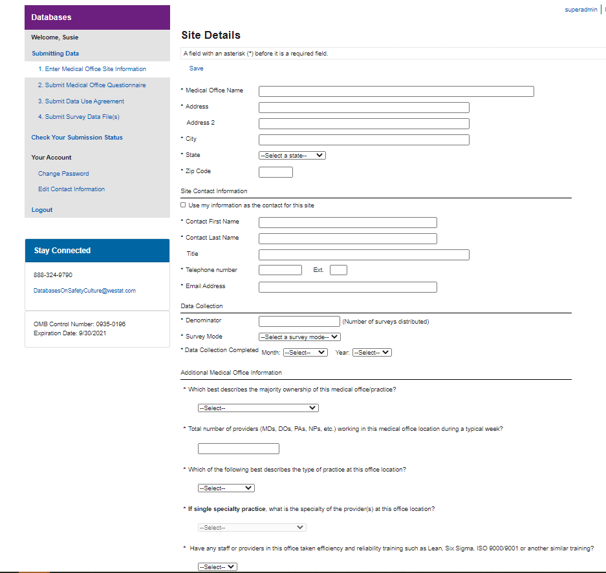
Response options for Specialties (separated by semi-colons): Allergy/Immunology; Anesthesiology; Cardiology; Child & Adolescent Psychiatry; Dermatology; Diagnostic Radiology; Emergency Medicine; Endocrinology/ Metabolism; Family Practice/Family Medicine; Forensic Pathology; Gastroenterology; General Practice

Response options for Practice Type:
- Single specialty
- Multispecialty

Response options for Majority Ownership (separated by semicolon): Provider(s) and/or Physician(s); Hospital or Health System; University or Academic Medical Center; Community Health Center; Federal, state, or local government; Other

Response options for Survey Mode: (separated by semicolon): Paper; Web; Mixed mode (paper & web); Other

