NCI/Office of Communications and Public Liaison
APPENDIX 1B
LIVE HELP QUESTIONS

Questions can be found at:
https://nci--tst.custhelp.com/ci/documents/detail/5/2/12/218a56af55ca6c4f61a9e9e09420e475cb004c0e

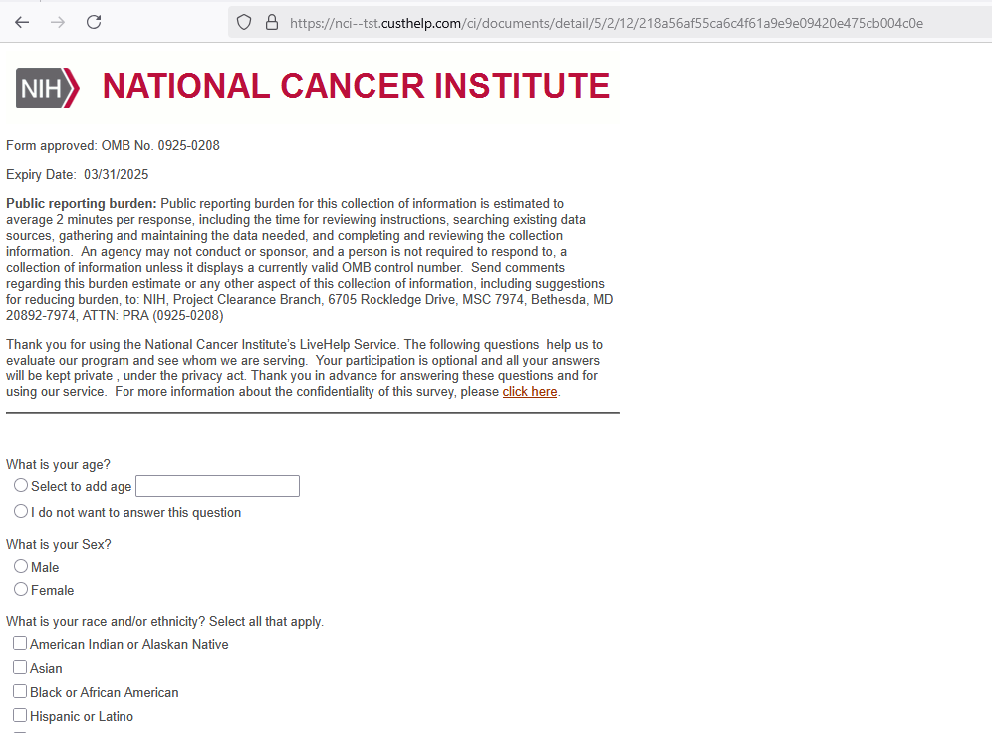
Demographic Survey Questions
What is your age?

- Select to add age (text box)
- I do not want to answer this question

What is your Sex?

- Male
- Female

What is your race and/or ethnicity? Select all that apply
- American Indian or Alaska Native
- Asian
- Black or African American
- Hispanic or Latino
- Middle Eastern or North African
- Native Hawaiian or Pacific Islander
- White

American Indian or Native Alaskan: Please include nationality or tribe. For example, the Navajo Nation, the Blackfeet Tribe of the Blackfeet Indian Reservation of Montana, the Native Village of Barrow Inupiat Traditional Government, the Nome Eskimo Community, Aztec, Maya, etc.

Asian: Please select all that apply.
- Valid Skip
- Chinese
- Vietnamese
- Asian Indian
- Korean
- Filipino
- Japanese
- Other Asian

If "Other Asian," please include an example, like Pakastani, Hmong, Afghan, etc.

Black or African American: Please select all that apply.
- Valid Skip
- African American
- Nigerian
- Jamaican
- Ethiopian
- Haitian
- Somali
- Other Black/African American

If "Other Black African American," please include an example, such as Trinidadian and Tobagonian, Ghanaian, Congolese, etc.

Hispanic or Latino: Please select all that apply.
- Valid Skip
- Mexican
- Cuban
- Puerto Ricon
- Dominican
- Salvadoran
- Guatemalan
- Other Hispanic or Latino

If "Other Hispanic Latino," please include an example, such as Columbian, Honduran, Spaniard, etc.

Middle Eastern or Northern African: Please select all that apply.
- Valid Skip
- Lebanese
- Syrian
- Iranian
- Iraqi
- Egyptian
- Israeli
- Other Middle Eastern or Northern African

If "Other Middle Eastern Northern African," please include examples like Moroccan, Yemeni, Kurdish, etc.

Native Hawaiian or Pacific Islander: Please select all that apply.
- Valid Skip
- Native Hawaiian
- Tongan
- Samoan
- Fijian
- Chamorro
- Marshallese
- Other Native Hawaiian or Pacific Islander

If "Other Native Hawaiian or Pacific Islander," please include an example, such as Chuukese, Palauan, Tahitian, etc.

White: Please select all that apply.
- Valid Skip
- English
- Italian
- German
- Polish
- Irish
- Scottish
- Other White

If "Other White," please include examples like French, Swedish, Norwegian, etc.

What Is the Highest Level of Education You Have Completed?

- Grade school
- Some high school
- High school graduate
- Some college
- College graduate
- Post-graduate
- I do not want to answer this question

Is There a Place You Usually Go to When You Are Sick or Need Advice About Your Health?

- Yes
- No
- Don't Know
- I do not want to answer this question
What Kind of Place Do You Go to Most Often?

- A doctor’s office
- A clinic, health center, or hospital clinic
- The emergency room, or
- Some other place
- No one place
- I do not want to answer this question

In the Last 12 Months, Did You Have Any Healthcare Coverage, Including Health Insurance, Prepaid Plans Such as HMOs, or Government Plans Such as Medicare?

- Yes
- No
- Don’t know
- I do not want to answer this question

Would You Say You Had This Coverage During All 12 Months or Less Than 12 Months?

- All 12 months
- Less than 12 months
- Don’t know
- I do not want to answer this question

Which Type of Coverage Did You Have?

- Was it public, such as Medicare, Medicaid, or other government plans?
- Was it private, such as an HMO, Blue Cross, Kaiser, or Aetna?
- Or was it both public and private?
- Valid skip
- Don’t know
- I do not want to answer this question

What Was Your Total Household Income from All Sources Before Taxes Last Year? Just Stop Me When I Get to the Right Category

- Less than $10,000
- $10,000 to $19,000
- $20,000 to $29,000
- $30,000 to $39,000
- $40,000 to $59,000
- $60,000 to $79,000
- $80,000 or more
- Don’t know
- I do not want to answer this question

Including Yourself, How Many People Living in Your Household are Supported by This Total Household Income?

- Select this option to enter the total (text box)
- Don’t know
- I do not want to answer this question

