2025 and 2027 National Youth Risk Behavior Survey

Attachment P1

Letter to Teachers in Participating School for the national YRBS
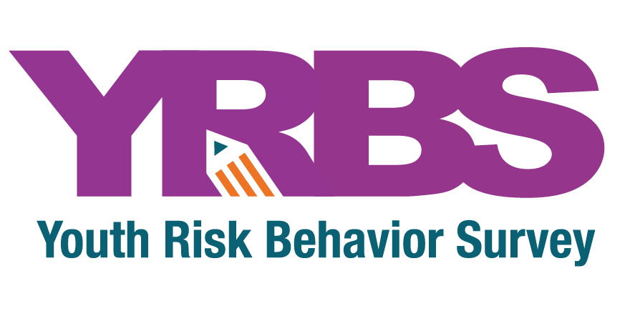

Dear Teacher:

We appreciate your classroom hosting the [YEAR] national Youth Risk Behavior Survey (YRBS), sponsored by the Centers for Disease Control and Prevention (CDC), Division of Adolescent and School Health. Monitoring the behaviors that put our youth at greatest risk for harm provides essential information used to improve outcomes for students in our schools.

See the enclosed fact sheet for information about the survey and recent results from students just like yours. A report summarizing the results of this year’s study will be published in [YEAR], and your school will be notified when the report is available for download.

You play a very important role in the survey. Your support and encouragement will help ensure students’ voices are heard. Your class was randomly selected and cannot be replaced.

The survey will be administered by a specially trained survey representative and will take approximately 25 minutes. We will provide all the necessary materials. Please follow the instructions on the left in order to prepare for the survey administration.

Survey procedures have been designed to protect your students’ privacy and allow for anonymous participation. During survey administration, you will be asked to remain at the front of the classroom to increase student candor. A copy of the questionnaire is available with your school’s contact person if you would like to view it.

Your support and encouragement will help ensure students’ voices are heard so that CDC, educators, lawmakers, doctors, community organizations, and public health officials are able to assess and improve efforts to reduce priority health risk behaviors among adolescents. If you have any questions, please call me toll-free at 1-800-675-9727 between 8:30 a.m. and 5:00 p.m. eastern time. Thank you again for your cooperation.
Sincerely,

Alice Roberts, Project Director
National Youth Risk Behavior Survey

To prepare for the YRBS administration, please:

- Review the enclosed Summary of School Arrangements form, which confirms the classes that were randomly selected to participate and the date of survey administration.

- Distribute a parental permission form to each student in your selected class as soon as possible, at least 10 days prior to the survey date. We have provided “Instructions to be Read When Distributing Permission Forms.”

- Follow the directions on the Permission Form Tracking Log and use it to track and record the return of any permission forms. Please be sure to complete this form prior to the survey date so that we can easily determine which students are eligible to participate in the survey. Our survey representative will collect this form from you.

- Distribute a reminder slip and/or another parental permission form three days prior to the survey administration date for those students who have not yet returned a signed form.

- Plan an alternate activity for the day of the survey for those students who are not participating or complete the survey early.

