2025 and 2027 National Youth Risk Behavior Survey

Attachment J3

Parental Permission Form Distribution Script for the national YRBS

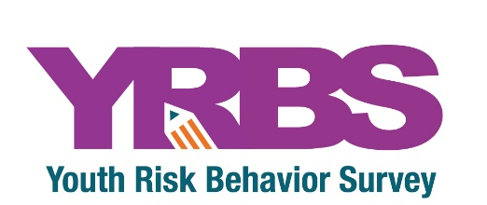

Instructions to be Read
When Distributing Permission Forms

Dear Teacher:

Please read this as you distribute the parental permission forms to encourage student participation in the [YEAR] National Youth Risk Behavior Survey. Thank you for your time and support!

Our class has been selected to participate in the [YEAR] National Youth Risk Behavior Survey conducted by the Centers for Disease Control and Prevention. By participating, you are taking part in an extremely important effort to understand the health and well-being of the Nation’s teens. This is an opportunity to make sure the voices of high school students are heard. YOUR voice matters and participating allows you to anonymously share your needs and concerns directly with adults, educators, and health officials. You will be asked questions about your health behaviors (such as nutrition, physical activity, and sleep routine), experiences (including emotional well-being and social media use), and general characteristics about yourself (such as your age, grade, and race/ethnicity). You will also be asked about sexual behaviors, and tobacco, alcohol, and drug use. Your participation is very important as you represent thousands of students around the country. Each of you will receive a parental permission form to take home for a parent or guardian to sign and check “yes” or “no.” Please bring this form back within three days. You must return this form to take part.

IF YOU DO NOT HAVE A SIGNED PARENTAL PERMISSION FORM, YOU MAY NOT PARTICIPATE.

Teachers: Please notify your principal or the YRBS survey coordinator at your school that you have handed out these permission forms.

