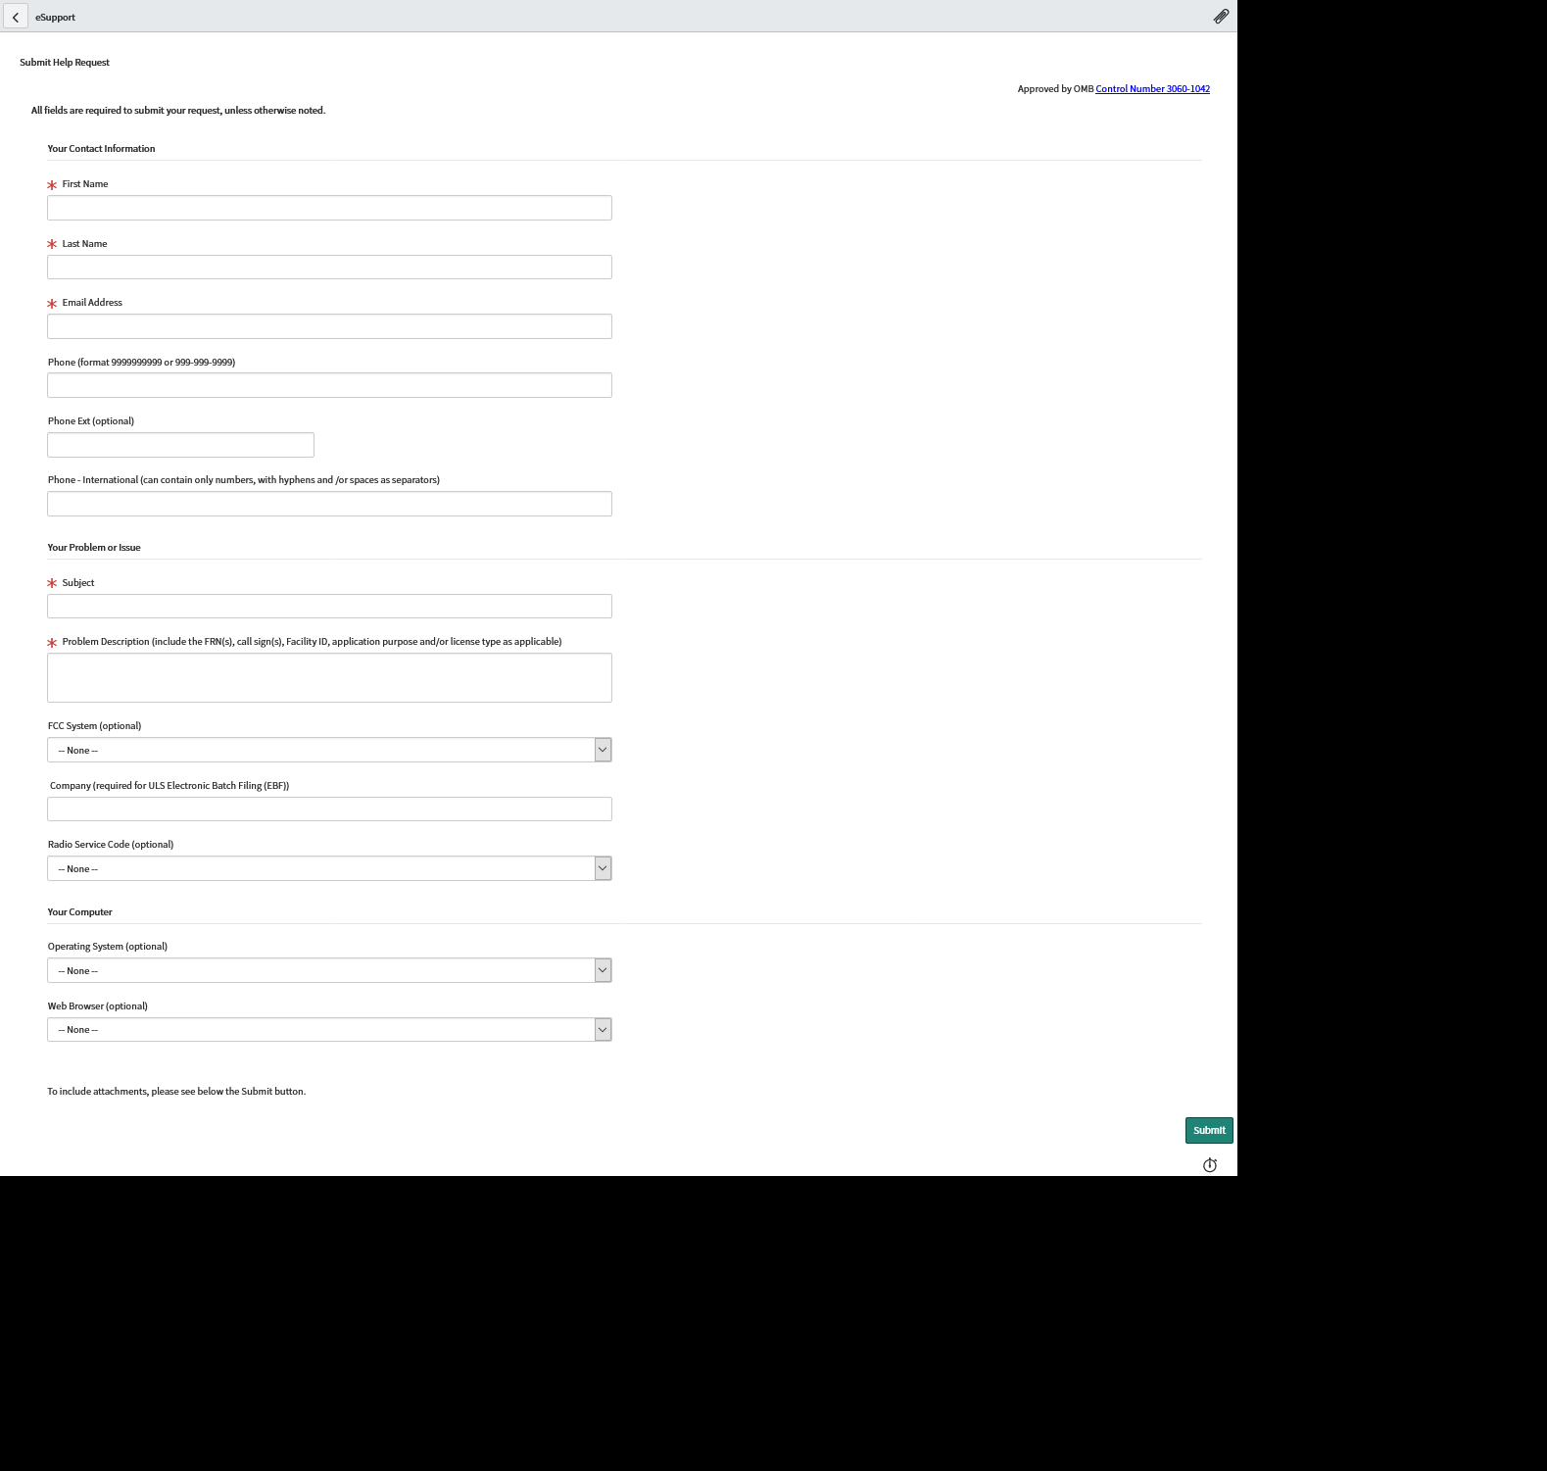
We propose to add the following text between the problem description and FCC System Fields

Please provide any upcoming filing date (i.e. call sign expiration date, required notification date, ect.):

