TITLE: Telehealth Emergency Medicine Survey Update
Working Draft, Pre-Decisional, Deliberative document – Internal VA Use Only


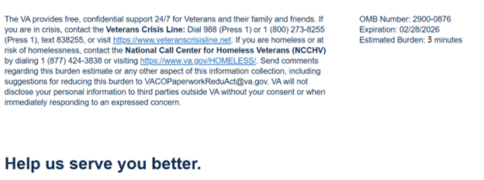

We want to hear about your recent Atlanta VA Medical Center Emergency Room (ER) visit. By indicating how much you agree or disagree with the statements below, you directly help us improve VA services.
This survey should take approximately 3 minutes to complete.
1. Which of the following influence your decision to utilize tele-emergency care? (Select all that apply. Required)
- I trust VA to take care of me.
- I was worried about receiving bills if I went to an ER in my community.
- It was more convenient.
- The distance to the nearest VAMC is too far.
- None of the above.
2. The process to be seen by a tele-emergency care provider was easy to follow. (Required)
- Strongly Disagree
- Disagree
- Neither Agree nor Disagree
- Agree
- Strongly Agree
3. The tele-emergency care provider listened to my concerns and showed they cared. (Required)
- Strongly Disagree
- Disagree
- Neither Agree nor Disagree
- Agree
- Strongly Agree
4. The tele-emergency care provider made it easy for me to understand my after-care instructions. (Required)
- Strongly Disagree
- Disagree
- Neither Agree nor Disagree
- Agree
- Strongly Agree
5. Overall, I was satisfied with the tele-emergency care service. (Required)
- Strongly Disagree
- Disagree
- Neither Agree nor Disagree
- Agree
- Strongly Agree
6. Based on this tele-emergency care visit, I trust tele-emergency care to serve me in the future. (Required)
- Strongly Disagree
- Disagree
- Neither Agree nor Disagree
- Agree
- Strongly Agree
7. Would you like to provide additional feedback about your tele-emergency care visit? (Select all that apply. Required)
- Compliment
- Concern
- Recommendation
- Will not provide additional feedback
8. Can VA contact you about your feedback? (Required)
- Yes, VA can contact me about my patient experience.
- No, I do not want VA to contact me about my patient experience.

Privacy Notice: By filling out this survey, you are authorizing VA database access to retrieve Veteran contact information to follow up with you accordingly for purposes of service recovery, potential crisis, or to learn more about feedback you have shared regarding your experience with VA. Your contact information and response may be referred to the Veterans Crisis Line if an automated review indicates your response may be concerning. The Veterans Crisis Line may contact you for follow up as a result of that referral. VA may utilize individual Veteran survey data from this survey or other sources to ensure the final scores truly and accurately represent the experiences of Veterans. This collection of information is authorized by 38 U.S.C. Section 301 (https://www.federalregister.gov/d/2021-01526).

Respondent Burden: An agency may not conduct or sponsor, and a person is not required to respond to, a collection of information unless it displays a currently valid OMB control number. The OMB control number for this project is 2900-0876, and it expires 02/28/2026. Public reporting burden for this collection of information is estimated to average 3 minutes per respondent, per year, including the time for reviewing instructions, searching existing data sources, gathering, and maintaining the data needed, and completing and reviewing the collection of information. Send comments regarding this burden estimate and any other aspect of this collection of information, including suggestions for reducing the burden, to VA Reports Clearance Officer at VACOPaperworkReduAct@va.gov. Please refer to OMB Control No. 2900-0876 in any correspondence. Do not send your completed VA Form to this email address.

