Receiving Education Benefits Survey
V4 DRAFT 12/6/2024
Working Draft, Pre-Decisional, Deliberative document – Internal VA Use Only


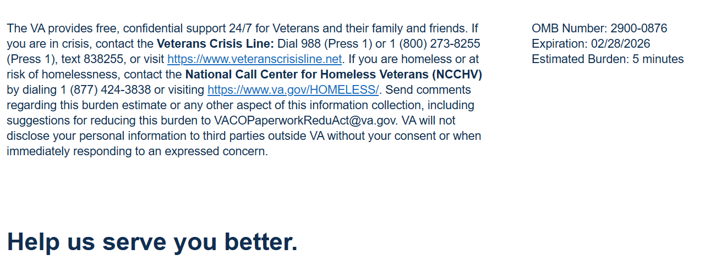

We want to hear about your experience with receiving education benefit payments from VA Education Service. By responding to this survey, you will directly help us improve, and provide better support to beneficiaries like you.

This voluntary survey should take approximately 5 minutes to complete.

[1] VA provides my educational benefits without difficulty.

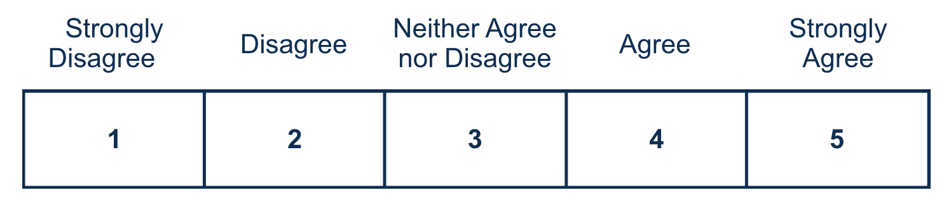

[2] I understood my education benefit may change based on my enrollment status.

[3] It was easy to find information about my educational benefits when needed.
[4] I sought assistance from the VA regarding my education benefits (Y/N) – if yes:
If response is ‘‘N” skip to Q5

[4a] VA provided effective assistance.
[5] The VA properly informed me of what to expect in regard to my issued payments.

[6] For GI Bill benefits, I trust Education Service to fulfill its commitment to Veterans, families, caregivers, and survivors.
Required

[7] Is there anything else you would like to share about your experience of receiving your educational benefits?

0/400



Privacy Notice: By filling out this survey, you are authorizing VA database access to retrieve Veteran contact information to follow up with you accordingly for purposes of service recovery, potential crisis, or to learn more about feedback you have shared regarding your experience with VA. Your contact information and response may be referred to the Veterans Crisis Line if an automated review indicates your response may be concerning. The Veterans Crisis Line may contact you for follow up as a result of that referral. VA may utilize individual Veteran survey data from this survey or other sources to ensure the final scores truly and accurately represent the experiences of Veterans. This collection of information is authorized by 38 U.S.C. Section 301. The Systems of Records Notice can be found here: https://www.federalregister.gov/d/2021-01526.
Respondent Burden: An agency may not conduct or sponsor, and a person is not required to respond to, a collection of information unless it displays a currently valid OMB control number. The OMB control number for this project is 2900-0876, and it expires 02/28/2026. Public reporting burden for this collection of information is estimated to average 5 minutes per respondent, per year, including the time for reviewing instructions, searching existing data sources, gathering, and maintaining the data needed, and completing and reviewing the collection of information. Send comments regarding this burden estimate and any other aspect of this collection of information, including suggestions for reducing the burden, to VA Reports Clearance Officer at VACOPaperworkReduAct@va.gov. Please refer to OMB Control No. 2900-0876 in any correspondence. Do not send your completed VA Form to this email address.

