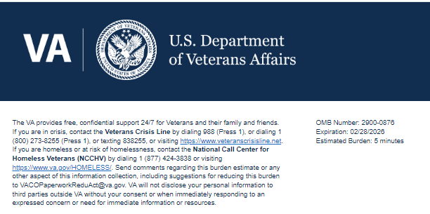
TITLE: Veterans Family and Community Engagement (VFCE) Veterans Engagement Action Center (VEAC) Email Survey

We want to hear about your experience with the VA Outreach Event. Your answers to these questions directly help us improve our services.
This voluntary survey should take approximately 5 minutes to complete.

- What best describes you as you're participating in this VA Outreach Event? Required
- Veteran
- Active Military/National Guard/ Reserve
- Family Member
- Caregiver
- Survivor

- Is this the first time you have interacted with VA? Required
- Yes
- No
- Unsure

3a. Do you currently receive VA health care services or VA benefits, such as compensation, pension, education, home loan, or pre-burial benefits? Required
Logic: Only displays if the answer to Q2 is 'No' or 'Unsure'
- Yes
- No
- Unsure

3b. Please indicate why you may not have interacted with VA. Please select all the following reasons that apply. Required
Logic: Only displays if the answer to Q2 is 'Yes' or 'Unsure'
- I did not know I was eligible for VA health care or benefits.
- I haven't had the time to look into VA health care or benefits.
- I did not wish to apply for any VA health care or benefits.
- I did not know how to apply for VA health care or benefits.
- Other

- Did you have any challenges during the VA Outreach Event? Please select all that apply. Required
- No challenges.
- Event time wasn't convenient.
- Parking was a challenge.
- Location wasn't convenient.
- My disabilities made it hard to attend.
- Making an appointment was difficult.
- Call wasn't conducted at the time I desired.
- Issues with calls (call went too long, too many transfers, too long to be connected to resource provider)
- Technical failures (dropped calls, audio problems)
- Other

- Please describe what challenge you had attending the VA Outreach Event. Please do not include any personally identifiable information such as Name, Social Security Number, Veteran ID, or medical information, but do provide details about your challenge. Required
Logic: Only displays if the answer to Q4 is 'Other'
[Free Text input]

- It was easy to get the information and/or services that I needed at the VA Outreach Event. Required
Strongly Disagree Disagree Neither Agree nor Disagree Agree Strongly Agree

- I was able to get my information and/or service support needs met at the VA Outreach Event. Required
Strongly Disagree Disagree Neither Agree nor Disagree Agree Strongly Agree

- I felt respected and valued during my participation at the VA Outreach Event. Required
Strongly Disagree Disagree Neither Agree nor Disagree Agree Strongly Agree

- I trust VA to fulfill our country’s commitment to Veterans. Required
Strongly Disagree Disagree Neither Agree nor Disagree Agree Strongly Agree

- I would recommend this VA Outreach Event to other Veterans. Required
Strongly Disagree Disagree Neither Agree nor Disagree Agree Strongly Agree

- What race/ethnicity do you identify with? Please select all that apply.
- American Indian or Alaska Native
- Asian
- Black or African American
- Hispanic or Latino
- Middle Eastern or North African
- Native Hawaiian or Pacific Islander
- White

- Would you like to provide additional feedback with a concern, compliment, or recommendation about your experience(s) with VA Outreach Event? Please select from one of the following options. Required
- Compliment
- Concern
- Recommendation
- Will not provide additional feedback.

- Use the text box below to enter details of the additional feedback (optional). Please do not include any personally identifiable information such as Name, Social Security Number, Veteran ID, or medical information, but do provide details about your experience.
Logic: Does not display when the answer to Q13 is 'Will not provide additional feedback'.
[Free text input]

Thank you for choosing VA.

The U.S. Department of Veterans Affairs uses these surveys to collect your feedback in order to continuously improve your experience with VA Services.
VA Burden Statement: An agency may not conduct or sponsor, and a person is not required to respond to, a collection of information unless it displays a currently valid OMB control number. The OMB control number for this project is 2900-0876, and it expires 02/28/2026. Public reporting burden for this collection of information is estimated to average 5 minutes per respondent, per year, including the time for reviewing instructions, searching existing data sources, gathering, and maintaining the data needed, and completing and reviewing the collection of information. Send comments regarding this burden estimate and any other aspect of this collection of information, including suggestions for reducing the burden, to VA Reports Clearance Officer at VACOPaperworkReduAct@va.gov. Please refer to OMB Control No. 2900-0876 in any correspondence. Do not send your completed VA Form to this email address.
Privacy Notice: By filling out this survey, you are authorizing VA database access to retrieve Veteran contact information to follow up with you accordingly for purposes of service recovery, potential crisis, or to learn more about feedback you have shared regarding your experience with VA. Your contact information and response may be referred to the Veterans Crisis Line if an automated review indicates your response may be concerning. The Veterans Crisis Line may contact you for follow up as a result of that referral. VA may utilize individual Veteran survey data from this survey or other sources to ensure the final scores truly and accurately represent the experiences of Veterans. This collection of information is authorized by 38 U.S.C. Section 301.

