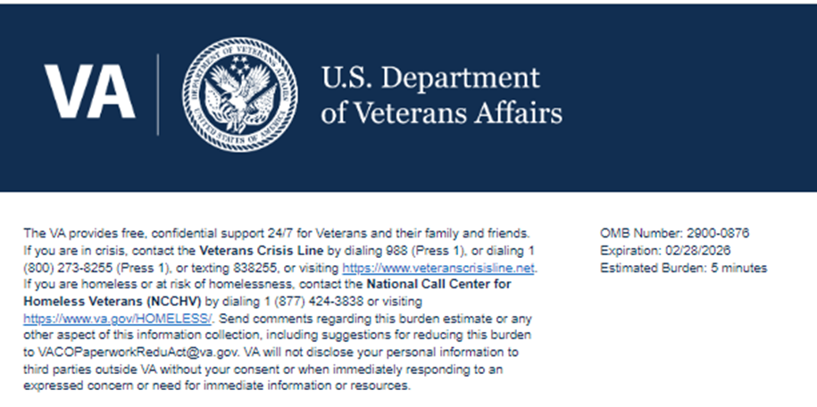
Title: Office of Small & Disadvantaged Business Utilization (OSDBU) Customer Service (CS) Survey

Help us serve you better.

Your opinion matters. We care about your time with VA. Please take this survey to let us know about your experience. The more information you share with us, the better we can serve you.

This voluntary survey should take you approximately 5 minutes to complete.

*Note: The survey path changes based on the Department selected in Question 1. There are 4 possible paths, each with 15 questions or fewer. All possible paths are included in this wireframe.

AST Survey
1. Which department did you interact with during your most recent experience with OSDBU?
- Acquisition Support Team (AST)
- Executive Front Office
- Shared Services Team (SST)
- Strategic Outreach and Communications (SOC)
2. I am satisfied with my most recent [Department pipe-in value] experience.
- Strongly Disagree
- Disagree
- Neutral
- Agree
- Strongly Agree
3. I received the service I needed from the [Department pipe-in value] team.
- Strongly Disagree
- Disagree
- Neutral
- Agree
- Strongly Agree
4. It was easy to get the service I needed from the [Department pipe-in value] team.
- Strongly Disagree
- Disagree
- Neutral
- Agree
- Strongly Agree
5. I felt like a valued customer with the [Department pipe-in value] team.
- Strongly Disagree
- Disagree
- Neutral
- Agree
- Strongly Agree
6. Would you like to provide a comment about the service you received?
- Yes
- No
7. How can the service provided to you be improved? Logic: Only displays if answer for Question 6 is “Yes”
- [Free-text response]
8. What was the most notable aspect of the service you received? Logic: Only displays if answer for Question 6 is “Yes”
- [Free-text response]
9. First Name Logic: Only displays if answer for Question 6 is “Yes”
- [Free-text response]
10. Last Name Logic: Only displays if answer for Question 6 is “Yes”
- [Free-text response]
11. Phone Number (10-digits, for example 9999999999) Logic: Only displays if answer for Question 6 is “Yes”
- [Free-text response]
12. Can VA contact you about your feedback? Logic: Only displays if answer for Question 6 is “Yes”
- Yes
- No
13. I trust VA to fulfill our country's commitment to Veterans.
- Strongly Disagree
- Disagree
- Neutral
- Agree
- Strongly Agree

EFO Survey
1. Which department did you interact with during your most recent experience with OSDBU?
- Acquisition Support Team (AST)
- Executive Front Office
- Shared Services Team (SST)
- Strategic Outreach and Communications (SOC)
2. Which program did you interact with during your most recent experience with the [Department pipe-in]?
- Admin/Operations (OPS)
- Human Resources (HR)
- Quality Assurance (QA)
- Deputy Director, Acquisition
- Executive Assistant to the Executive Director
3. I am satisfied with my most recent [Program Area pipe-in] experience.
- Strongly Disagree
- Disagree
- Neutral
- Agree
- Strongly Agree
4. Please select the specific services the [Program Area pipe-in] team provided to you from the list below (check all that apply). Logic: Dropdown selection based on Program selected in Question 2
- Admin/Operations (OPS):
  - Administrative Support
  - Financial / Budget Support
  - Space Management
  - Office Equipment / Supplies
  - Data Analytics / Power BI
  - G-Invoicing / IAAs
  - Other
- Human Resources (HR):
  - PIV Badge Sponsorship/ Inquiries
  - TMS/ Trainings (Talent Management System)
  - Onboarding (Federal and Contractors)
  - Out-processing (De-activating accounts)
  - Email Account Issues
  - HR Form inquires
  - Parking Pass Inquiries
  - Benefit Inquiries
  - Other
- Quality Assurance (QA):
  - Adhoc Reports
  - Audit
  - Corrective Actions
  - OSDBU Data
  - General Policies (Internal and External)
  - Standard Operating Procedures (SOP)
  - Other
5. I received the service I needed from the [Program Area pipe-in] team.
- Strongly Disagree
- Disagree
- Neutral
- Agree
- Strongly Agree
6. It was easy to get the service I needed from the [Program Area pipe-in] team.
- Strongly Disagree
- Disagree
- Neutral
- Agree
- Strongly Agree
7. I felt like a valued customer with the [Program Area pipe-in] team.
- Strongly Disagree
- Disagree
- Neutral
- Agree
- Strongly Agree
8. Would you like to provide a comment about the service you received?
- Yes
- No
9. How can the service provided to you be improved? Logic: Only displays if answer for Question 8 is “Yes”
- [Free-text response]
10. What was the most notable aspect of the service you received? Logic: Only displays if answer for Question 8 is “Yes”
- [Free-text response]
11. First Name Logic: Only displays if answer for Question 8 is “Yes”
- [Free-text response]
12. Last Name Logic: Only displays if answer for Question 8 is “Yes”
- [Free-text response]
13. Phone Number (10-digits, for example 9999999999) Logic: Only displays if answer for Question 8 is “Yes”
- [Free-text response]
14. Can VA contact you about your feedback? Logic: Only displays if answer for Question 8 is “Yes”
- Yes
- No
15. I trust VA to fulfill our country's commitment to Veterans.
- Strongly Disagree
- Disagree
- Neutral
- Agree
- Strongly Agree

SST Survey
1. Which department did you interact with during your most recent experience with OSDBU?
- Acquisition Support Team (AST)
- Executive Front Office
- Shared Services Team (SST)
- Strategic Outreach and Communications (SOC)
2. Which program did you interact with during your most recent experience with the [Department pipe-in]?
- Contract Management Team (CMT)
- IT System Integration (ITSI)
- OSDBU Call Center
- Veteran Status Validation
- Staff Assistant
- Primary Timekeeper
- Miscellaneous Support and Interactions
3. I am satisfied with my most recent [Program Area pipe-in] experience.
- Strongly Disagree
- Disagree
- Neutral
- Agree
- Strongly Agree
4. Please select the specific services the [Program Area pipe-in] team provided to you from the list below (check all that apply). Logic: Dropdown selection based on Program selected in Question 2
- Contract Management Team (CMT):
  - Contract Closeout
  - Contact Modification
  - Contractor Performance Assessment Reporting (CPAR)
  - Independent Government Cost Estimate (IGCE)/Performance Work Statement (PWS) support
  - Option Year Renewal
  - Technical Evaluation Support
  - RFI Announcement Support
  - Subcontracting Plan Reviews
  - Other
- IT System Integration (ITSI):
  - Customer Relationship Management (CRM)
  - Event Management Software as a Service (EMSS)
  - Fedmine
  - SharePoint
  - Web Portal
  - Training on OSDBU I.T. Tools
  - OSDBU I.T. Tool Trouble Ticket
  - Other
- Primary Timekeeper:
  - General GovTA Assistance
  - Timecards to include corrections
  - Tour of Duty Update
  - Assistance with submitting entries in GovTA
  - Other
- Miscellaneous Support and Interactions:
  - Freedom of Information Act (FOIA)
  - Records Management
  - Coordination on various reports
  - Other
5. I received the service I needed from the [Program Area pipe-in] team.
- Strongly Disagree
- Disagree
- Neutral
- Agree
- Strongly Agree
6. It was easy to get the service I needed from the [Program Area pipe-in] team.
- Strongly Disagree
- Disagree
- Neutral
- Agree
- Strongly Agree
7. I felt like a valued customer with the [Program Area pipe-in] team.
- Strongly Disagree
- Disagree
- Neutral
- Agree
- Strongly Agree
8. Would you like to provide a comment about the service you received?
- Yes
- No
9. How can the service provided to you be improved? Logic: Only displays if answer for Question 8 is “Yes”
- [Free-text response]
10. What was the most notable aspect of the service you received? Logic: Only displays if answer for Question 8 is “Yes”
- [Free-text response]
11. First Name Logic: Only displays if answer for Question 8 is “Yes”
- [Free-text response]
12. Last Name Logic: Only displays if answer for Question 8 is “Yes”
- [Free-text response]
13. Phone Number (10-digits, for example 9999999999) Logic: Only displays if answer for Question 8 is “Yes”
- [Free-text response]
14. Can VA contact you about your feedback? Logic: Only displays if answer for Question 8 is “Yes”
- Yes
- No
15. I trust VA to fulfill our country's commitment to Veterans.
- Strongly Disagree
- Disagree
- Neutral
- Agree
- Strongly Agree

SOC Survey
1. Which department did you interact with during your most recent experience with OSDBU?
- Acquisition Support Team (AST)
- Executive Front Office
- Shared Services Team (SST)
- Strategic Outreach and Communications (SOC)
2. Which program did you interact with during your most recent experience with the [Department pipe-in]?
- Training and Outreach
- Women Veteran-Owned Small Business Initiative (WVOSBI)
- Direct Access Program (DAP)
3. I am satisfied with my most recent [Program Area pipe-in] experience.
- Strongly Disagree
- Disagree
- Neutral
- Agree
- Strongly Agree
4. How did you interact with the [Program Area pipe-in] team?
- In-person
- Phone
- Email
- Online Chat
- Other (please specify)
5. I received the service I needed from the [Program Area pipe-in] team.
- Strongly Disagree
- Disagree
- Neutral
- Agree
- Strongly Agree
6. It was easy to get the service I needed from the [Program Area pipe-in] team.
- Strongly Disagree
- Disagree
- Neutral
- Agree
- Strongly Agree
7. I felt like a valued customer with the [Program Area pipe-in] team.
- Strongly Disagree
- Disagree
- Neutral
- Agree
- Strongly Agree
8. Would you like to provide a comment about the service you received?
- Yes
- No
9. How can the service provided to you be improved? Logic: Only displays if answer for Question 8 is “Yes”
- [Free-text response]
10. What was the most notable aspect of the service you received? Logic: Only displays if answer for Question 8 is “Yes”
- [Free-text response]
11. First Name Logic: Only displays if answer for Question 8 is “Yes”
- [Free-text response]
12. Last Name Logic: Only displays if answer for Question 8 is “Yes”
- [Free-text response]
13. Phone Number (10-digits, for example 9999999999) Logic: Only displays if answer for Question 8 is “Yes”
- [Free-text response]
14. Can VA contact you about your feedback? Logic: Only displays if answer for Question 8 is “Yes”
- Yes
- No
15. I trust VA to fulfill our country's commitment to Veterans.
- Strongly Disagree
- Disagree
- Neutral
- Agree
- Strongly Agree

Thank you for choosing VA.

The U.S. Department of Veterans Affairs uses these surveys to collect your feedback in order to continuously improve your experience with VA Services.
VA Burden Statement: An agency may not conduct or sponsor, and a person is not required to respond to, a collection of information unless it displays a currently valid OMB control number. The OMB control number for this project is 2900-0876, and it expires 02/28/2026. Public reporting burden for this collection of information is estimated to average 5 minutes per respondent, per year, including the time for reviewing instructions, searching existing data sources, gathering, and maintaining the data needed, and completing and reviewing the collection of information. Send comments regarding this burden estimate and any other aspect of this collection of information, including suggestions for reducing the burden, to VA Reports Clearance Officer at VACOPaperworkReduAct@va.gov. Please refer to OMB Control No. 2900-0876 in any correspondence. Do not send your completed VA Form to this email address.
Privacy Notice: By filling out this survey, you are authorizing VA database access to retrieve Veteran contact information to follow up with you accordingly for purposes of service recovery, potential crisis, or to learn more about feedback you have shared regarding your experience with VA. Your contact information and response may be referred to the Veterans Crisis Line if an automated review indicates your response may be concerning. The Veterans Crisis Line may contact you for follow up as a result of that referral. VA may utilize individual Veteran survey data from this survey or other sources to ensure the final scores truly and accurately represent the experiences of Veterans. This collection of information is authorized by 38 USC Section 301.

