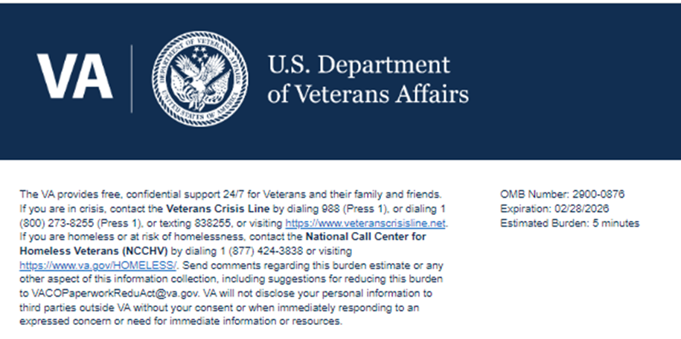
Title: Office of Small & Disadvantaged Business Utilization (OSDBU) Lunch "N" Learn Survey

Help us serve you better.

Your opinion matters. We care about your time with VA. Please take this survey to let us know about your experience. The more information you share with us, the better we can serve you.

This voluntary survey should take you approximately 5 minutes to complete.

1. Overall, I am satisfied with the Lunch "N" Learn.
- Strongly Disagree
- Disagree
- Neither Agree nor Disagree
- Agree
- Strongly Agree
2. How did you attend the Lunch "N" Learn?
- In Person
- Virtual
3. The information I received at the Lunch "N" Learn met my expectations.
- Strongly Disagree
- Disagree
- Neither Agree nor Disagree
- Agree
- Strongly Agree
4. The information presented at the Lunch "N" Learn was understandable.
- Strongly Disagree
- Disagree
- Neither Agree nor Disagree
- Agree
- Strongly Agree
5. The information presented at the Lunch "N" Learn was useful to me.
- Strongly Disagree
- Disagree
- Neither Agree nor Disagree
- Agree
- Strongly Agree
6. Would you like to provide a comment about the service you received?
Please leave your comments to the following questions in the spaces provided. We are requesting your contact information [name, phone number, permission to contact] so we may provide assistance should your responses indicate you are in a state of crisis. If your responses do not indicate you are in need of crisis assistance, you will not be contacted. Please do not include PII, SSN, Vet ID, or other personal information.
- Yes
- No
7. First Name Logic: Only displays if the answer for Question 6 is “Yes”
- [Free-text response]
8. Last Name Logic: Only displays if the answer for Question 6 is “Yes”
- [Free-text response]
9. Phone Number (10-digits, for example 9999999999) Logic: Only displays if the answer for Question 6 is “Yes”
- [Free-text response]
10. Can VA contact you about your feedback? Logic: Only displays if the answer for Question 6 is “Yes”
- Yes
- No

Thank you for choosing VA.

The U.S. Department of Veterans Affairs uses these surveys to collect your feedback in order to continuously improve your experience with VA Services.
VA Burden Statement: An agency may not conduct or sponsor, and a person is not required to respond to, a collection of information unless it displays a currently valid OMB control number. The OMB control number for this project is 2900-0876, and it expires 02/28/2026. Public reporting burden for this collection of information is estimated to average 5 minutes per respondent, per year, including the time for reviewing instructions, searching existing data sources, gathering, and maintaining the data needed, and completing and reviewing the collection of information. Send comments regarding this burden estimate and any other aspect of this collection of information, including suggestions for reducing the burden, to VA Reports Clearance Officer at VACOPaperworkReduAct@va.gov. Please refer to OMB Control No. 2900-0876 in any correspondence. Do not send your completed VA Form to this email address.

