

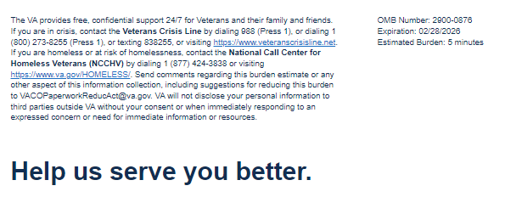
We want to hear about your experiences with your treatment for ALS. By responding to this survey, you will directly help us improve the quality of care the VA provides Veterans with ALS.
This voluntary survey should take you approximately 5 minutes to complete.

Where do you receive your ALS Care? (Select only one option) Required

- VA
- Community Provider
- Both

Which of the following ALS symptoms do you have and are being treated for? (Select all that apply)

Symptom | I have these Symptom(s) | I have received treatment for these Symptom(s)
Muscle Weakness
Muscle Cramps
Twitching
Stiff Muscles
Speech Challenges
Trouble Swallowing
Drooling
Involuntary Emotional expressions
Fatigue
Trouble breathing or shortness of breath
Insomnia
Constipation
Urinary Difficulty
Stomach pain, Nausea, bloating, or fullness
Pain

<Logic only display if Veteran selects Community Provider or both> Why might you choose to get treated for ALS at a community medical facility as opposed to VA? (Select all that apply)

- I am treated with courtesy and respect
- I don’t trust VA in general
- I am familiar with the community medical facility
- I trust the community medical facility to provide comprehensive ALS treatment
- I have more options for appointment dates/times
- The process of scheduling appointments is easier
- Close to my home/easy to get to
- Continuity of care from provider who initially diagnosed me
- I am not familiar with the VA healthcare benefits (e.g. equipment, medication management) that I’m entitled to for my ALS care

I have experienced barriers in accessing the following related to my ALS care. (Select all that apply)

- Scheduling a VA clinical appointment
- Medications/Prescriptions
- Equipment
- Specialty referrals
- Home Care Services
- Support for my Caregiver
- Mental Health Support
- Transportation
- Lodging
- Telehealth care
- Delay in receiving Disability Compensation Benefits
- N/ A have not encountered any barriers

My ALS care team and/or Veteran Service Officer (VSO) provided me with information regarding the following (Select all that apply)

- Research Opportunities
- Home Modifications
- Equipment
- Vehicle Grant
- Monthly VA Disability Compensation payments
- Caregiver Support
- Planning for Future Care Needs
- Genetic Testing
- N/A

What would you like prioritized most related to your ALS care? (Rank all that apply)
- Symptom Management
- Access to Assistive Devices
- Quality of Life Support
- Coordination of Care
- Access to Clinical Trials and Research
- Home Care Services
- Support for my Caregiver
- Mental Health Support
- Information about VA benefits that I am entitled to for ALS (i.e. Equipment, medication management, disability compensation, special adaptive housing grants)

I know where to access information about VA ALS care and benefits online.
- Strongly Disagree
- Disagree
- Neither Disagree nor Agree
- Agree
- Strongly Agree

<Logic Only display if in VA Care or both> My VA ALS care is coordinated (e.g. appointments, medications, equipment and specialty referrals).

- Strongly Disagree
- Disagree
- Neither Disagree nor Agree
- Agree
- Strongly Agree

<Logic Only display if Community Provider> My ALS care is coordinated. (e.g. appointments, medications, equipment and specialty referrals).

- Strongly Disagree
- Disagree
- Neither Disagree nor Agree
- Agree
- Strongly Agree

<Logic Only display if in VA Care or both> I receive ALS support from my ALS care team in a reasonable amount of time.

- Strongly Disagree
- Disagree
- Neither Disagree nor Agree
- Agree
- Strongly Agree

My personal preferences (i.e. cultural and/or spiritual) are considered during my ALS treatment to address my needs.

- Strongly Disagree
- Disagree
- Neither Disagree nor Agree
- Agree
- Strongly Agree

My ALS Care team communicates in a way that I understand.

- Strongly Disagree
- Disagree
- Neither Disagree nor Agree
- Agree
- Strongly Agree

My ALS care team takes time to understand my goals and preferences and assists in documenting in Advance Care Directive.

- Strongly Disagree
- Disagree
- Neither Disagree nor Agree
- Agree
- Strongly Agree

<Logic Only display if in VA Care or both> I am satisfied with the care I receive from the VA for ALS.

- Strongly Disagree
- Disagree
- Neither Disagree nor Agree
- Agree
- Strongly Agree

I trust VA ALS Care team to fulfill its commitment to Veterans, families, caregivers, and survivors. Required

- Strongly Disagree
- Disagree
- Neither Disagree nor Agree
- Agree
- Strongly Agree

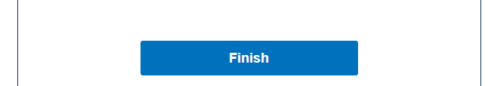
VA Burden Statement: An agency may not conduct or sponsor, and a person is not required to respond to, a collection of information unless it displays a currently valid OMB control number. The OMB control number for this project is 2900-0876, and it expires 02/28/2026. Public reporting burden for this collection of information is estimated to average 5 minutes per respondent, per year, including the time for reviewing instructions, searching existing data sources, gathering, and maintaining the data needed, and completing and reviewing the collection of information. Send comments regarding this burden estimate and any other aspect of this collection of information, including suggestions for reducing the burden, to VA Reports Clearance Officer at VACOPaperworkReduAct@va.gov. Please refer to OMB Control No. 2900-0876 in any correspondence. Do not send your completed VA Form to this email address.
Privacy Notice: By filling out this survey, you are authorizing VA database access to retrieve Veteran contact information to follow up with you accordingly for purposes of service recovery, potential crisis, or to learn more about feedback you have shared regarding your experience with VA. Your contact information and response may be referred to the Veterans Crisis Line if an automated review indicates your response may be concerning. The Veterans Crisis Line may contact you for follow up as a result of that referral. VA may utilize individual Veteran survey data from this survey or other sources to ensure the final scores truly and accurately represent the experiences of Veterans. This collection of information is authorized by 38 USC Section 301.

