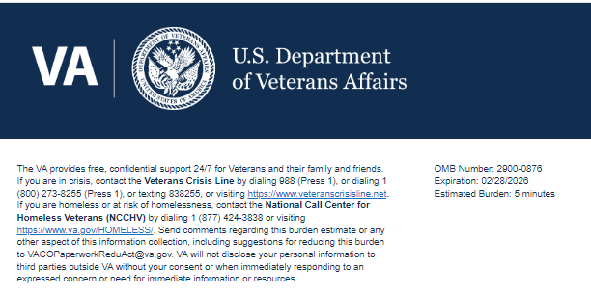
We want to hear about your experience with your Community Living Center. By responding
to this survey, you will directly help us improve the services we provide to CLC residents like
you. VA wants to provide you with the best possible living experiences!

This voluntary survey should take approximately 2 minutes to complete.

- Are you a Spinal Cord Injury and Disorders (SCI/D) resident? Required [Logic: Display only for CLCs with an SCI/D section: Louis Stokes Cleveland Department of Veterans Affairs Medical Center, OH (541), Brockton VA Medical Center, MA (523A5), Hampton VA Medical Center, VA (590), Tibor Rubin VA Medical Center, CA (600), & James A. Haley Veterans' Hospital, FL (673)]
  - Yes
  - No

- I feel like the staff really listen to me here.
  - Strongly Disagree
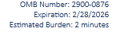
  - Disagree
  - Neither Agree nor Disagree
  - Agree
  - Strongly Agree

- If I have a problem, I feel comfortable speaking up.
  - Strongly Disagree
  - Disagree
  - Neither Agree nor Disagree
  - Agree
  - Strongly Agree

- This CLC feels home-like to me.
  - Strongly Disagree
  - Disagree
  - Neither Agree nor Disagree
  - Agree
  - Strongly Agree

- I’m getting good quality care here.
  - Strongly Disagree
  - Disagree
  - Neither Agree nor Disagree
  - Agree
  - Strongly Agree

- I trust VA CLC to take care of me. Required
  - Strongly Disagree
  - Disagree
  - Neither Agree nor Disagree
  - Agree
  - Strongly Agree

- CLC can contact me about my experience to learn more about the feedback you provided to improve your experience.
  - Yes [Logic proceed to question #7]
  - No [Logic proceed to question #8]

- Please provide your last name and date of birth so our staff can identify you to contact you about your experience:
Last Name: Required [Logic: Display and make required if question #7 is yes]
Date of Birth: Required [Logic: Display and make required if question #7 is yes]

- Would you like to volunteer your demographic information to help VA better serve you?
  - Yes [Logic proceed to Demographics page]
  - No [Logic skip Demographics page]

Next

Help VA improve its services.

We are working to better understand our customers. The following questions are voluntary. Your responses can help us improve VA care and services. Thank you for your participation.

- What is your age?
  - <30
  - 30-39
  - 40-49
  - 50-59
  - 60-69
  - 70-79
  - 80-89
  - 90+

- How would you describe your race? Please select all that apply.
  - American Indian or Alaska Native
  - Asian
  - Black or African American
  - Native Hawaiian or Pacific Islander
  - White
  - Middle Eastern or North African

- Are you Hispanic or Latino?
  - Yes
  - No

- How would you describe your gender? Please select all that apply.
  - Male
  - Female
  - Transgender
  - Non-Binary/Third Gender
  - Prefer not to say [Logic: when Prefer not to say is selected, no other option can be selected in the question]
  - Other

Submit
VA Burden Statement: An agency may not conduct or sponsor, and a person is not required to respond to, a collection of information unless it displays a currently valid OMB control number. The OMB control number for this project is 2900-0876, and it expires 02/28/2026. Public reporting burden for this collection of information is estimated to average 2 minutes per respondent, per year, including the time for reviewing instructions, searching existing data sources, gathering, and maintaining the data needed, and completing and reviewing the collection of information. Send comments regarding this burden estimate and any other aspect of this collection of information, including suggestions for reducing the burden, to VA Reports Clearance Officer at VACOPaperworkReduAct@va.gov. Please refer to OMB Control No. 2900-0876 in any correspondence. Do not send your completed VA Form to this email address.
Privacy Notice: By filling out this survey, you are authorizing VA database access to retrieve Veteran contact information to follow up with you accordingly for purposes of service recovery, potential crisis, or to learn more about feedback you have shared regarding your experience with VA. Your contact information and response may be referred to the Veterans Crisis Line if an automated review indicates your response may be concerning. The Veterans Crisis Line may contact you for follow up as a result of that referral. VA may utilize individual Veteran survey data from this survey or other sources to ensure the final scores truly and accurately represent the experiences of Veterans. This collection of information is authorized by 38 U.S.C. Section 301.

