Personalized Career Planning and Guidance Survey
V3 DRAFT 10/25/2024
Working Draft, Pre-Decisional, Deliberative document – Internal VA Use Only


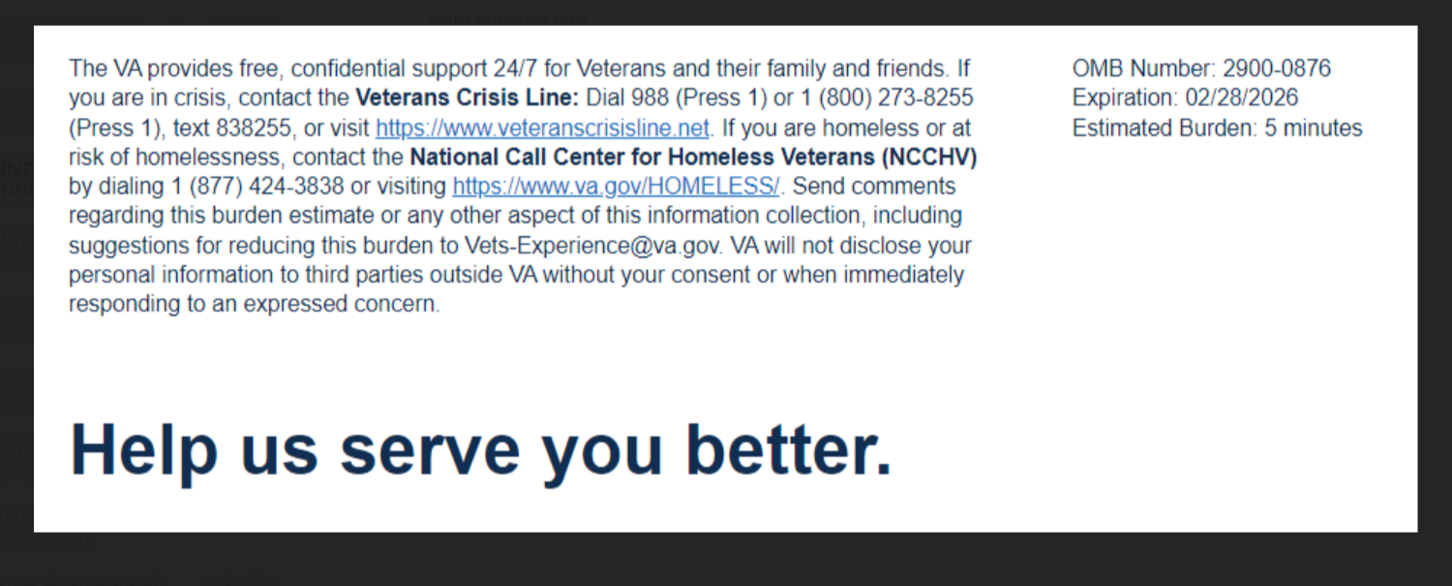

We want to hear about your experience with the Personalized Career Planning and Guidance program/Chapter 36 (PCPG/CH36).
PCPG/CH36 services include:
- Career choice assistance
- Educational and employment plans
- Academic and adjustment counseling
- VA benefit coaching
- Resume writing
- Interview skills

By responding to this survey, you will directly help us improve the services we provide!

This voluntary survey should take approximately 5 minutes to complete.

[1] Please let us know which PCPG/CH36 services you have used. (Select all that apply)
  - Education & Career Assessment Services (Interview, Intake, Assessment, Benefit Utilization, Occupational Selection, and Counseling Collaboration)
  - Employment Services (Resume Development, Labor Market Research, Employment Resources, and Job Seeking Skills Development)
  - Educational Services (Educational Benefits Reviews, Training Major(s) and/or Programs, and Identifying Training Facilities and/or Schools)
  - Educational & Career Counseling Services (Additional Supplemental Counseling Support Services)

[2] The process of applying for my PCPG/CH36 benefit was easy.
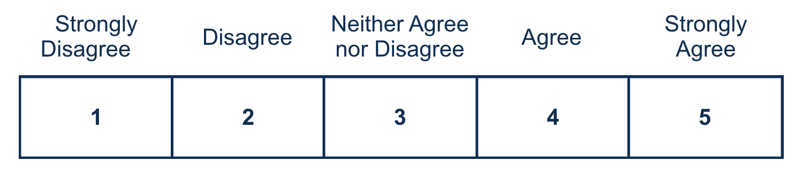
[3] The counselor I met with treated me with dignity and respect.
[4] The PCPG/CH36 Next Steps Checklist was easy to understand.
[5] The career counseling services I received allowed me to choose a suitable vocational goal compatible with my interests and abilities. [This question only appears if Educational and Career Counseling Services are selected in Q1]
[6] The PCPG/CH36 services I received provided me with information on how to effectively use my educational benefits (e.g., Post 9/11 G.I. Bill Chapter 33, Montgomery G.I. Bill Chapter 30, Survivors’ and Dependents’ Educational Assistance Program Chapter 35, etc.). [This question only appears if ‘Educational Services’ is selected in Q1]
[7] After receiving PCPG/CH36 services I now understand my career options based on my interests and abilities. [This question only appears if ‘Employment Services’ is selected in Q1]
[8] After receiving PCPG/CH36 services I now understand my educational options based on my interests and abilities. [This question only appears if ‘Educational Services’ is selected in Q1]
[9] I am satisfied with the PCPG/CH36 services I received.

[10] I trust PCPG/CH36 to administer education and employment services. [Required]


VA Burden Statement: An agency may not conduct or sponsor, and a person is not required to respond to, a collection of information unless it displays a currently valid OMB control number. The OMB control number for this project is 2900-0876, and it expires 02/28/2026. Public reporting burden for this collection of information is estimated to average 5 minutes per respondent, per year, including the time for reviewing instructions, searching existing data sources, gathering, and maintaining the data needed, and completing and reviewing the collection of information. Send comments regarding this burden estimate and any other aspect of this collection of information, including suggestions for reducing the burden, to VA Reports Clearance Officer at VACOPaperworkReduAct@va.gov. Please refer to OMB Control No. 2900-0876 in any correspondence. Do not send your completed VA Form to this email address.
Privacy Notice: By filling out this survey, you are authorizing VA database access to retrieve Veteran contact information to follow up with you accordingly for purposes of service recovery, potential crisis, or to learn more about feedback you have shared regarding your experience with VA. Your contact information and response may be referred to the Veterans Crisis Line if an automated review indicates your response may be concerning. The Veterans Crisis Line may contact you for follow up as a result of that referral. VA may utilize individual Veteran survey data from this survey or other sources to ensure the final scores truly and accurately represent the experiences of Veterans. This collection of information is authorized by Executive Order 14058 on Transforming Federal Customer Experience and Service Delivery to Rebuild Trust in Government.

