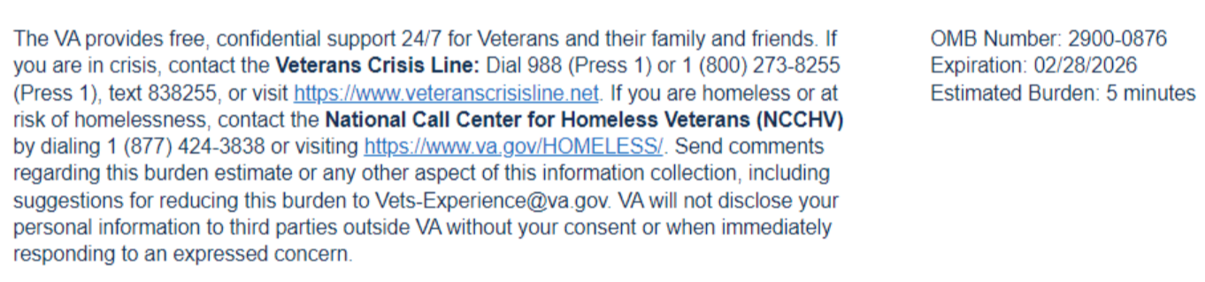
Estimated Burden 3 minutes
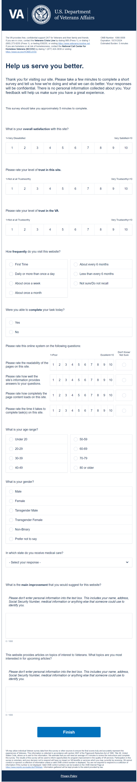
This voluntary survey should take approximately 3 minutes to complete.

1. I easily found what I needed in my after-visit summary. Required
o 1 Strongly Disagree
o 2 Disagree
o 3 Neither Disagree or Agree
o 4 Agree
o 5 Strongly Agree
2. I am satisfied with the time it took to review my after-visit summary. Required
o 1 Strongly Disagree
o 2 Disagree
o 3 Neither Disagree or Agree
o 4 Agree
o 5 Strongly Agree
3. I found the terminology easy to understand. Required
o 1 Strongly Disagree
o 2 Disagree
o 3 Neither Disagree or Agree
o 4 Agree
o 5 Strongly Agree

4. I found the information was accurate on my after-visit summary. Required

o 1 Strongly Disagree
o 2 Disagree
o 3 Neither Disagree or Agree
o 4 Agree
o 5 Strongly Agree
5. Please select your age range:
o Under 20 years old
o 20-29 years old
o 30-39 years old
o 40-49 years old
o 50-59 years old
o 60-69 years old
o Over 70 years old
6. How can we make this experience better? In the box below, please tell us what you would like to change or add to make this experience more useful and enjoyable.

7. How did this interaction (AVS) change your trust in Veteran Affairs? Required
o Decreased my trust
o Somewhat decreased my trust
o Neither increased nor decreased my trust
o Somewhat increased my trust
o Increased my trust

- How much do you trust Veteran Affairs to fulfill our country’s commitment to Veterans? Required
- High level of distrust
- Modest level of distrust
- Neither trust or distrust
- Modest level of trust
- High level of trust

