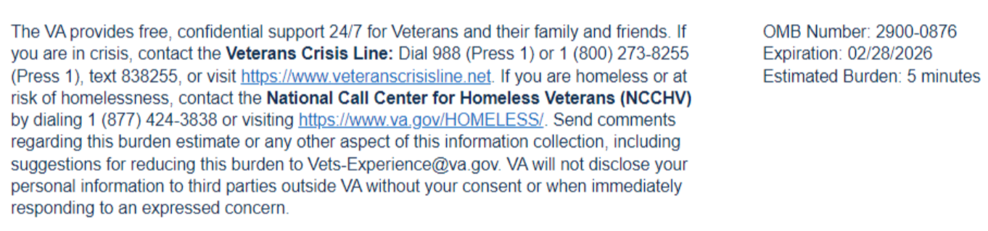
Estimated Burden 3 minutes
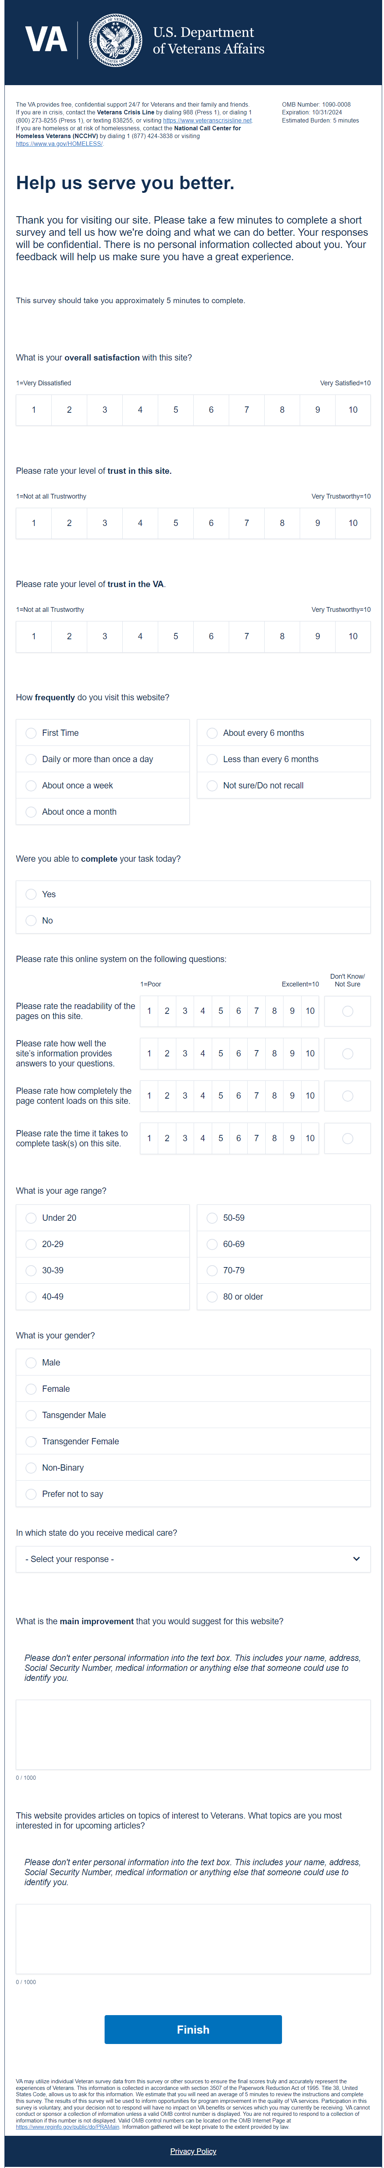

- Were you able to complete your task today?
  - Yes
  - No
- Please rate your experience with this site today.
  - Very bad
  - Somewhat bad
  - Neither good nor bad
  - Somewhat good
  - Very good
- Why did you select that rating?
  - Open text
- What is your overall satisfaction with this site?
  - Not at all satisfied
  - Dissatisfied
  - Neither Satisfied or Dissatisfied
  - Satisfied
  - Very Satisfied
- How did this interaction change your trust in Veteran Affairs?
  - Decreased my trust
  - Somewhat decreased my trust
  - Neither increased nor decreased my trust
  - Somewhat increased my trust
  - Increased my trust
- How much do you trust Veteran Affairs to fulfill our country’s commitment to Veterans?
  - High level of distrust
  - Modest level of distrust
  - Neither trust or distrust
  - Somewhat increased my trust
  - Increased my trust
- Please rate how understandable this site's information is.
  - 1 = Poor
  - 2
  - 3
  - 4
  - 5 = Excellent
- Please rate how well the site's information provides answers to your questions.
  - 1 = Poor
  - 2
  - 3
  - 4
  - 5 = Excellent
- Please rate how completely the page content loads on this site.
  - 1 = Poor
  - 2
  - 3
  - 4
  - 5 = Excellent
- How frequently do you visit this website?
  - First time
  - Daily or more than once a day
  - About once a week
  - About once a month
  - About every 6 months
  - Less than every 6 months
  - Not sure/ do not recall
- What is your age range?
  - Under 20
  - 20-29
  - 30-39
  - 40-49
  - 50-59
  - 60-69
  - 70-79
  - 80 or older
- What is your gender?
  - Male
  - Female
  - Transgender Male
  - Transgender Female
  - Non-Binary
  - Prefer not to say
- In which state do you receive medical care?
  - Dropdown list
- Which Medical Center in ____ did you visit?
  - Dropdown list
- This website provides articles on topics of interest to Veterans. What topics are you most interested in for upcoming articles?
3

