Blind Rehabilitation Survey
V3 DRAFT 5/22/2024
Working Draft, Pre-Decisional, Deliberative document – Internal VA Use Only


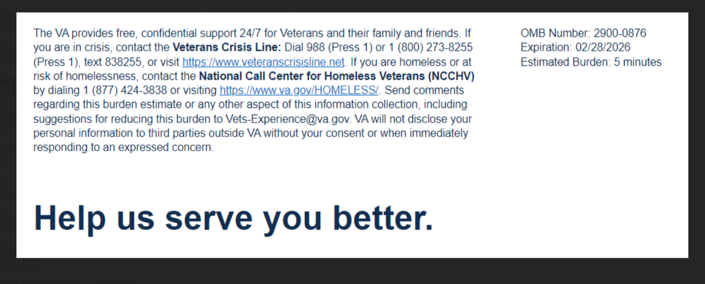

We want to hear about your experience regarding your most recent VA Blind and Low Vision Rehabilitation appointment. By indicating how much you agree or disagree with the statements below, you directly help us improve VA services!

This voluntary survey should take approximately 5 minutes to complete.

[1] How did you learn about Blind and Low Vision Rehabilitation Services? (Select all that apply)
  - Another VA provider
  - I received a call from the VA
  - I received a mailing from the VA
  - I called the VA
  - I found information on VA.gov
  - A family member or friend told me
  - Another Veteran told me
  - A nonprofit organization
  - I attended an outreach event
  - Other (Please Specify) ______________
[2] My Blind and Low Vision Rehabilitation appointments were scheduled on days and times that worked for me.
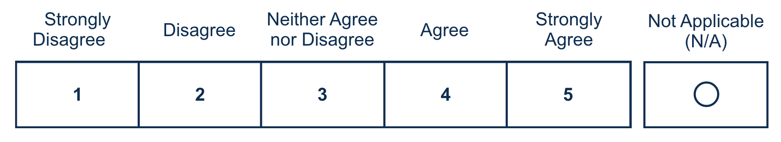

[3] Transportation options were available to me to attend Blind and Low Vision Rehabilitation training appointments. (Select only one option) Required
  - Yes, Always
  - Yes, but unreliable
  - No, Never
  - Not Applicable (N/A)
[4] My provider modified my rehabilitation with accommodations specific to my vision impairment. Required
[5] My personal preferences were considered during vision rehabilitation training to address my needs.
[6] Efforts were made to have, my family, friends, and/or caregivers participate in my training. Required

[7] My Blind and Low Vision Rehabilitation team focused on my goals and what matters most to me. Required
[8] I had enough time to complete my Blind and Low Vision Rehabilitation training.
[9] I am using the devices issued to me from Blind and Low Vision Rehabilitation Service (example: magnifier, talking device, technology, etc.) (Select only one option) Required
  - Yes
  - No (Please specify) ___________________
  - N/A

[10] I know who to contact if I need help with my auditory needs. Required
[11] I trust Blind and Low Vision Rehabilitation Services for my vision rehabilitation needs. Required

[12] Would you like to provide additional feedback with a concern, compliment, or recommendation about your experience(s) with Blind and Low Vision Rehabilitation Services? Please select from one of the following options.
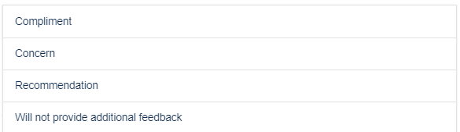

[13] Use the text box below to enter details of the additional feedback (optional). Please do not include any personally identifiable information, Social Security Number, Veteran ID, or medical information, but do provide details about your experience.
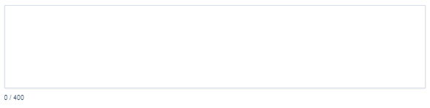

[14] Can VA contact you about your feedback? Required
