Survivor Survey
V5 DRAFT 5/7/2024
Working Draft, Pre-Decisional, Deliberative document – Internal VA Use Only


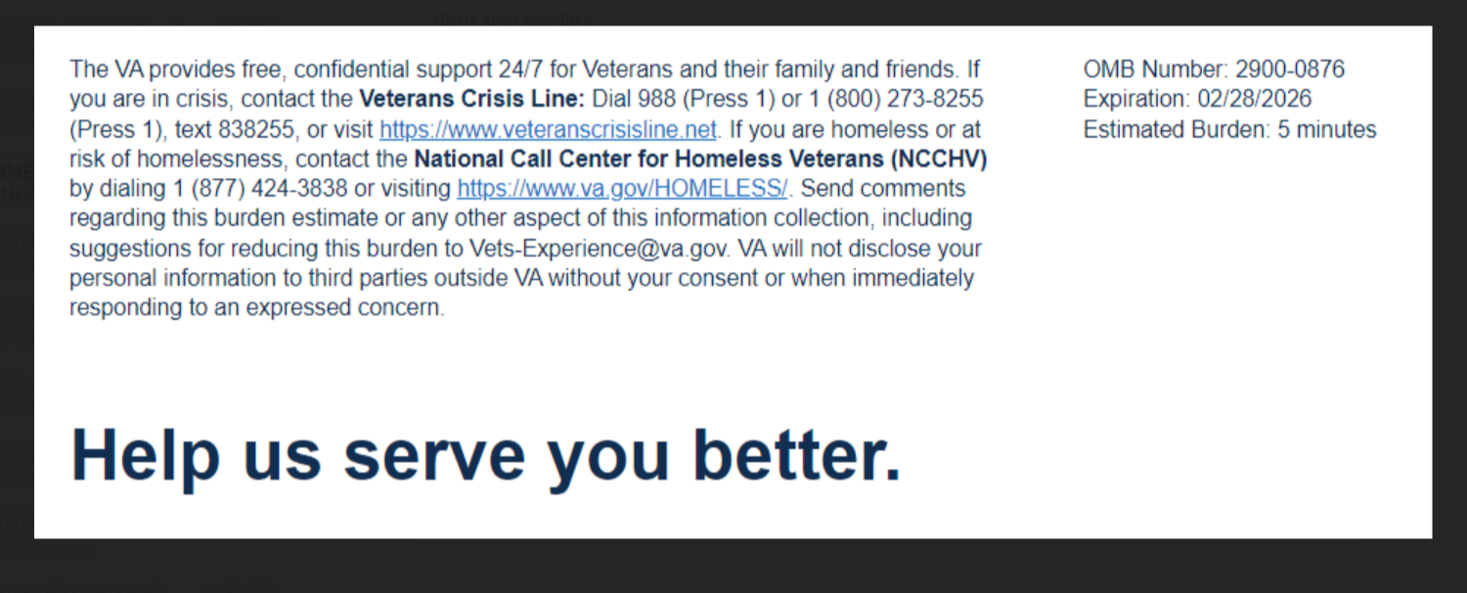

Thank you for joining us at this event. We want to hear about your experience with applying for and receiving your VA survivor benefits and services. By responding to this survey, you will directly help us improve the services we provide!

This voluntary survey should take approximately 5 minutes to complete.

[1] Survivors may be eligible for a wide variety of benefits and services. Please let us know which services or benefits you have used. (Select all that apply)
  - Health Care
  - Education
  - Employment
  - Home Loans
  - Life Insurance
  - Burial
  - Dependency and Indemnity Compensation (DIC)
  - Pension

[2] The VA Office of Survivor Assistance serves as a resource regarding all benefits and services furnished to survivors of deceased Veterans. Did you contact the VA Office of Survivor Assistance to learn more about Survivor benefits and services?
  - Yes
  - No
  - I was unaware that there was a VA Office of Survivor Assistance

[3] I am satisfied with the service I received from the VA Office of Survivor Assistance. [Question skipped if “No” or “I was unaware that there was a VA Office of Survivor Assistance.” was selected for question 2.]
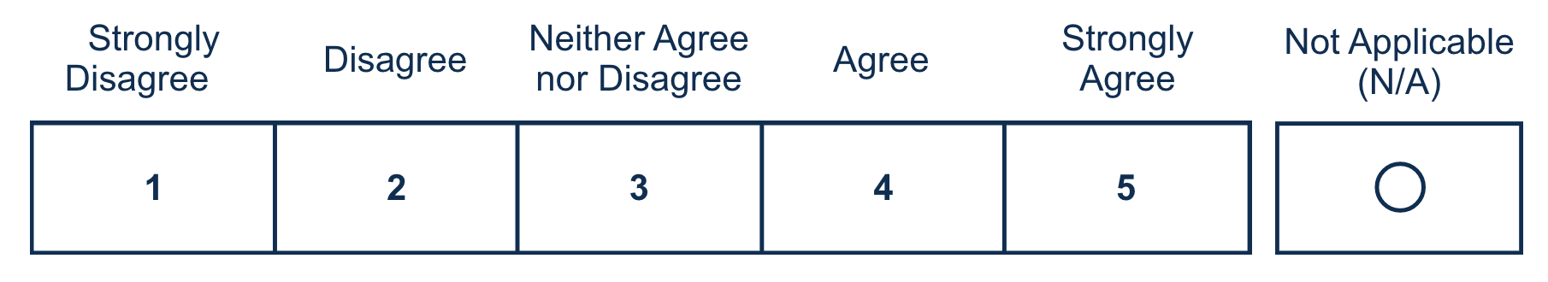
[4] Regarding survivor benefits and services, what would be the most effective method of communication from the VA?
  - Email
  - Mail
  - Telephone
  - Text

[5] What was the status of your Veteran when they died?
  - Active Duty Service Member
  - National Guard/Reserve
  - Veteran
  - Not Applicable (N/A)

[6] Overall, I found the process of applying for survivors benefits and services to be easy.

[7] If you learned about survivors benefits and services through independent research, what sources did you use? (Select all that apply)
  - VA.gov or benefits.va.gov websites
  - Spouse and/or family member
  - Friend
  - Social Media (e.g. Facebook, LinkedIn)
  - Veterans Service Organization (e.g. Veterans of Foreign Wars, The American Legion)
  - Tragedy Assistance Program for Survivors (TAPS)
  - I did not learn about benefits and services through independent research [Add error message if they select "I did not learn about benefits and services through independent research" with other answer options - Error: “I did not learn about benefits and services through independent research” may not be selected with any other answers.]
  - Other [If selected a free text will appear]

[8] Please indicate who you relied upon most to file your DIC and/or pension claim.
  - National Call Center
  - VA Office of Survivor Assistance
  - VA Regional Office
  - State Veterans Affairs Office
  - County Veterans Service Officer
  - Veterans Service Organization (e.g. Veterans of Foreign Wars, The American Legion)
  - Casualty Assistance Officer
  - Tragedy Assistance Program for Survivors (TAPS)
  - Other [If selected a free text will appear]
  - Not Applicable (N/A)

[9] Please tell us how long it took for your DIC and/or pension to be approved.
  - Less than 60 days
  - 61 to 90 days
  - 91 to 120 days
  - More than 120 days
  - Not Applicable (N/A)
[10] After my Veteran’s death was reported to the VA, I received information on survivors benefits and services.

[11] At today’s event, the VA employee I communicated with treated me with respect.
[12] At today’s event, the VA employee I communicated with did a good job of explaining survivors benefits and services.
[13] After communicating with a VA employee at today’s event, I clearly understood what my next steps should be.
[14] The VA met my expectations as it relates to survivors benefits and services.
[15] I trust the VA to effectively administer survivors benefits and services. [Required]

By filling out this survey, you are authorizing VA database access to retrieve Veteran contact information to follow up with you accordingly for purposes of service recovery, potential crisis, or to learn more about feedback you have shared regarding your experience with VA. VA may utilize individual Veteran survey data from this survey or other sources to ensure the final scores truly and accurately represent the experiences of Veterans. This information is collected in accordance with section 3507 of the Paperwork Reduction Act of 1995. Title 38, United States Code, allows us to ask for this information. We estimate that you will need an average of 5 minutes to review the instructions and complete this survey. The results of this survey will be used to inform opportunities for program improvement in the quality of VA services. Participation in this survey is voluntary, and your decision not to respond will have no impact on VA benefits or services which you may currently be receiving. VA cannot conduct or sponsor a collection of information unless a valid OMB control number is displayed. You are not required to respond to a collection of information if this number is not displayed. Valid OMB control numbers can be located on the OMB Internet Page at https://www.reginfo.gov/public/do/PRAMain. Information gathered will be kept private to the extent provided by law.



