Completing VR&E Survey
V1 DRAFT 01/23/2024
Working Draft, Pre-Decisional, Deliberative document – Internal VA Use Only


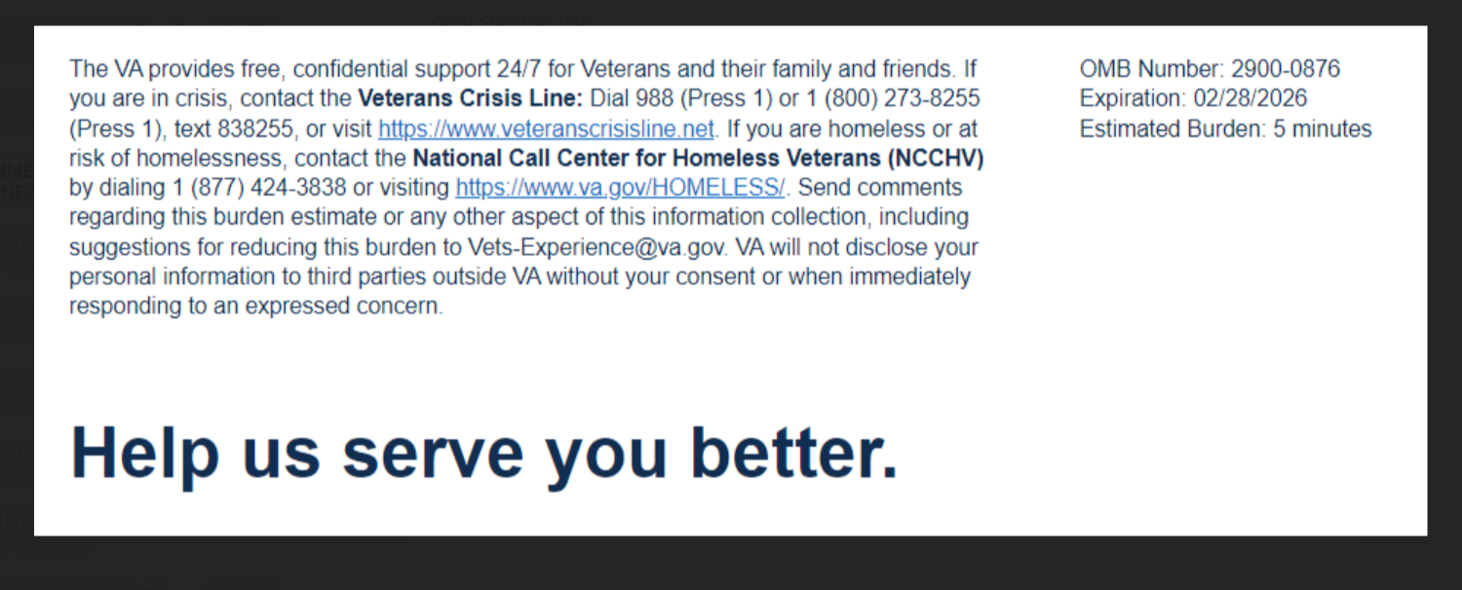
We want to hear about your experience learning about the Veteran Readiness & Employment (VR&E) Program, also known as Chapter 31. By responding to this survey, you will directly help us improve the program and provide better support to Veterans like you. Your ability to become employed and live independently is important to us!
The following questions ask about your most recent experience with your VA Vocational Rehabilitation Counselor.

This survey should take approximately 5 minutes to complete.

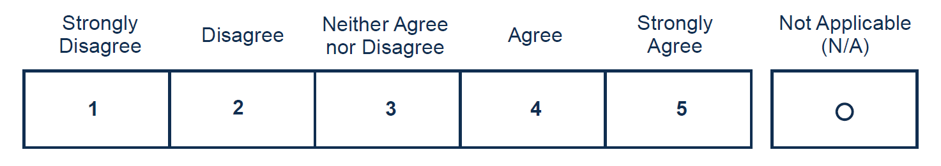
[1] The services I received were helpful in getting a job

[2] I found it easy to contact my counselor.

[3] My counselor treated me fairly
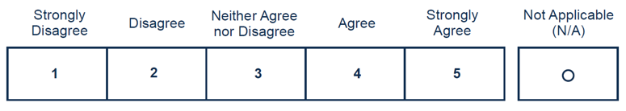

[4] The goals of my plan were met before my case was closed

[5] VR&E had a positive impact on my life (yes/no)
Yes – Free Text: You said yes to the question above. Please tell us why.
No – Free Text: You said no to the question above. Please tell us why.

[6] I trust VR&E to help me prepare for, obtain, and maintain suitable employment or achieve
Required
independence in my daily living.
