Discontinuing from VR&E Survey
V1 DRAFT 01/23/2024
Working Draft, Pre-Decisional, Deliberative document – Internal VA Use Only


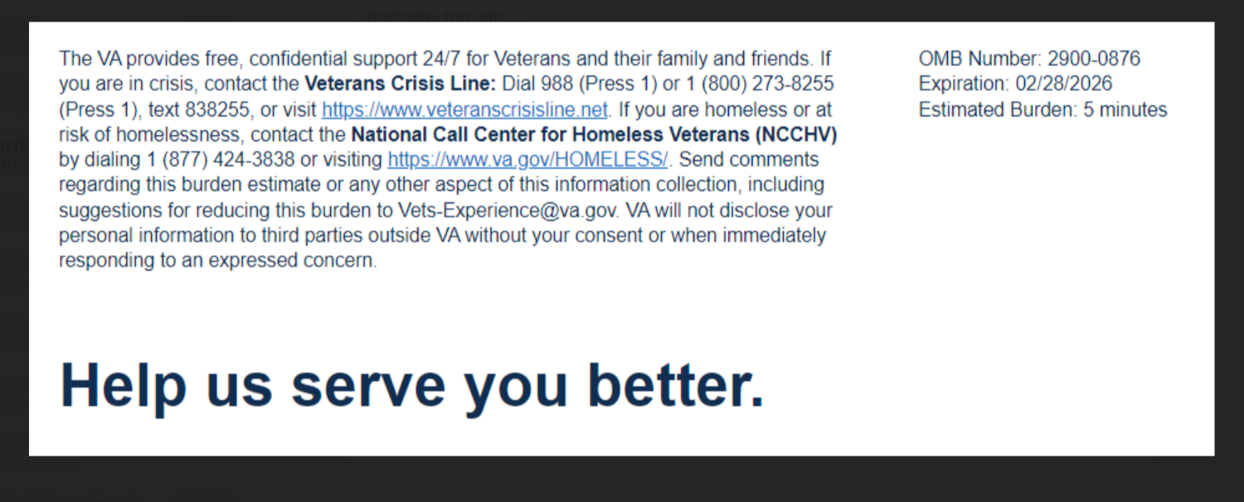
We want to hear about your experience learning about the Veteran Readiness & Employment (VR&E) Program, also known as Chapter 31. By responding to this survey, you will directly help us improve the program and provide better support to Veterans like you. Your ability to become employed and live independently is important to us!
The following questions ask about your most recent experience with your VA Vocational Rehabilitation Counselor.

This survey should take approximately 5 minutes to complete.
Required
[1] What was the main reason for discontinuing the VR&E program?
  - General Life Issues [Logic: When selected branch to Q2 and Q11]
  - Aspects of VR&E [When selected branch to Q3 through Q11]
  - Both [All questions are selected]
[2] What impacted your decision to discontinue your VR&E program?
Please select all that apply

  - Health concerns and/or family obligations
  - Job or financial responsibilities
  - Completed training and chose not to pursue employment
  - VA discontinued my VR&E program
  - Other [Logic: When selected, a text box appears]

[3]
I found it easy to access VR&E tools and resources

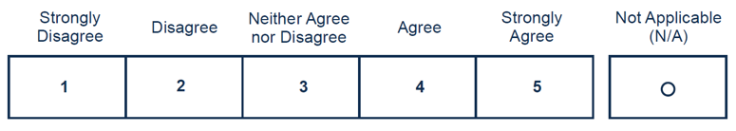
[4] Please indicate your satisfaction with the following:
Timeliness of the services I received
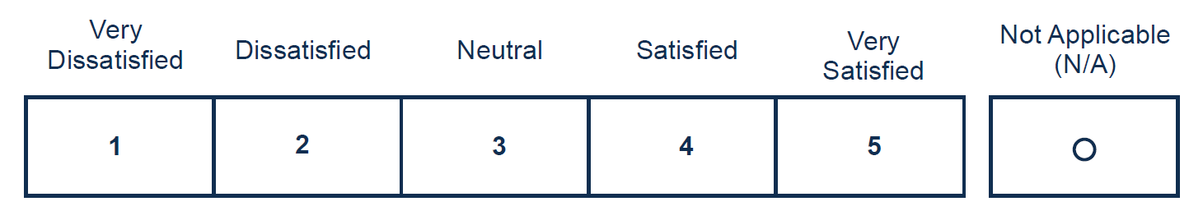

[5] Please indicate your overall satisfaction with the VR&E program
Free Text: What could VR&E have done better?
[6] I trust VR&E to help me prepare for, obtain, and maintain suitable employment or achieve independence in my daily living.
Required
