Help us serve you better.
We want to hear about your experience with the Veterans Experience Action Center (VEAC) event. Your answers to these questions directly help us improve our services.
This voluntary survey should take approximately 5 minutes to complete. Please respond to all questions to complete the survey.

- What best describes you as you’re participating in this Veterans Experience Action Center (VEAC) event? REQUIRED (if required)
- Veteran
- Active Military/National Guard/Reserve
- Family Member
- Caregiver
- Survivor

- Is this the first time you have interacted with VA?
- Yes
- No
- Unsure

- Do you currently receive VA healthcare services or VA benefits, such as compensation, pension, education, home loan, or pre-burial benefits?
Note: Display question only if answer is “No” or
“Unsure” in previous question (Is this the first time
you have interacted with VA?).
- Yes
- No
- Unsure

- Please indicate why you may not have interacted with VA. Please select all the following reasons that apply.
Note: Display question only if answer is “Yes” or “Unsure” in previous question (Is this the first time you have interacted with VA?).
- I did not know I was eligible for VA healthcare or benefits
- I haven’t had the time to look into VA healthcare or benefits
- I did not wish to apply for any VA healthcare or benefits
- I did not know how to apply for VA healthcare or benefits
- Other

- Did you have any challenges attending the outreach event? Please select all that apply.
- No challenges
- Making an appointment
- Call wasn’t conducted at the time I desired
- Issues with calls (call went too long, too many transfers, too long to be connected to resource provider)
- Technical failures (dropped calls, audio problems)
- Other

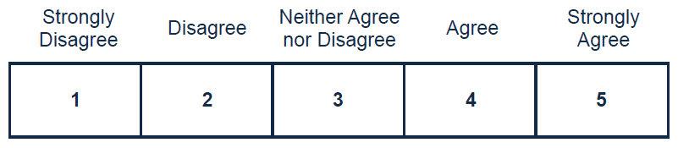
- I was able to get my information and/or service support needs met at the outreach event.

- It was easy to get the information and/or services that I needed at the outreach event.

- I felt respected and valued during my participation at the outreach event.

- I trust VA to fulfill our country’s commitment to Veterans.

- I would recommend this outreach event to other Veterans.

- What race/ethnicity do you identify with? Select all that apply.
- American Indian or Alaska Native
- Asian
- Black or African American
- Hispanic or Latino
- Native Hawaiian or Other Pacific Islander
- White

- Would you like to provide additional feedback with a concern, compliment, or recommendation about your experience(s) with VEAC events? Please select from one of the following options.
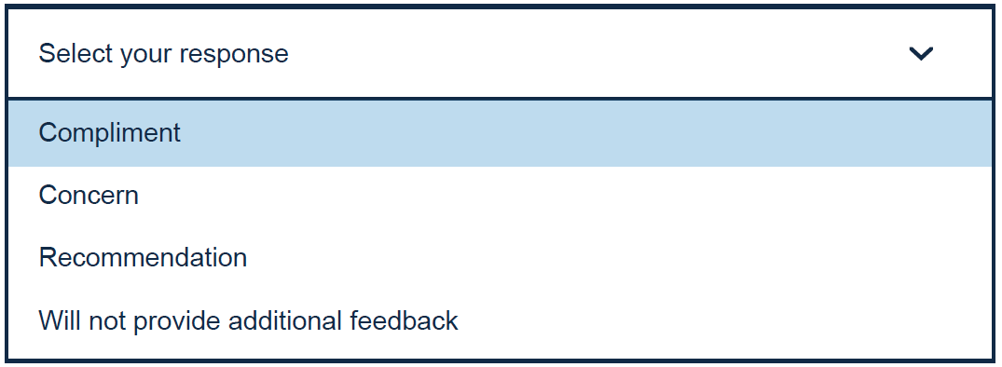

- Use the text box below to enter details of the additional feedback (optional). Please do not include any personally identifiable information, Social Security Number, Veteran ID, or medical information, but do provide details about your experience.

