VA Public Contact Team Survey
V10 DRAFT 2/14/2024
Working Draft, Pre-Decisional, Deliberative document – Internal VA Use Only


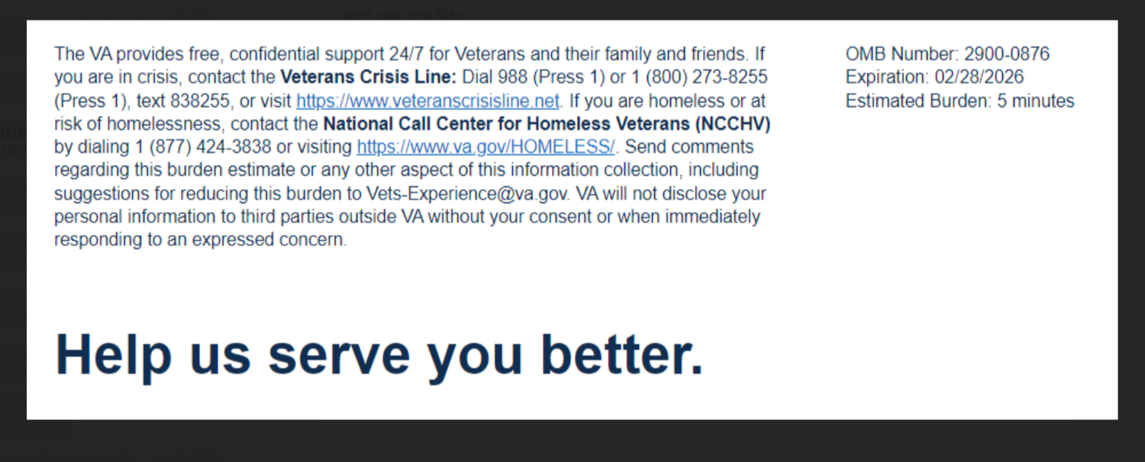

We want to hear about your experience with the VA Public Contact Team (PCT), which is dedicated to answering, aiding, and providing guidance for Veterans, beneficiaries, spouses, and stakeholders about Veteran Benefits Administration services and benefits. By responding to this survey, you will directly help us improve the services we provide!

This survey should take approximately 5 minutes to complete.

The following questions ask about your most recent experience with the VA PCT.

[1] What method would you have most liked to use to contact the VA? (Select all that apply)
  - In-person
  - Phone call / Call Center
  - Ask VA / Email
  - Scheduled Virtual Meeting
  - Online chat
  - Text messaging
  - VA mobile app

[2] What challenges did you experience getting to the PCT office? (Select all that apply) [Logic: proceed to question 6 if the interaction was not in person]
  - The office was too far away
  - It was difficult for me to get transportation
  - The location was not accessible for those with disabilities
  - It was difficult to find parking
  - I did not experience any challenges getting to the PCT office
Error Message: “I did not experience any challenges getting to the PCT” may not be selected with any other answers.

[3] My wait time was appropriate. [Skip if not in person]
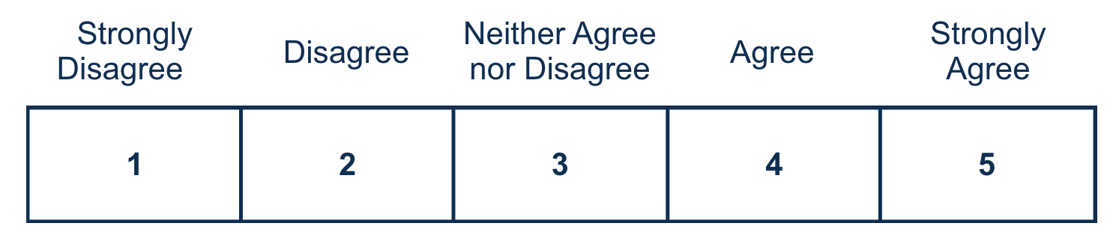
[4] Please tell us how long you waited before being assisted in the PCT office: [Skip if not in person]
  - 5 minutes or fewer
  - 6-15 minutes
  - 16-30 minutes
  - 31-60 minutes
  - Over an hour
  - I do not recall the time I waited for assistance
[5] The PCT office had a private interview space that made me comfortable discussing my information. [Skip if not in person]
You selected [Agree / Strongly Agree]. Please tell us why. (Select all that apply)
  - The interview space offered privacy
  - The interview space was a conducive environment for open communication
  - The interview space made me feel at ease
  - The interview space made me feel safe
  - The interview space had a professional appearance
  - The interview space was quiet
You selected [Disagree / Strongly Disagree]. Please tell us why. (Select all that apply)
  - The interview space did not allow for privacy
  - The interview space was loud
  - The interview space was distracting
  - I felt like our discussions could be overheard
  - The interview space had an unprofessional appearance
  - The interview space made me uncomfortable

[6] The PCT employee I met with was capable of addressing my situation.

[7] The PCT employee paid attention to me during my appointment.
[8] The Information provided to me by the PCT employee was easy to understand.
[9] At the end of my visit, I received appropriate guidance on my next steps.
[10] I am satisfied with the service I received from the PCT.
Required
[11] I trust the PCT to answer my questions and help me access my VBA benefits.
You selected [Agree / Strongly Agree]. Please tell us why. (Select all that apply)
Required if respondent selects Agree / Strongly Agree for question 11
  - I have full confidence in their abilities
  - I believe they are able to support me
  - I believe they are reliable
  - I believe they cared about my situation.
You selected [Disagree / Strongly Disagree]. Please tell us why. (Select all that apply)
Required if respondent selects Disagree / Strongly Disagree for question 11
  - I do not have confidence in their abilities
  - I do not believe they cared about my situation
  - I do not believe they are reliable
  - I do not feel comfortable relying on them

[12] Please provide additional details regarding your visit with the PCT. (optional)
0/400



