We want to hear about your experience with the Veterans Experience Action Center (VEAC) event. Your answers to these questions directly help us improve our services.
This voluntary survey should take approximately 5 minutes to complete. Please respond to each question that you are asked to complete the survey.
Was this the first time you supported a Veterans Experience Action Center (VEAC) event? Required
- Yes
- No
What best describes the training and certificate(s) you received prior to hosting this Veterans Experience Action Center (VEAC) event? (select all that apply) Required
(select all that apply)
- Systems Management
- Communications and Marketing
- Data Analysis
- Training Management
- Operations Management
- Project Management
Which training and certificate, received prior to hosting this VEAC event, MOST applied to your participation at the event? (select only one choice) Required
- Systems Management
- Communications and Marketing
- Data Analysis
- Training Management
- Operations Management
- Project Management
Please respond to the following prompts as you consider the training and certification process you completed regarding the (LOGIC: Display option selected above) responsibility.

- It was easy for me to use the recommended templates or tools.

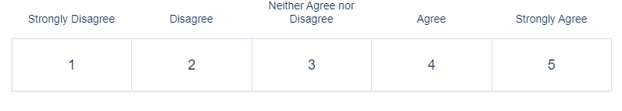
- The VEAC Playbook provided all of the information needed for me to perform in my supportive role.
- I felt the training prepared me well to complete the tasks of this responsibility in support of the VFCE event.
- I trust VFCE to prepare me to meet the needs of customers at VEAC events. Required
- I would recommend this training to anyone executing a VEAC event.
Would you like to provide additional feedback regarding your experience helping to support the VEAC event? Required
- Yes
- No
If yes, then please use the text box below to enter details of the additional feedback (max 240 characters).

