Telemammography Survey
DRAFT 08/07/2023
Working Draft, Pre-Decisional, Deliberative document – Internal VA Use Only


The VA provides free, confidential support 24/7 for Veterans and their family and friends. If you 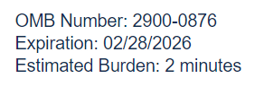
are in crisis, contact the Veterans Crisis Line by dialing 988 (Press 1), or dialing 1 (800)
273-8255 (Press 1), or texting 838255, or visiting https://www.veteranscrisisline.net. If you are
homeless or at risk of homelessness, contact the National Call Center for Homeless
Veterans (NCCHV) by dialing 1 (877) 424-3838 or visiting https://www.va.gov/HOMELESS/. VA will not disclose your personal information to third parties outside VA without out your consent or when immediately responding to an expressed concern. Send comments regarding this burden estimate or any other aspect of this information collection, including suggestions for reducing this burden to Vets-Experience@va.gov.

Help us serve you better.

We want to hear about your recent experience with labs or imaging on [August 19, 2019]. By indicating how much you agree or disagree with the statements below, you directly help us improve VA services.

This Voluntary survey will take about 2 minutes to complete.

<NEW QUESTION ONLY FOR MAMMOGRAM (STOP CODE 703 PATIENTS>
Why might you choose to get a mammogram at the VA as opposed to a community medical facility? (select all that apply)

□ I am treated with courtesy and respect
□ I like the Veteran-based culture
□ I am familiar with the VA facility
□ I trust VA facilities to provide effective mammography services
□ Inviting and respectful atmosphere for women
□ I have a lot of choices for appointment dates/times
□ The process of scheduling an appointment is easy
□ Close to my home/ easy to get to
□ Can schedule other appointments or services on the same day as my mammogram
□ Referral to community medical facility is a hassle for me
□ Other [fill in]
<NEW QUESTION ONLY FOR MAMMOGRAM (STOP CODE 703 PATIENTS>
Why might you choose to get a mammogram at a community medical facility as opposed to VA? (select all that apply)
□ I am treated with courtesy and respect
□ I don’t trust VA in general
□ I am familiar with the community medical facility
□ I trust the community medical facility to provide effective mammography services
□ Inviting and respectful atmosphere for women
□ I have a lot of choices for appointment dates/times
□ The process of scheduling an appointment is easier
□ Close to my home/ easy to get to
□ Multiple facilities to choose from
□ It is a hassle to get a mammogram at the VA, and then be sent for further breast imaging in a community medical facility
□ Other [fill in]
<NEW QUESTION ONLY FOR MAMMOGRAM (STOP CODE 703 PATIENTS>
If you were given the choice between getting a referral to a community medical facility or getting a mammogram at a VA facility, which would you prefer?
O Strongly prefer community medical facility
O Slightly prefer community medical facility
O No Preference/ Don’t know
O Slightly prefer VA facility
O Strongly prefer VA facility

It was easy to find the location for my lab tests or imaging

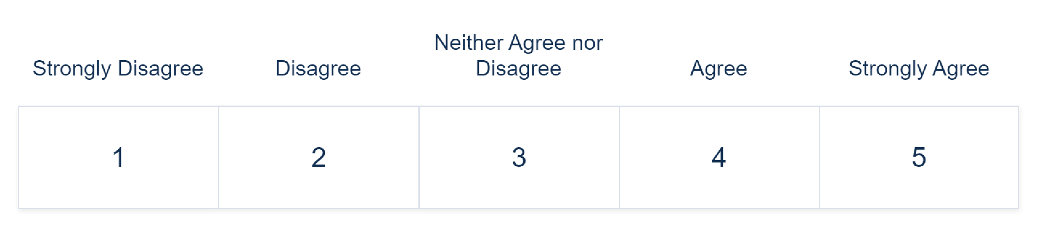

My lab tests or imaging were completed within a reasonable time frame

When I got my lab tests (blood draw, etc.) or imaging (X-ray, MRI, CT scan) done, I was treated with courtesy and respect. Required

I am satisfied with the service I received from [VA Facility]. Required.

During my most recent VA health care experience, I felt respected and comfortable.

I trust [VA Facility] for my health care needs. Required.

Would you like to provide additional feedback with a concern, compliment, or recommendation about your experience with [VA Facility]?

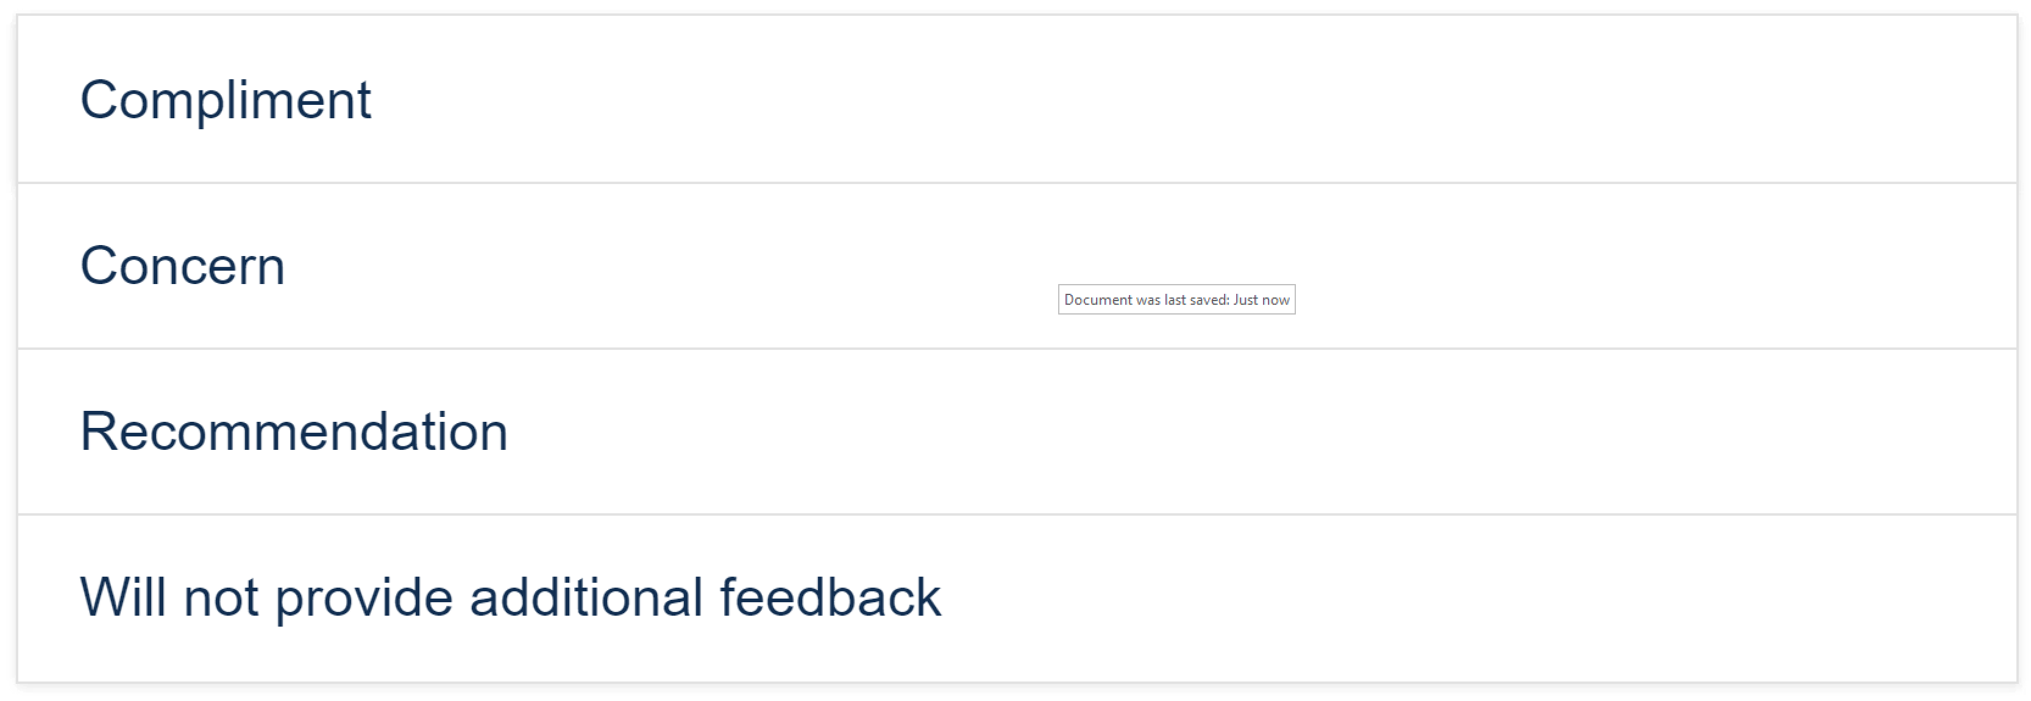

Use the text box below to enter details of the additional feedback [optional].
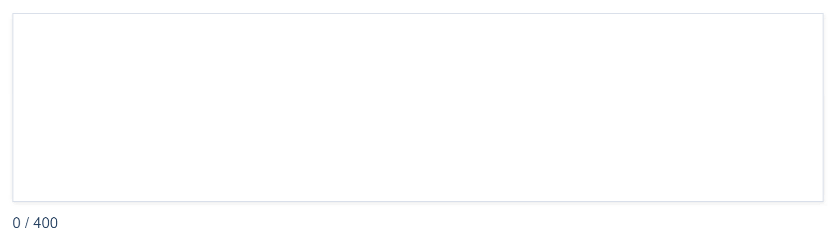

Can VA contact you about your feedback? Required.

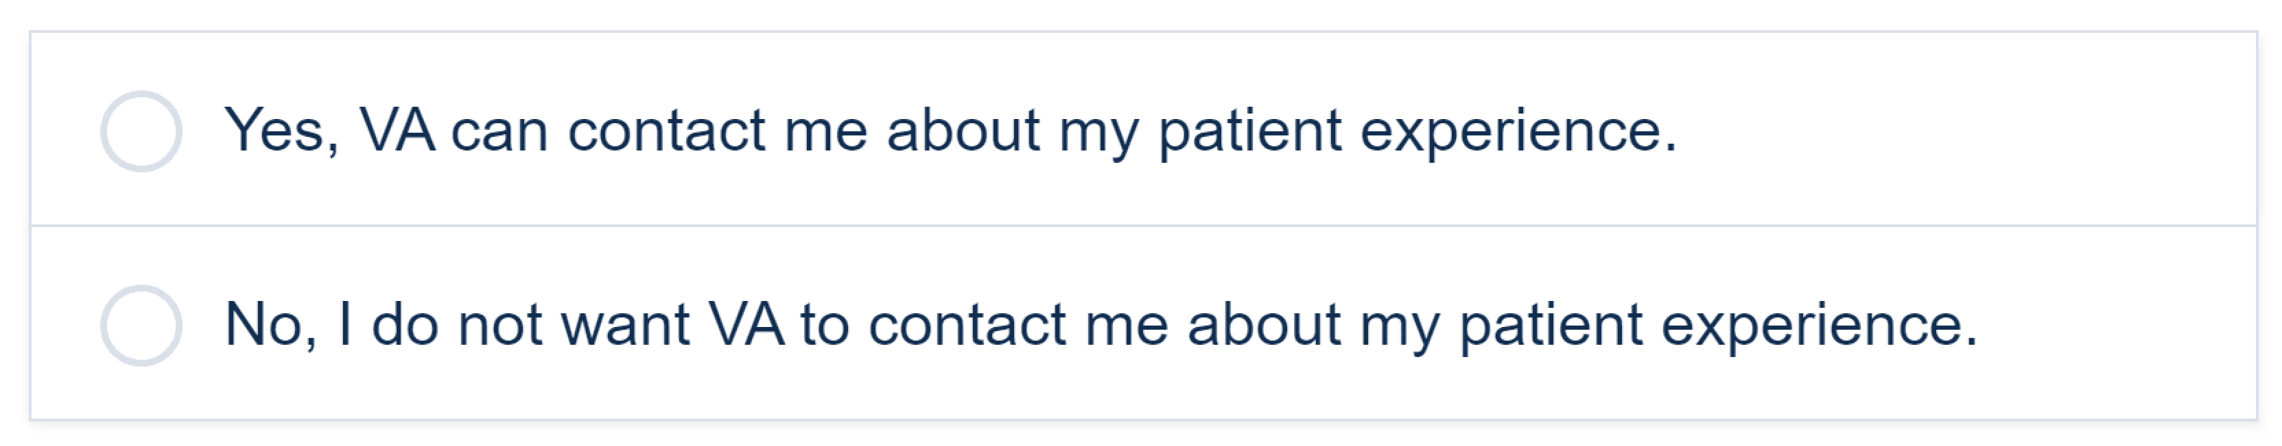

Would you like to volunteer your demographic information to help VA better serve you?

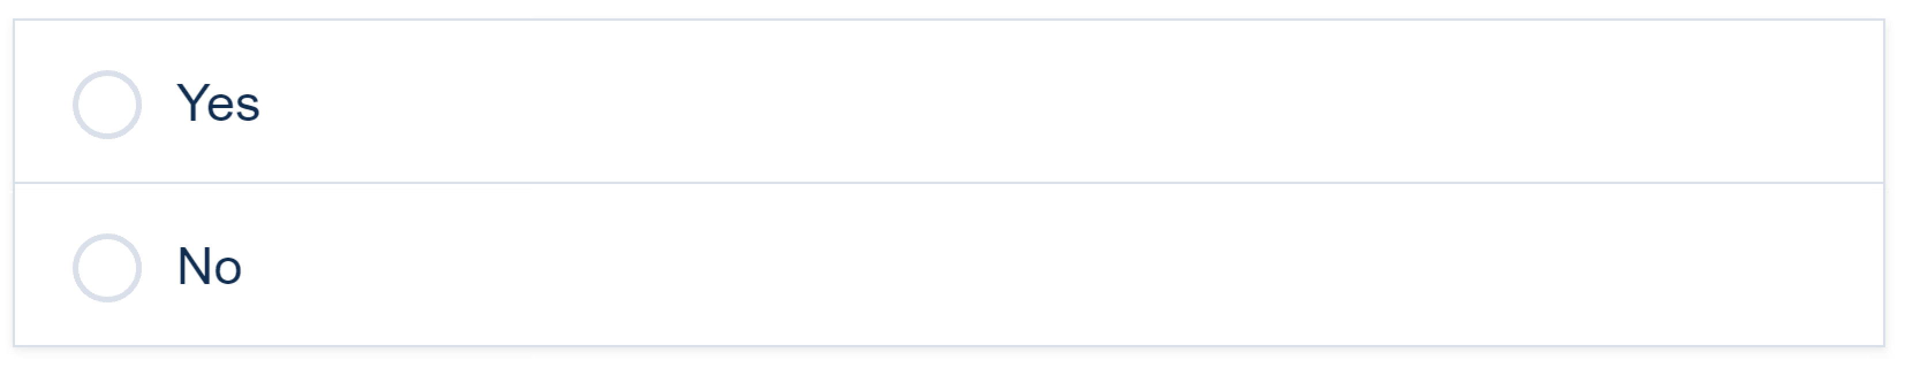

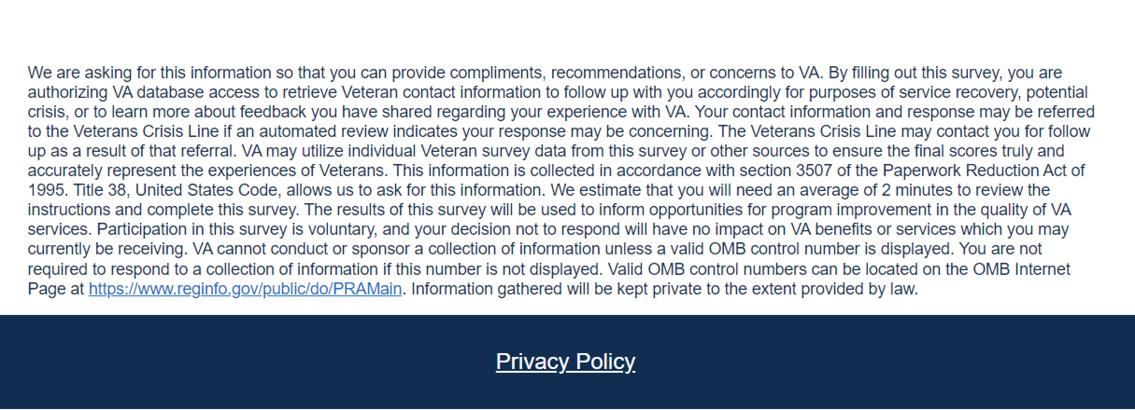

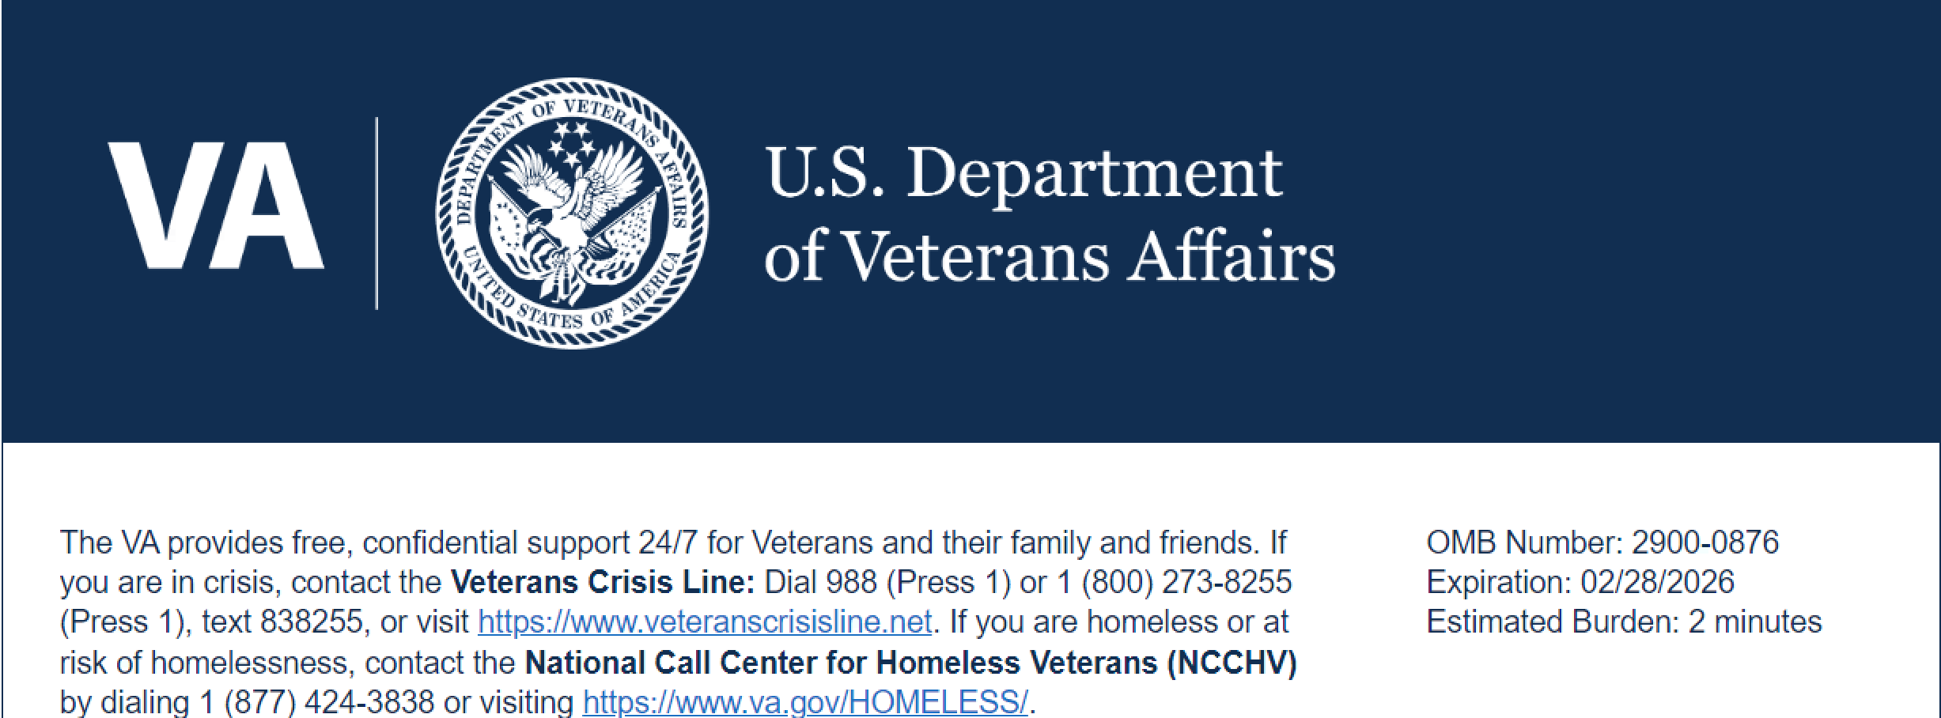

<Only If Respondent Selects Yes to Above>
We are working to better understand our customers. All questions on this survey, including the following questions, are voluntary.

Are you Hispanic or Latino?
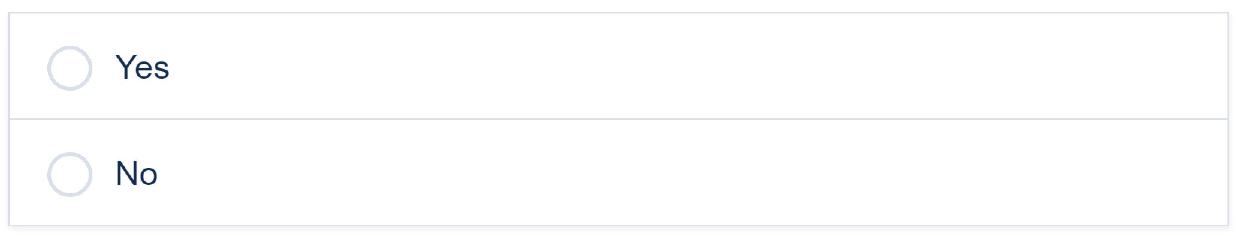

What is your race? Select all that apply.
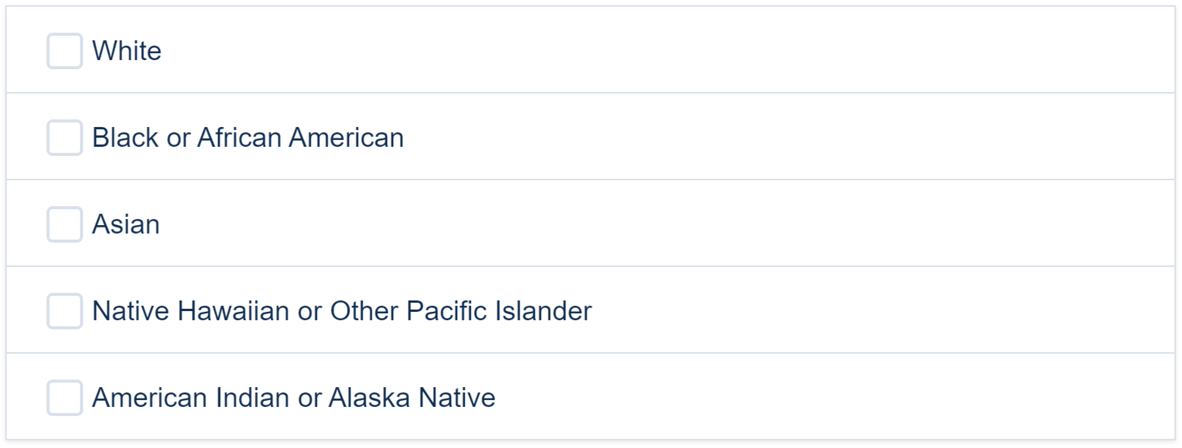



We are asking for this information so that you can provide compliments, recommendations, or concerns to VA. By filling out this survey, you are authorizing VA database access to retrieve Veteran contact information to follow up with you accordingly for purposes of service recovery, potential crisis, or to learn more about feedback you have shared regarding your experience with VA. Your contact information and response may be referred to the Veterans Crisis Line if an automated review indicates your response may be concerning. The Veterans Crisis Line may contact you for follow up as a result of that referral. VA may utilize individual Veteran survey data from this survey or other sources to ensure the final scores truly and accurately represent the experiences of Veterans. This information is collected in accordance with section 3507 of the Paperwork Reduction Act of 1995. Title 38, United States Code, allows us to ask for this information. We estimate that you will need an average of 2 minutes to review the instructions and complete this survey. The results of this survey will be used to inform opportunities for program improvement in the quality of VA services. Participation in this survey is voluntary, and your decision not to respond will have no impact on VA benefits or services which you may currently be receiving. VA cannot conduct or sponsor a collection of information unless a valid OMB control number is displayed. You are not required to respond to a collection of information if this number is not displayed. Valid OMB control numbers can be located on the OMB Internet Page at https://www.reginfo.gov/public/do/PRAMain. Information gathered will be kept private to the extent provided by law.

