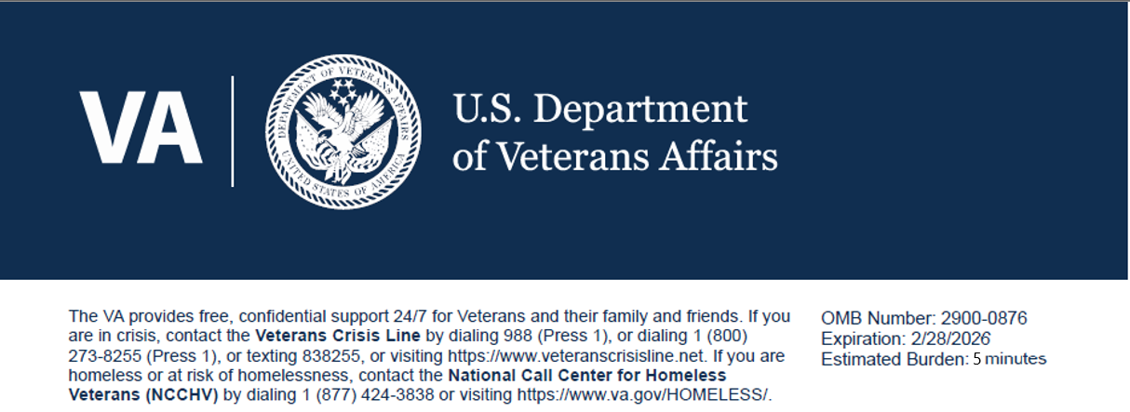

Survey Introduction: VA wants to better understand Veterans under the age of 40 and their relationship to the Department of Veterans Affairs across all the programs, services, and benefits as it relates to the level trust or distrust. We also are looking to build trust and understand what Veterans need to build a lasting relationship with the VA

Questions:
1. How many years did you serve in the US military?
- 0-1
- 2-4
- 5-10
- 11-15
- 16-20
- 21+
- Still Serving (National Guard/Reserve)

2. When you were transitioning out of the military, what were your initial impression of the VA?
Very Negative Negative Neutral Positive Very Positive

3. Please describe how your military experience has impacted your initial perception of the VA.

4. I trust the VA to fulfill our country’s commitment to Veterans and their families.
Strongly Disagree Disagree Neither Agree Strongly Agree
5. Please rank the characteristics below in order of most important to least important for building and maintaining trust, with “1” being most important and “7” being least important.
- Confidentiality / Privacy / Security
- Accessibility / Timeliness
- Reliability
- Honesty / Integrity
- Respect / Inclusivity
- Competency / Credibility
- Communication / Responsiveness / Transparency

6. How many times have you interacted with the Department of Veterans Aﬀairs in the last 12 months to include phone calls, visiting websites, personal interactions, etc.
- 0
- 1-5
- 6-10
- 11-20
- 21+

7. What VA Administrations have you interacted with? (Select all that apply)
- Veteran Beneﬁts Administration -VBA- Disability claims, home loans, GI Bill, Veteran Readiness & Employment, Insurance, etc.)
- Veterans’ Health Administration -VHA- Primary Care, Mental Health, Specialty Care
- Cemetery Administration - NCA- burial and memorial beneﬁts
- Vet Centers group and individual counselling
- None of the above

8. Where do you currently find trusted information regarding the VA? (Select all that apply)
- VA.GOV
- VA YouTube
- VA Social Media pages (Twitter, Facebook, Instagram, etc.)
- VA letters or VA Emails or other mailers
- TAP Program when exiting the military
- Military One Source
- VA Solid Start Phone Call post transition
- Veteran Service Organizations (DMV, AMVETS, PVA, VFW, etc.)
- Other Veteran related non-proﬁt (Wounded Warriors, Operation Home Front, Bob Woodruﬀ Family Foundation, etc.)
- Other Veterans or Servicemembers
- Family and Friends
- Other Social Media Platforms not sponsored by VA (Reddit, Snapchat, TikTok, Pinterest, YouTube, Facebook, Instagram, etc)
- Search Engines (Google, Bing, etc)
- None of these

9. How would you like the VA to communicate with you about its beneﬁts, programs and services? (Select all that apply)
- Email
- Text Message
- VA App/Webpage Push Notiﬁcations Phone
- Call
- Podcasts
- Social Media
- Online Events
- In-Person Events
- Blog
- Videos
- Newsletters
- Other

10. VA is doing a good job promoting a culture of diversity, inclusion, and acceptance for all (Eg. race, gender, ethnicity, etc.)
Strongly Disagree Disagree Neither Agree Strongly Agree

11. If you have not interacted with VA, why is that? (Select all that apply)
- I am not sure if I qualify for VA programs and services.
- I don't see any value.
- I don't feel like I need their services at this time.
- My day-to-day responsibilities make it diﬀicult (time/resources, etc.)
- It is too complicated (red tape) / I do not know where to start.
- I don't want to use resources that others may need more than I do.
- I haven't heard anything positive that would encourage me to engage .
- I tried, it takes too long, and I cannot reach anyone.
- VA does not oﬀer what I need in my location.
- I just want VA to enroll me for health care if I receive a service connection.

12. My interactions with VA staﬀ have had a positive impact on my overall trust with VA
Strongly Disagree Disagree Neither Agree Strongly Agree

13. Would you be willing to recommend VA to other Servicemembers or Veterans?
- Yes
- No
